

**INDIVIDUAL ASSIGNMENT**

**TECHNOLOGY PARK MALAYSIA**

**CT018-3-1-ICP**

**INTRODUCTION TO C PROGRAMMING**

**APU-APD1F2206/CE/EEE/ME/PE/CGD/CS/CS(CYB)/CS(DF)/CS(IS)/IT**

**STUDENT NAME: SOO JIUN GUAN**

**TP NUMBER: TP068687**

**INTAKE CODE: APD1F2206CS**

**LECTURER NAME: YOGESWARI A/P MUTHUSAMY**

**HAND OUT DATE: 23 DECEMBER 2022**

**HAND IN DATE: 28 FEBRUARY 2023**

**WEIGHTAGE: 50%**

**INSTRUCTIONS TO CANDIDATES:**

1. Submit your assignment online in Moodle unless advised otherwise.
2. Late submission will be awarded zero (0) unless Extenuating Circumstances (EC) are upheld.
3. Cases of plagiarism will be penalized.
4. You must obtain at least 50% in each component to pass this module.

Table of Content

1.0 Introduction & 2.0 Assumption 3

3.0 Design of the Program 4

3.1 Pseudocode 4

4.0 Main and Additional Features 29

5.0 Screenshot of Sample Inputs/Outputs & Explanation 97

5.1 Admin Functionalities 97

5.2 Applicant Functionalities 119

5.3 Approver Functionalities 127

6.0 Conclusion 132

7.0 References 133

# **1.0 Introduction & 2.0 Assumption**

In the past, staffs had to fill out physical forms and submit them to their department supervisors or HR personnel to apply for leave. This process was time-consuming and often involved a lot of paperwork.

However, with the continuous development of technology, many affairs have been digitized or transformed into a digital format. Nowadays, staffs can submit their leave applications online, either through a web-based platform or a mobile app. This has made the process more convenient and optimal, as employees can submit their leave applications from anywhere and at any time. It can also effectively prevent the waste of time and resources. Furthermore, approver can approve or reject the leave applications submitted by staff in real-time, without having to deal with physical forms. It is worth mentioning that the system can keep all the leave application records, which allows admin to track attendance of the specific staff, as well as generate monthly report of each department.

Through this assignment, I have opportunity to develop a leave application and management system for APU in order to automate and simplify the entire leave management process, from submitting to handling leave requests.

For this C programming assignment, I assume that:

1. APU can have a maximum of 500 staff.
2. Each ID and username can only exist once.
3. The initial leave balance of all staffs is 60 days.
4. Only 1000 leave application records can be stored in the text file.
5. Admin role has only an account to login the system.
6. Staff only can apply for leave in the current year.
7. Applicant cannot ask for another leave if he/she has a leave application haven’t been approved.
8. Staff cannot cancel leave application that is outdated.
9. Staff can still apply for leave even if their leave balance is insufficient, but they will be reminded to deduct their salary.
10. On-paid holiday would not deduct the leave balance.
11. Approver only can view and handle leave applications that belong to his/her category.

# **3.0 Design of the Program**

## **3.1 Pseudocode**

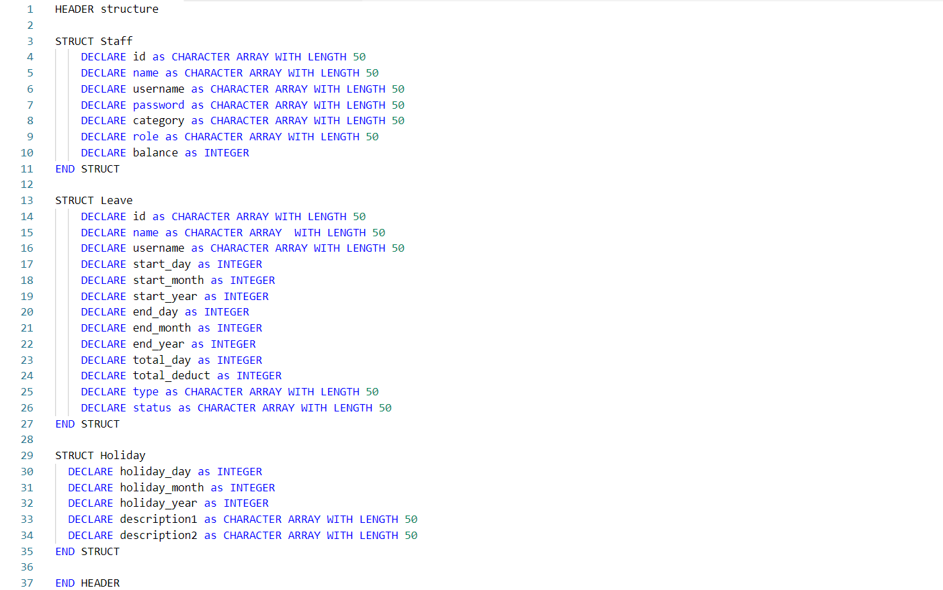

Figure 3.1.1: pseudocode of structure.h

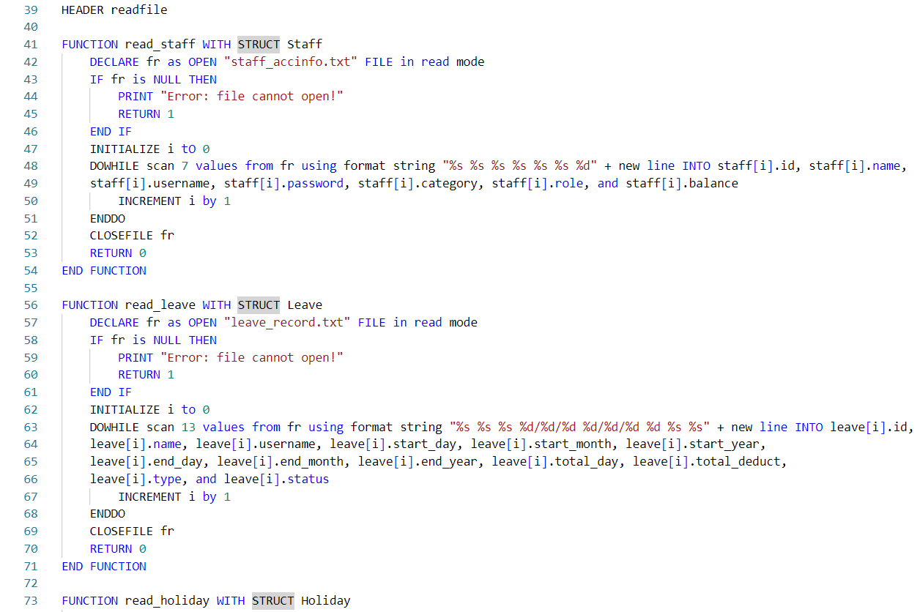 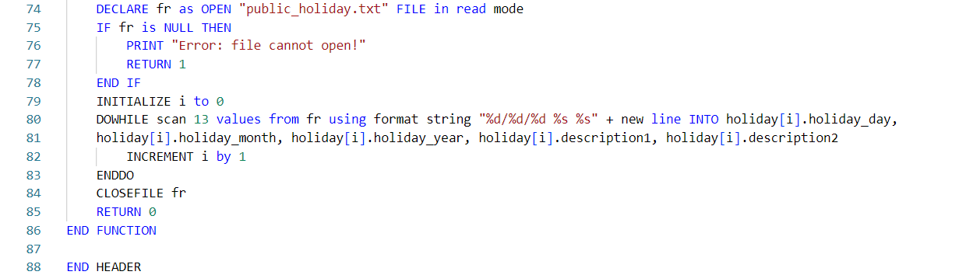

Figure 3.1.2: pseudocode of readfile.h

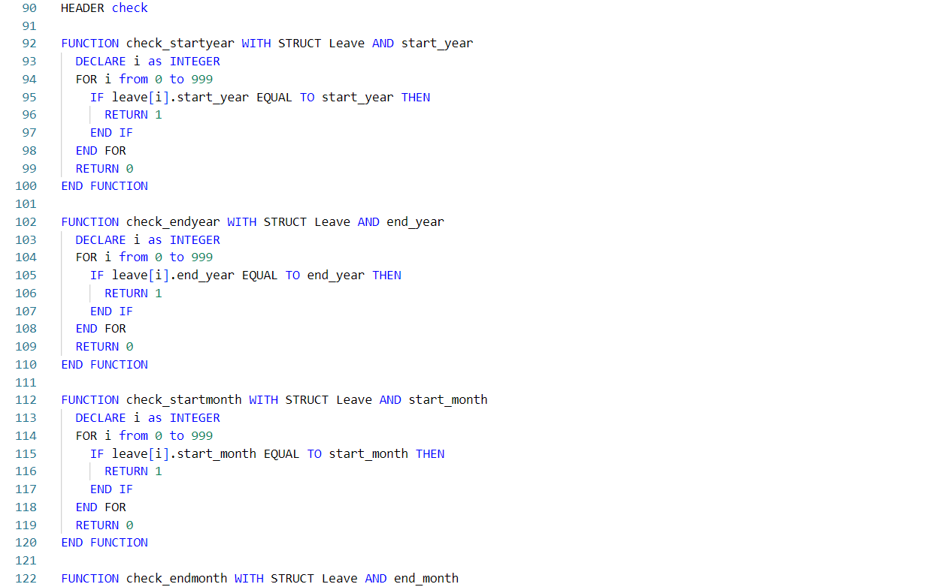

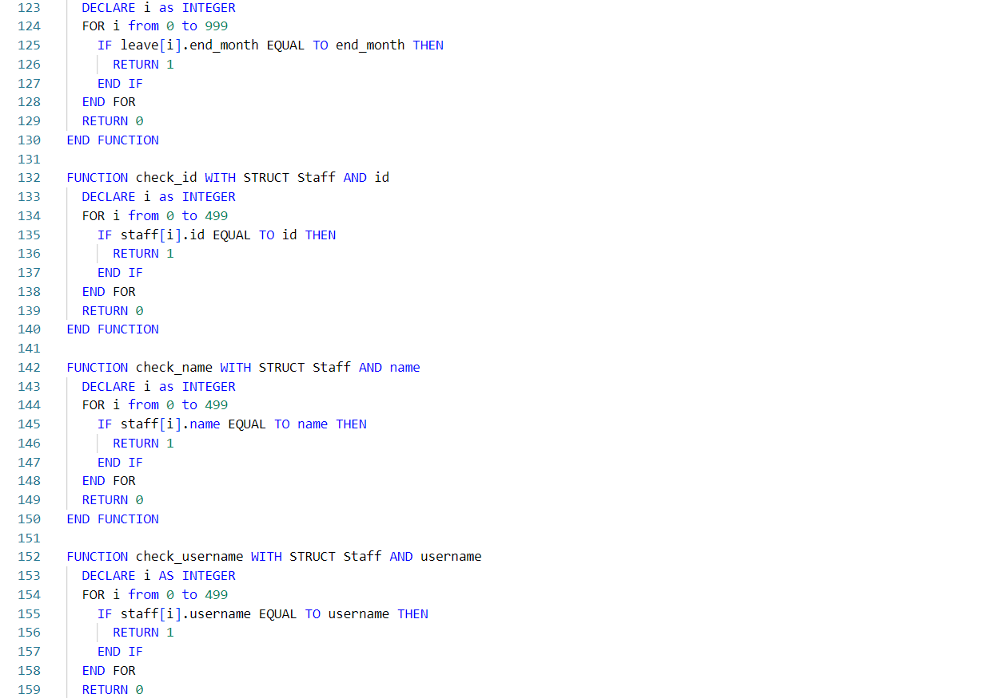 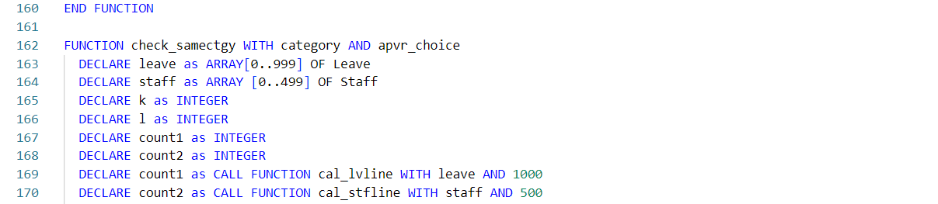

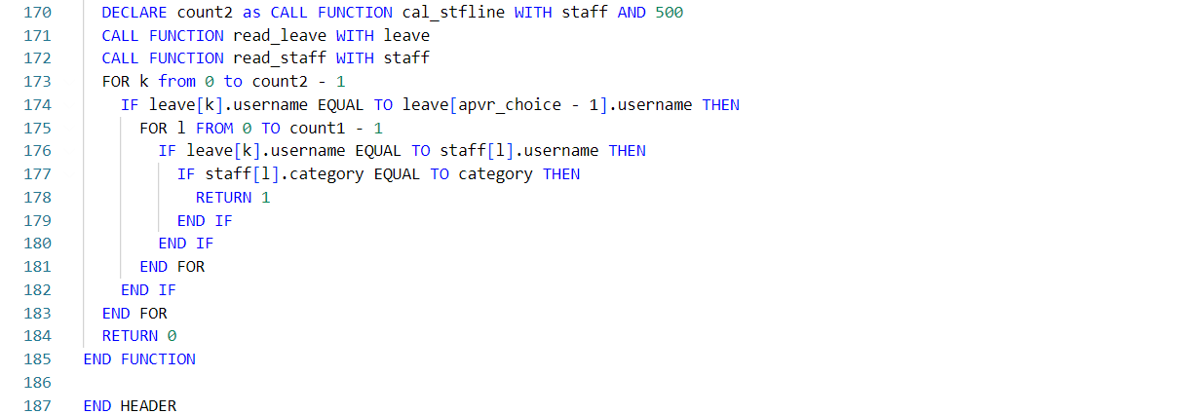

Figure 3.1.3: pseudocode of check.h

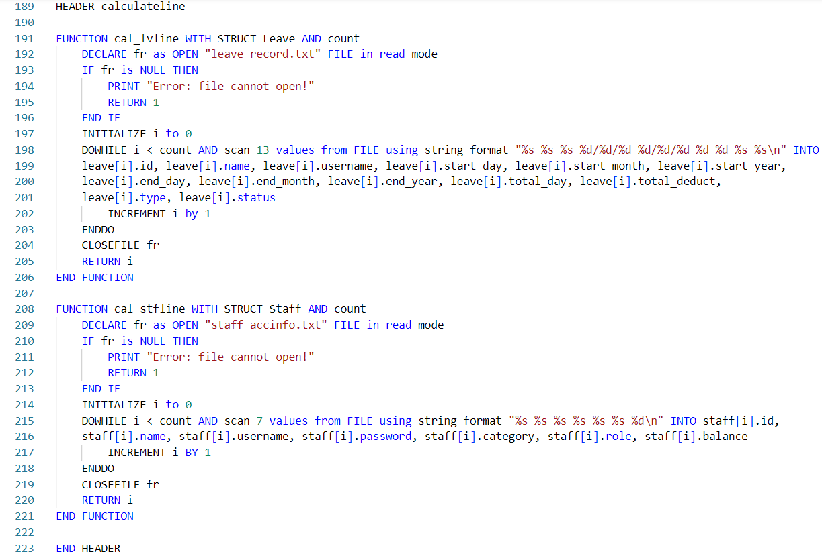

Figure 3.1.4: pseudocode of calculateline.h

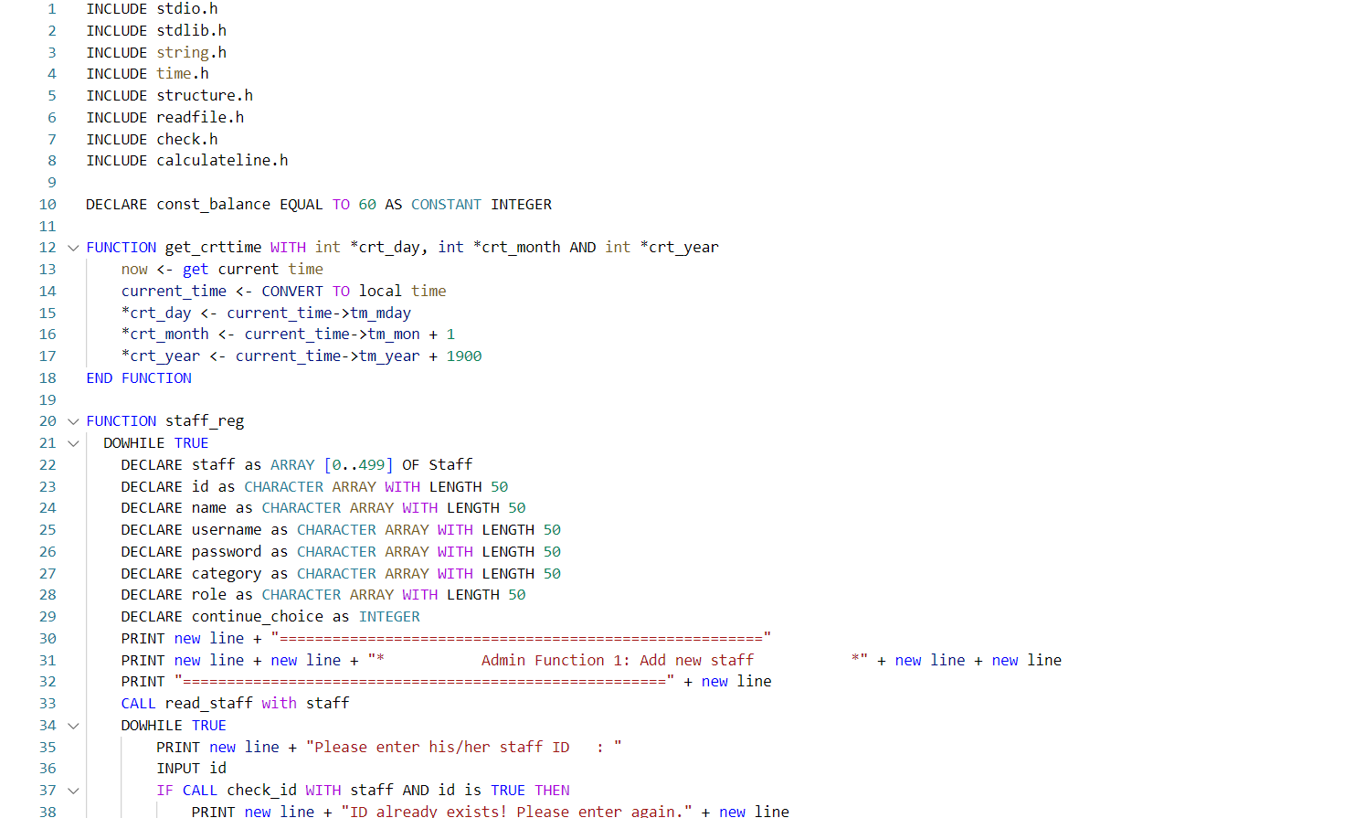

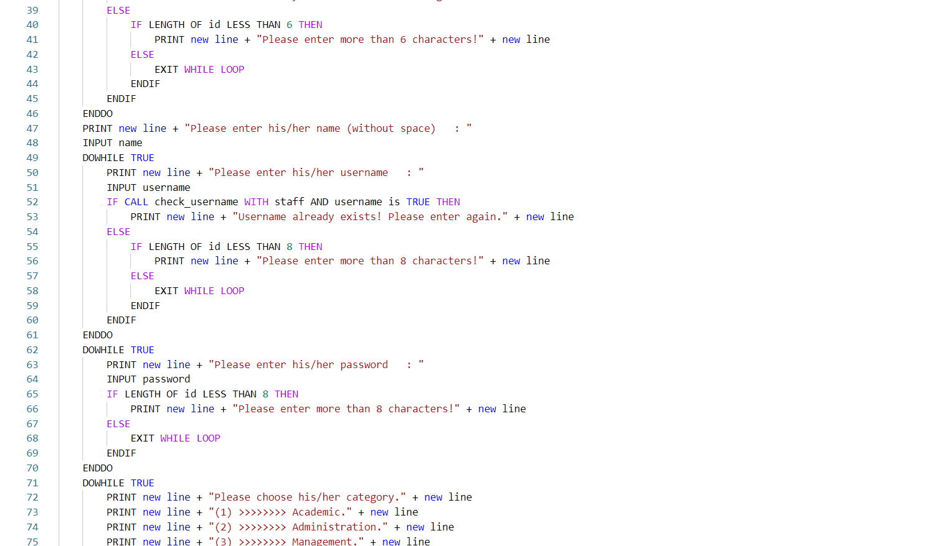 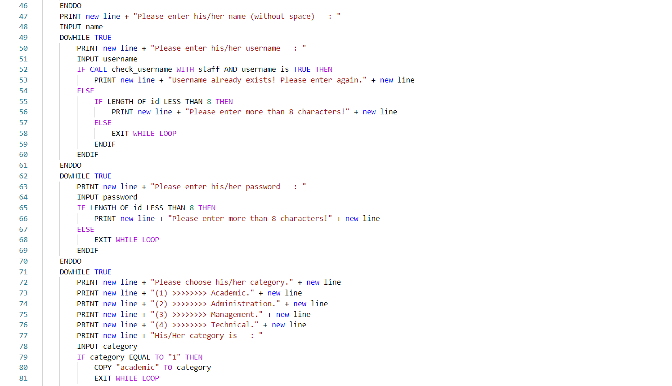 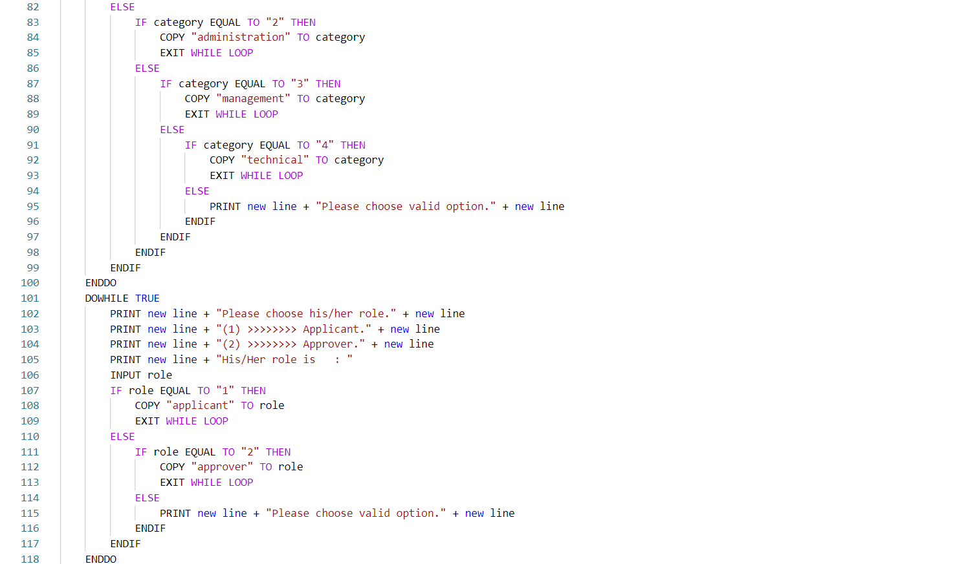 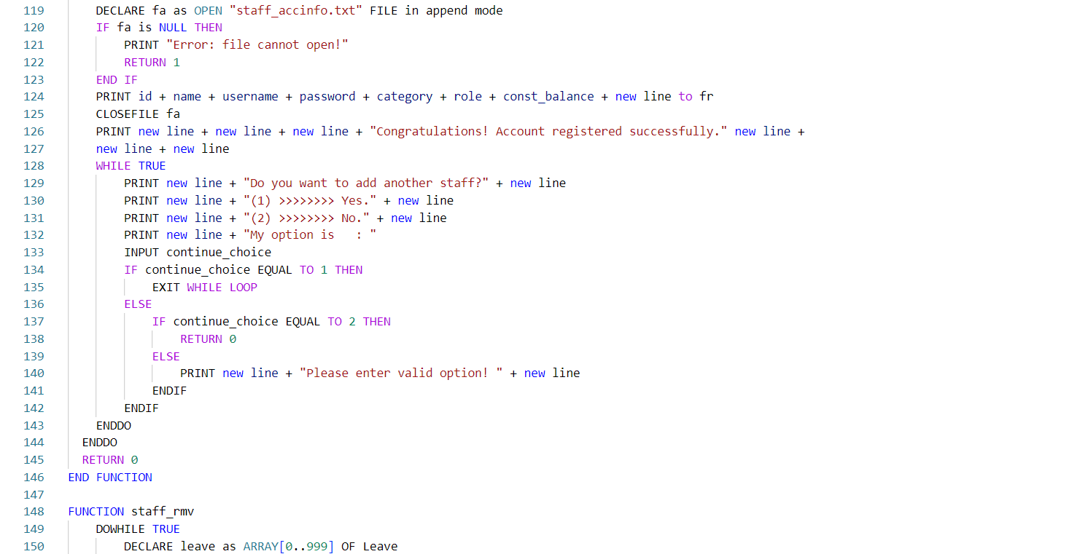

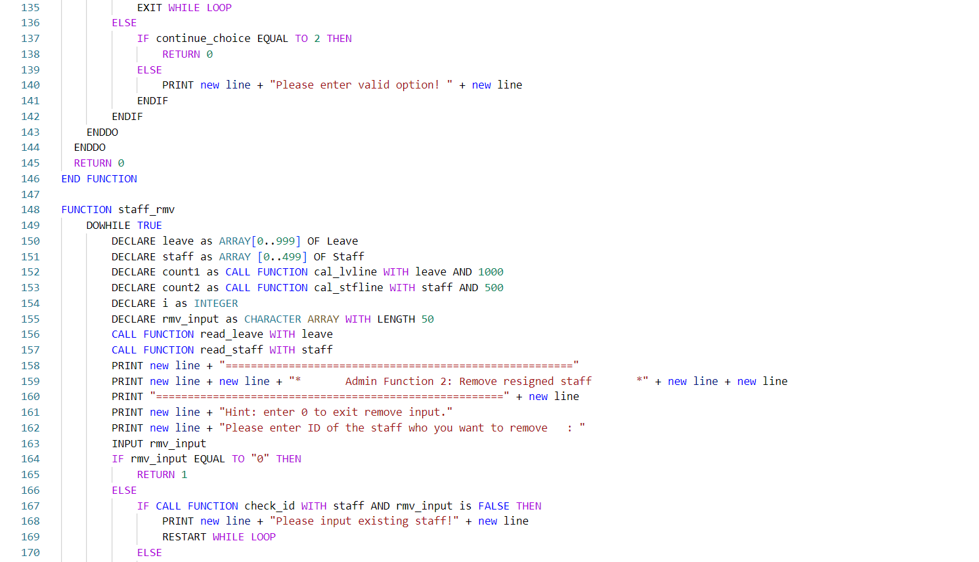 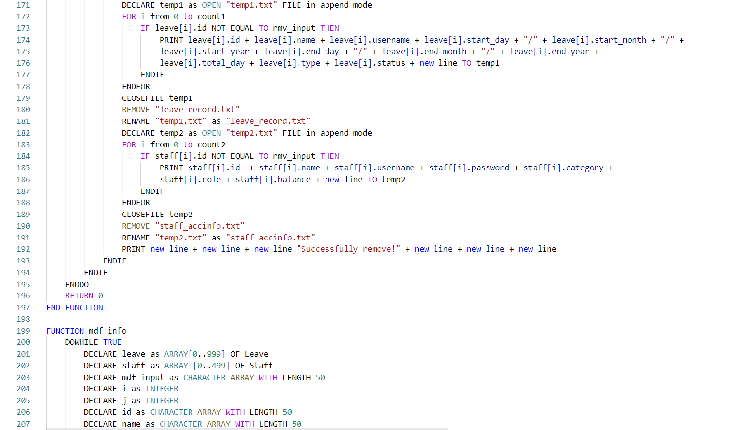 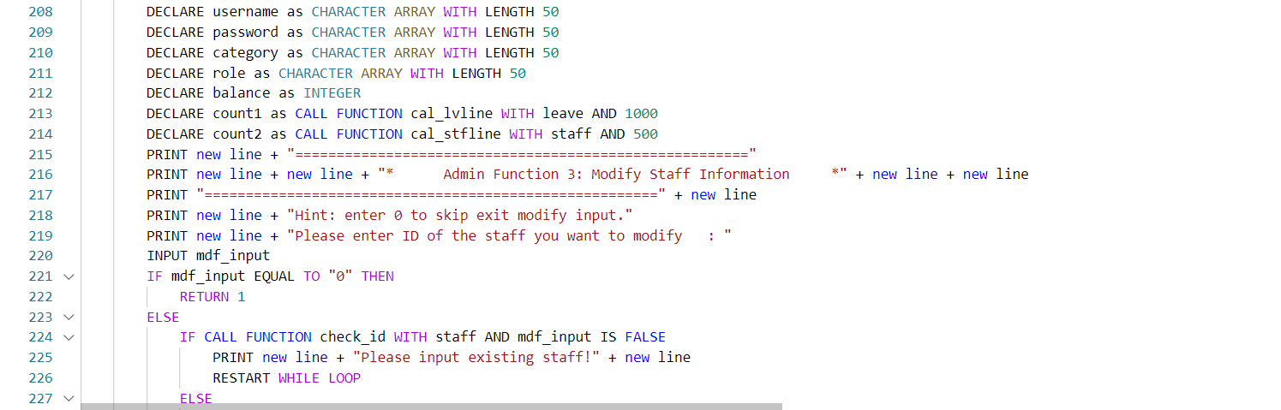 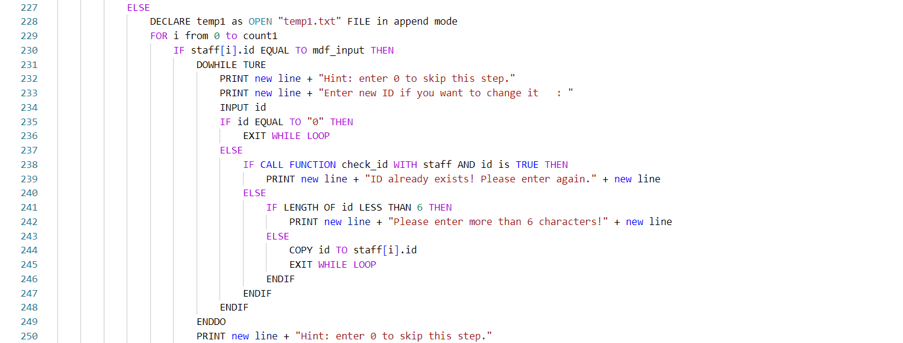 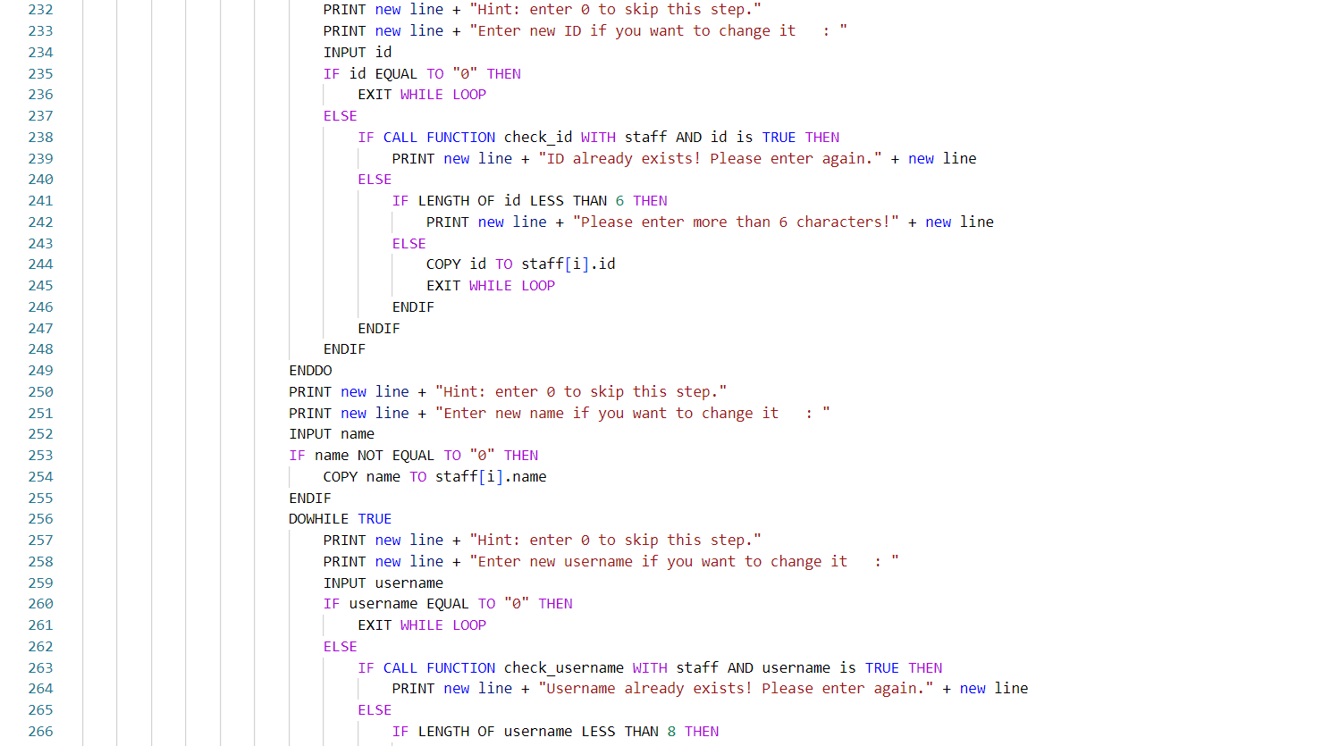 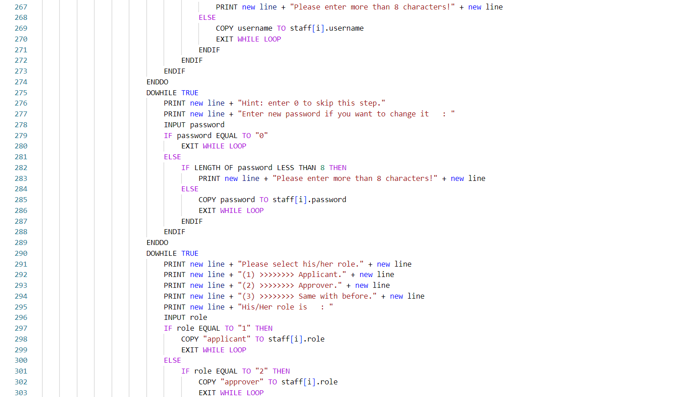 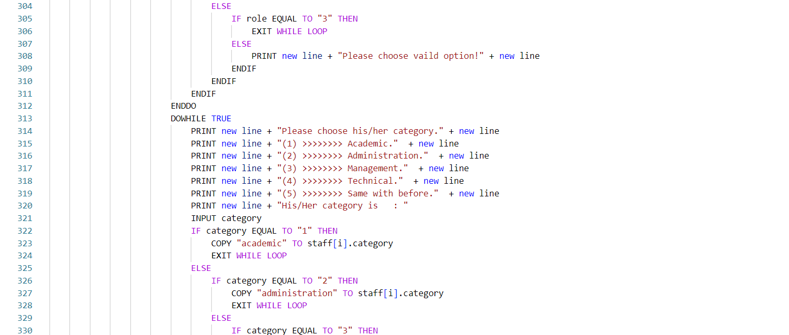

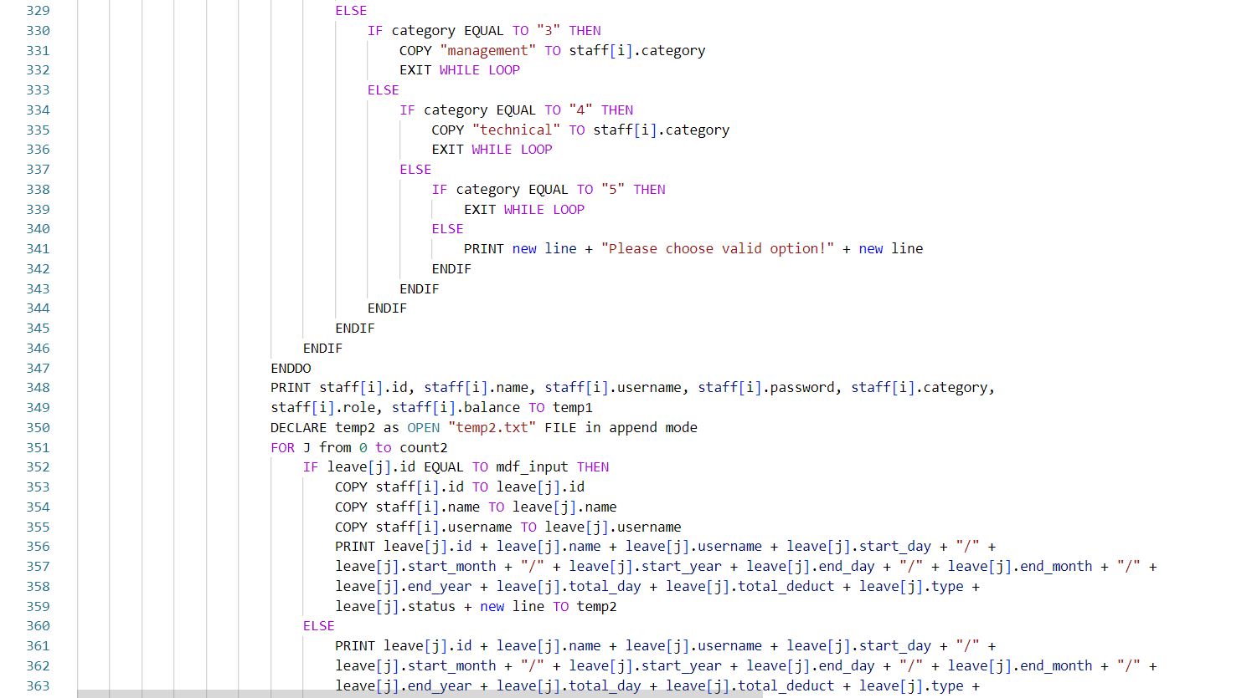 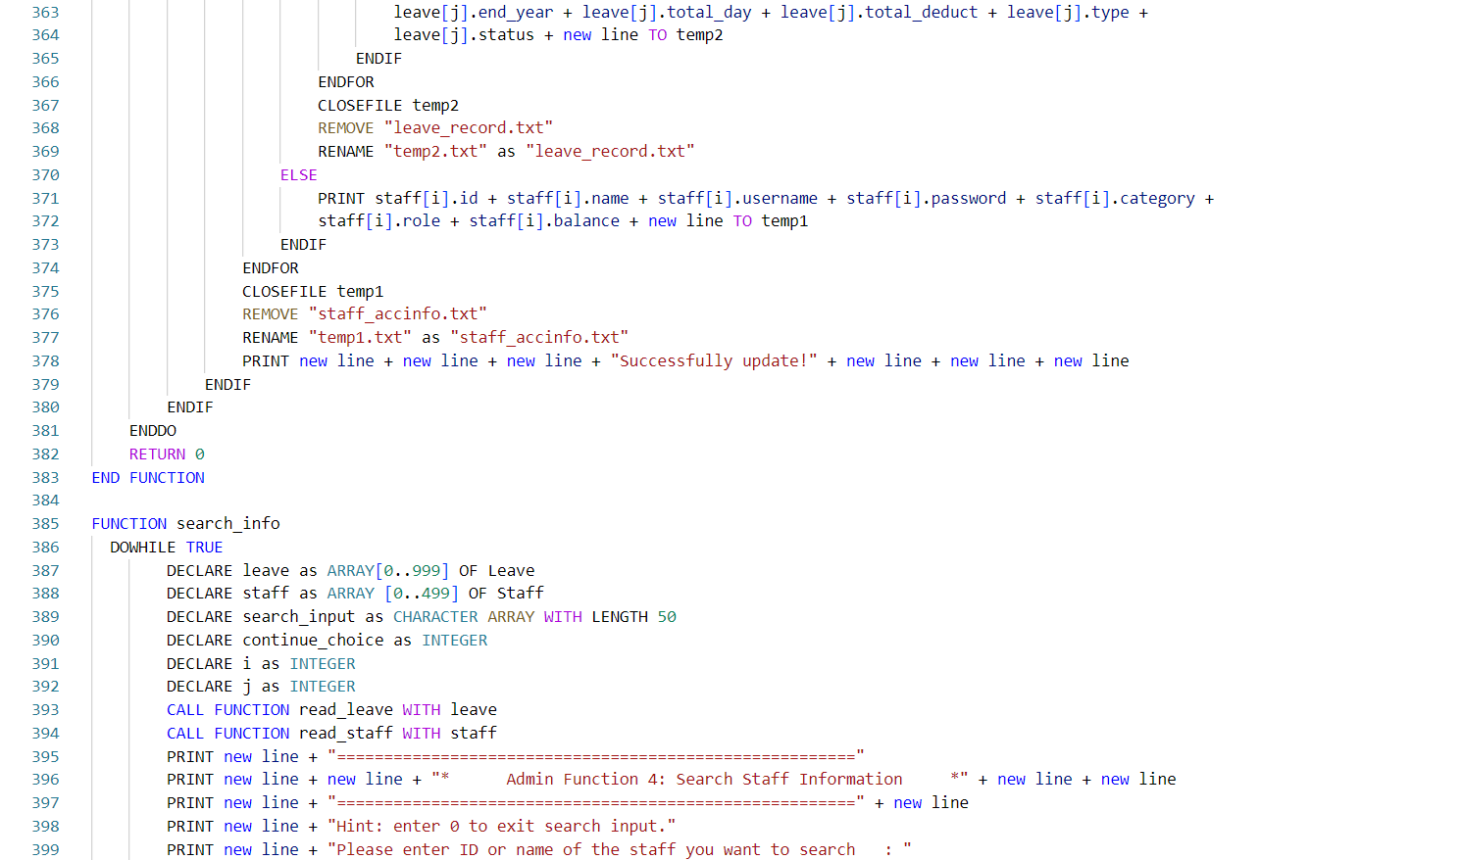 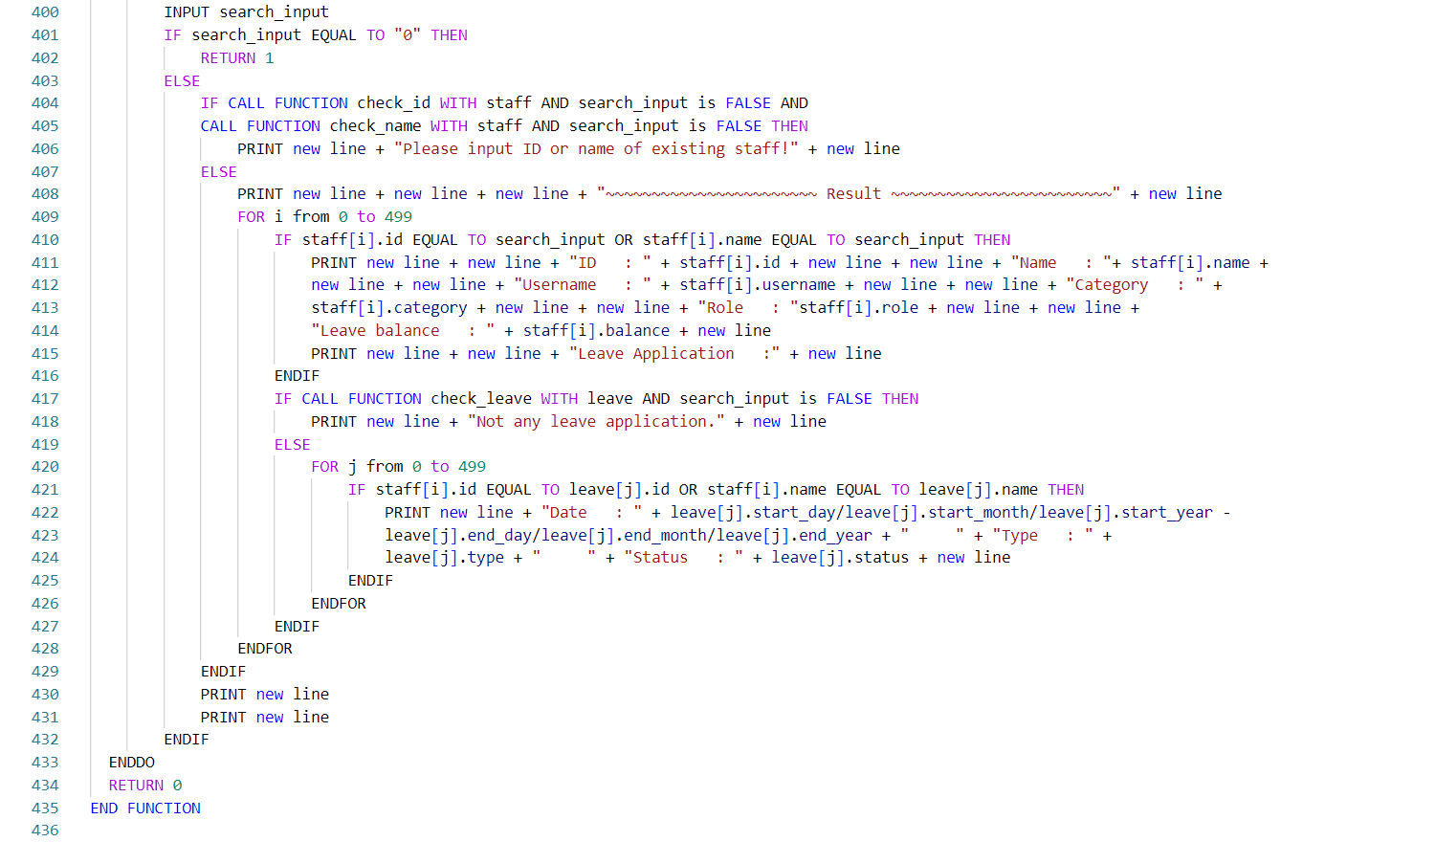

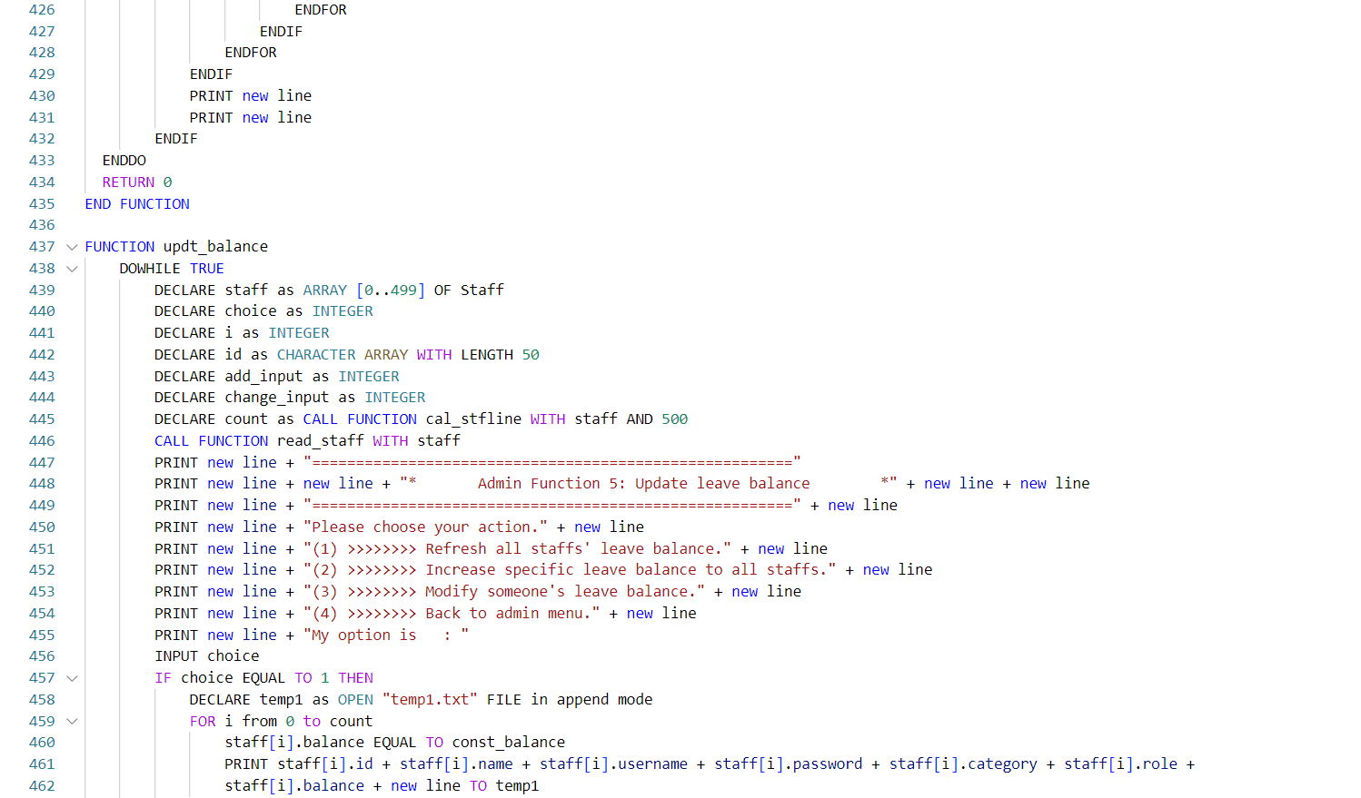 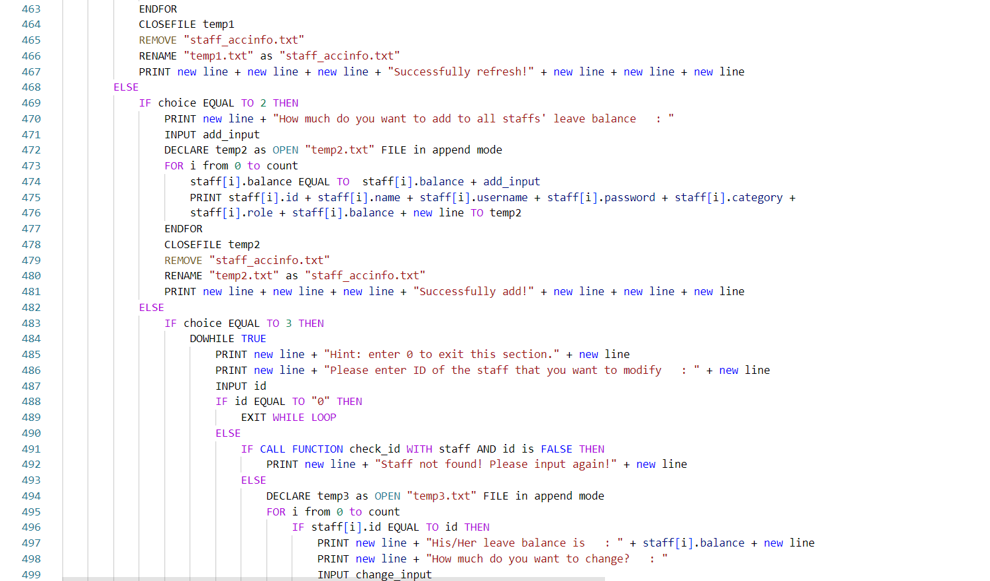 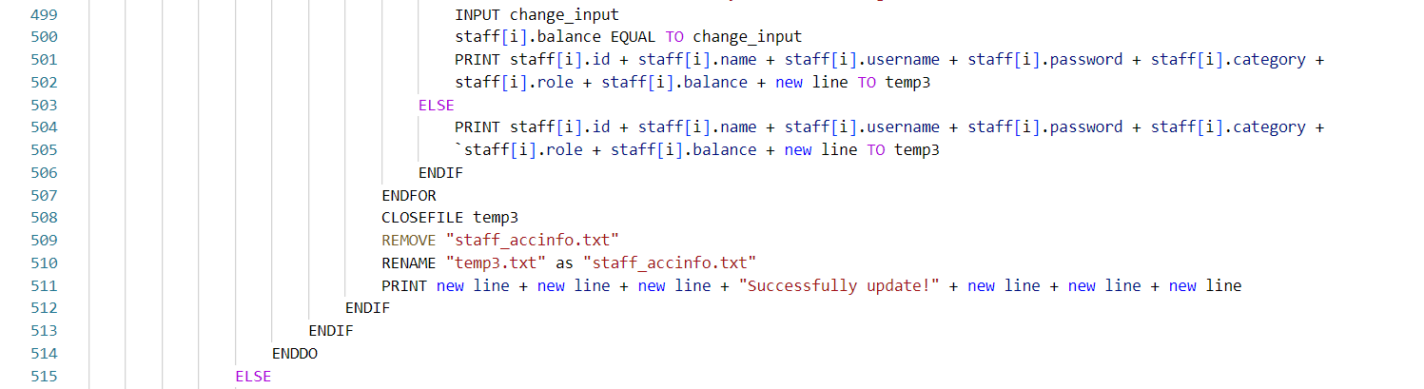 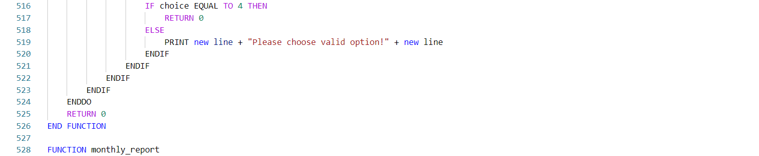

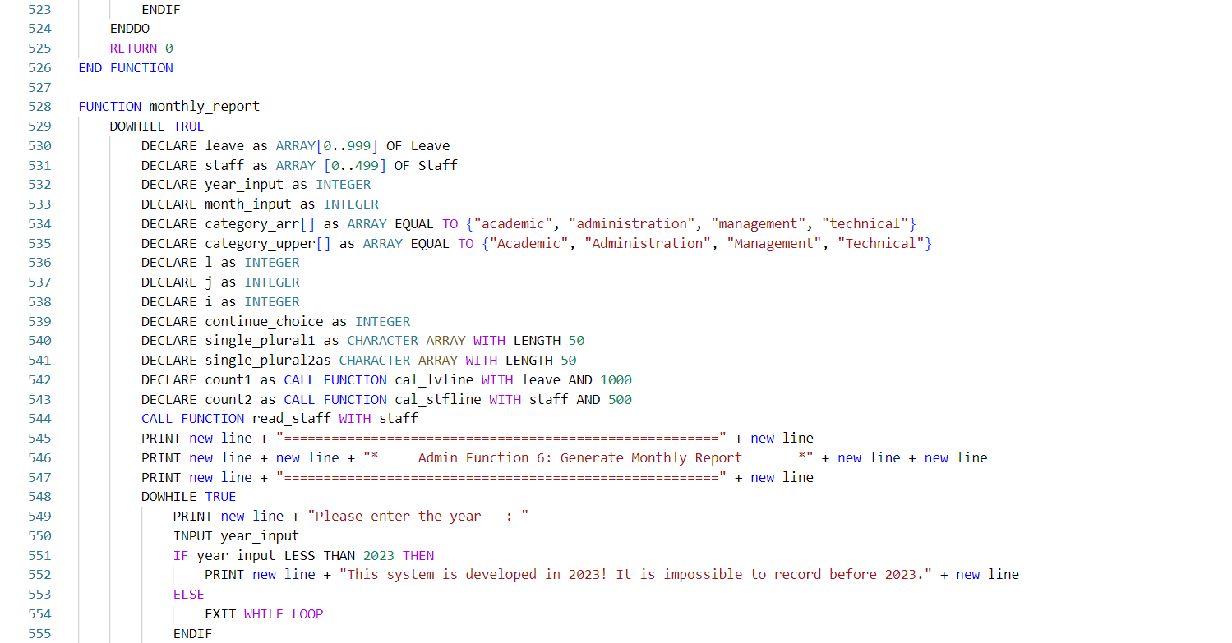 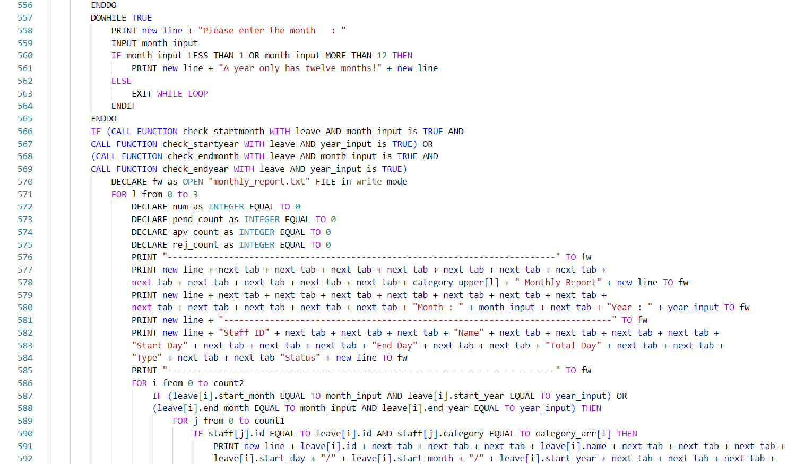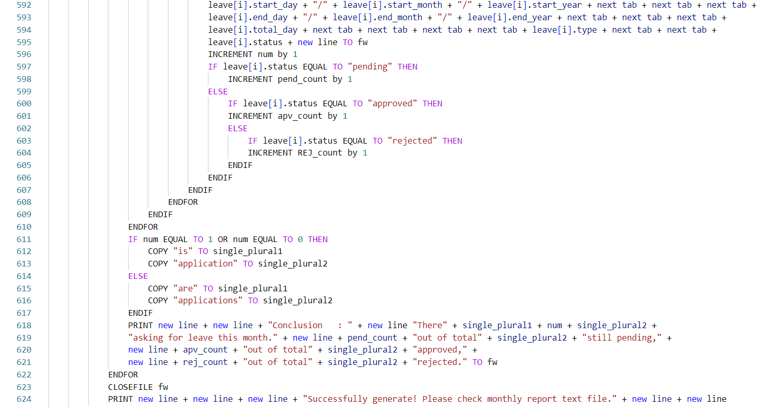

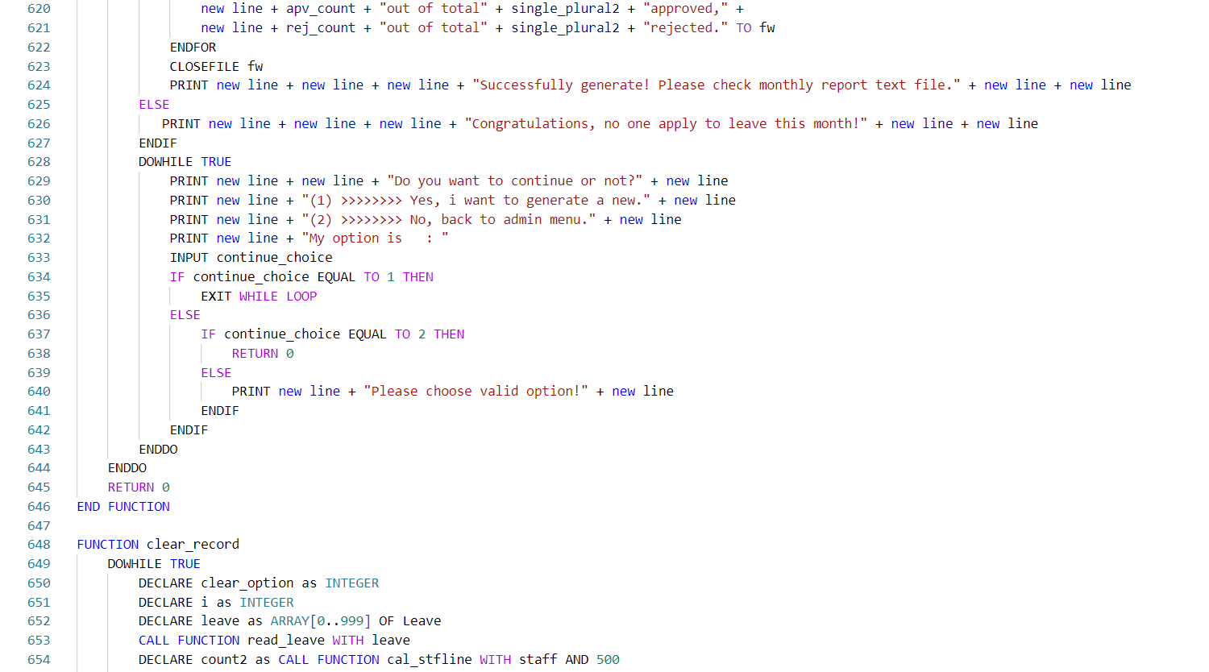 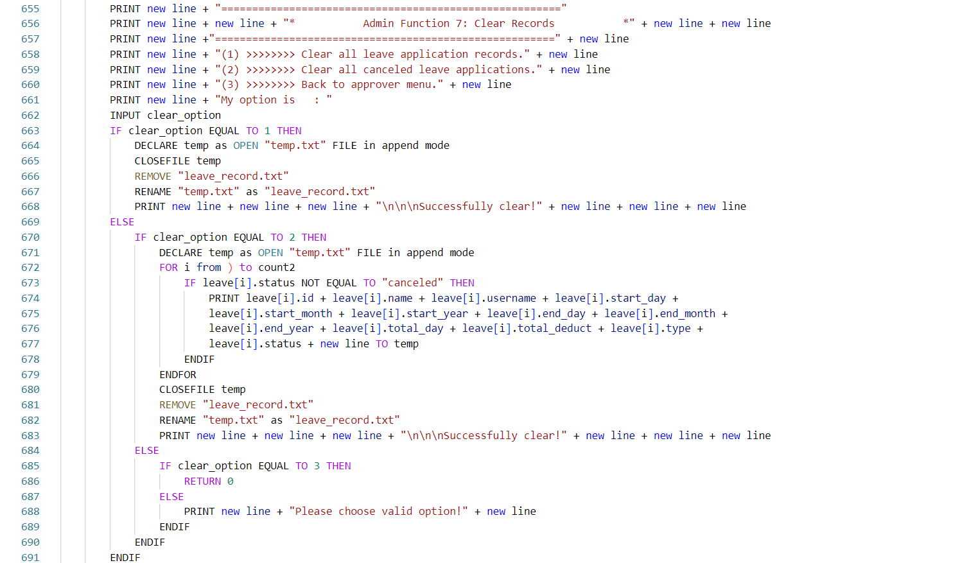 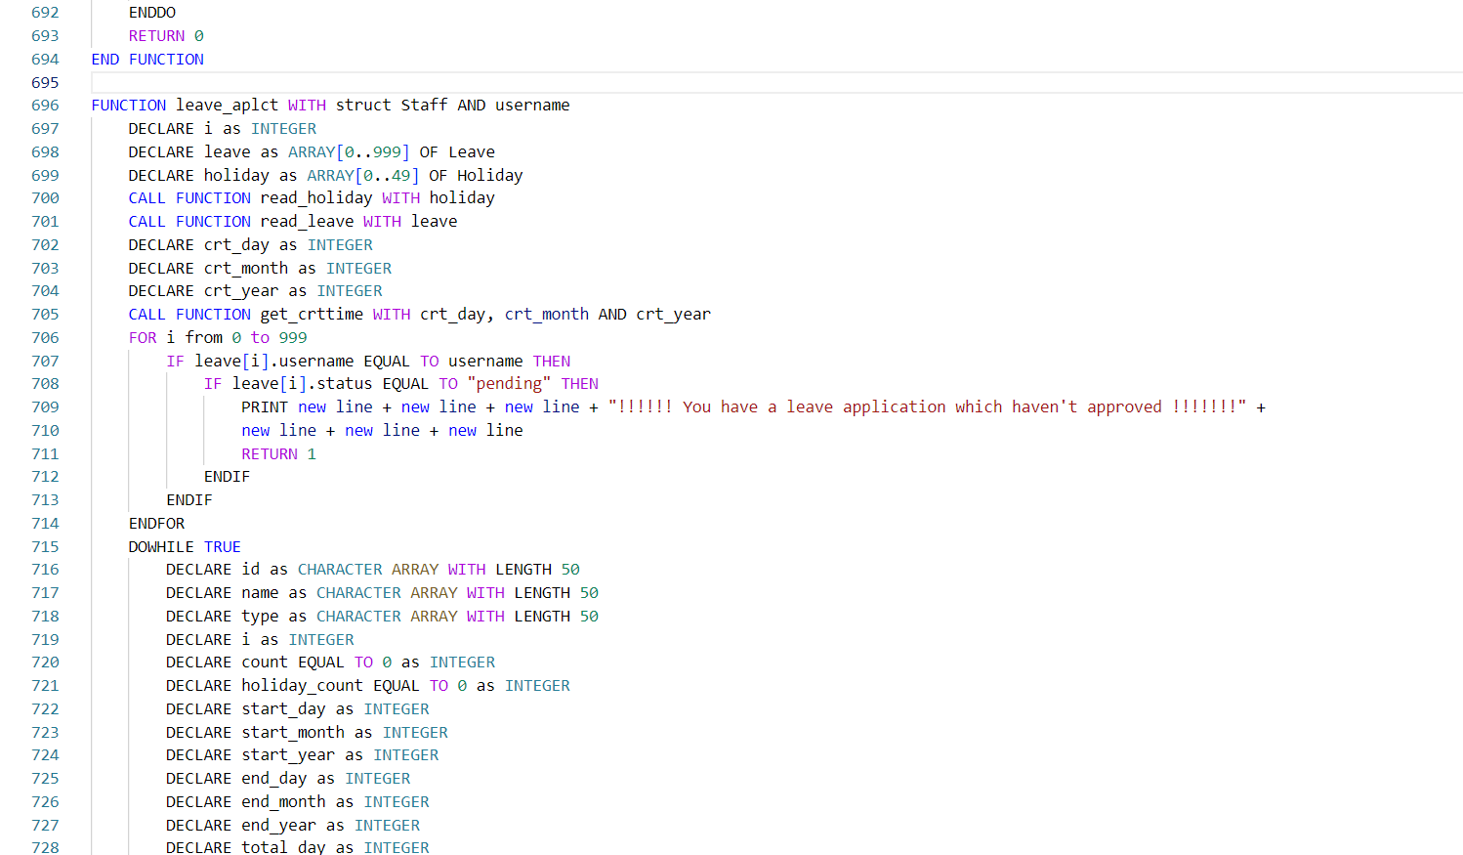

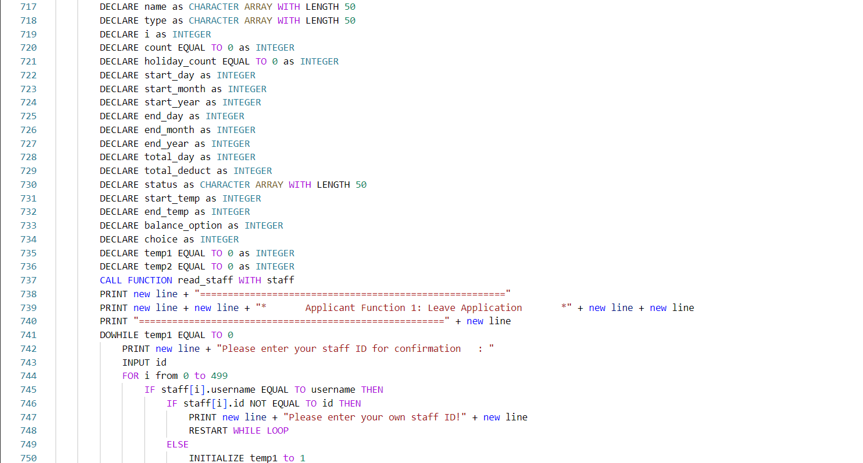 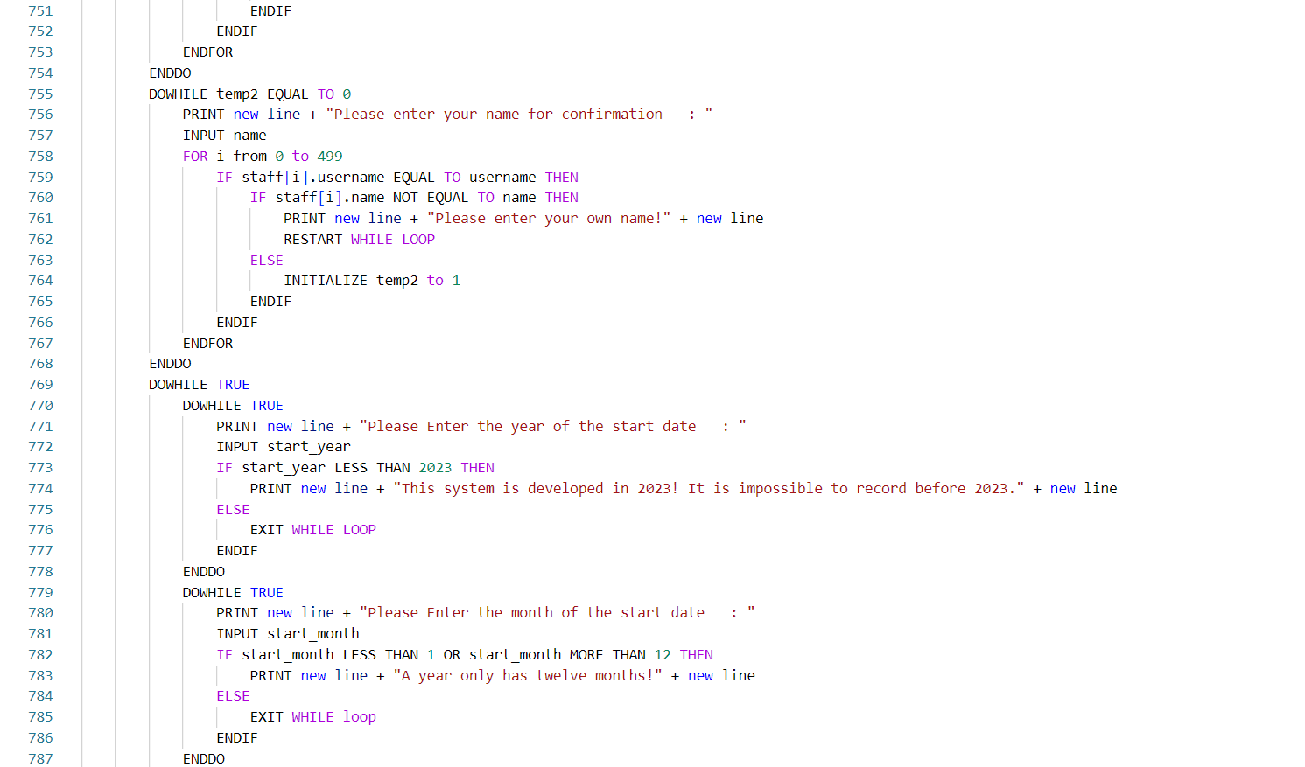 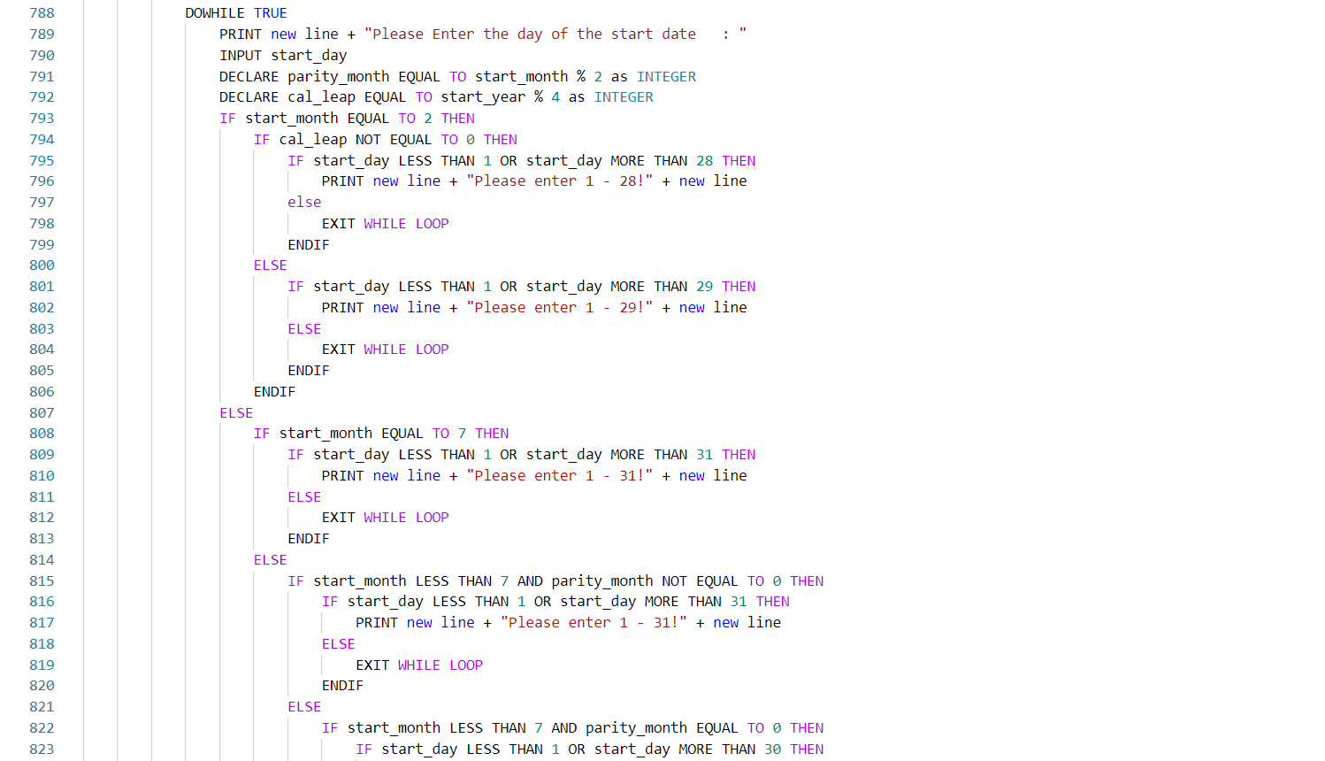

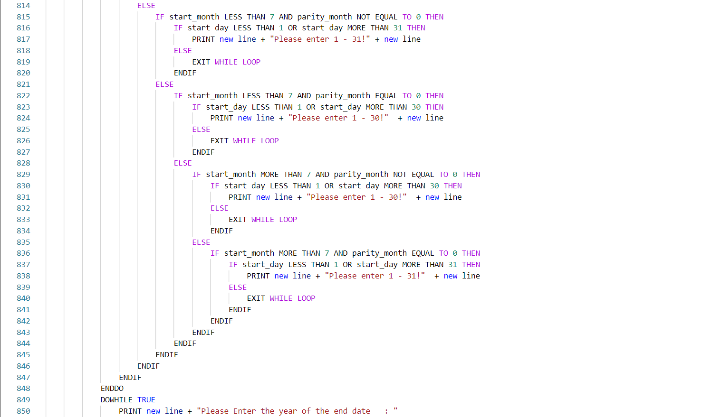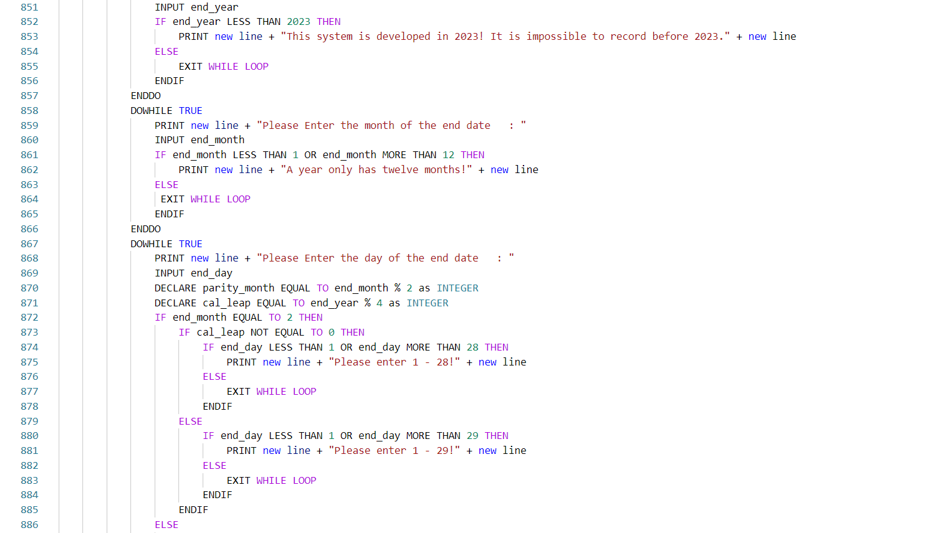 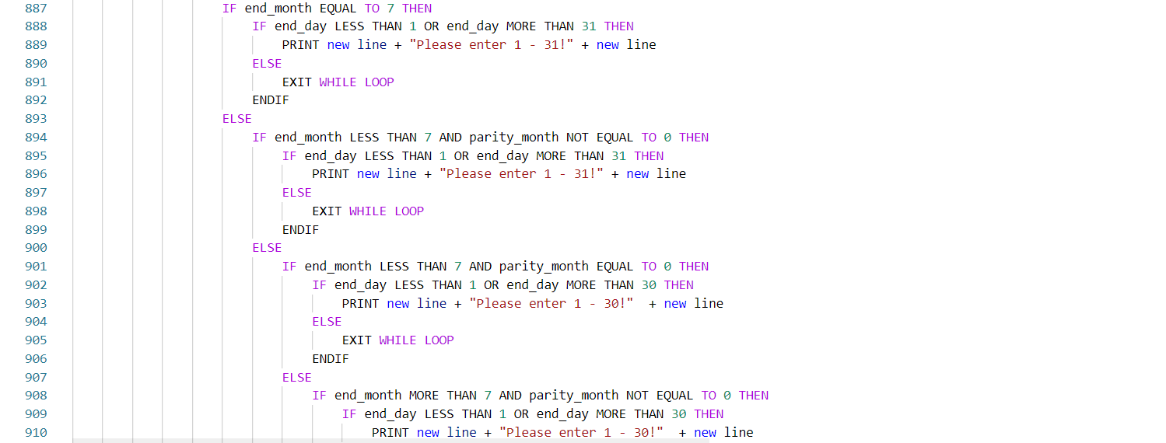 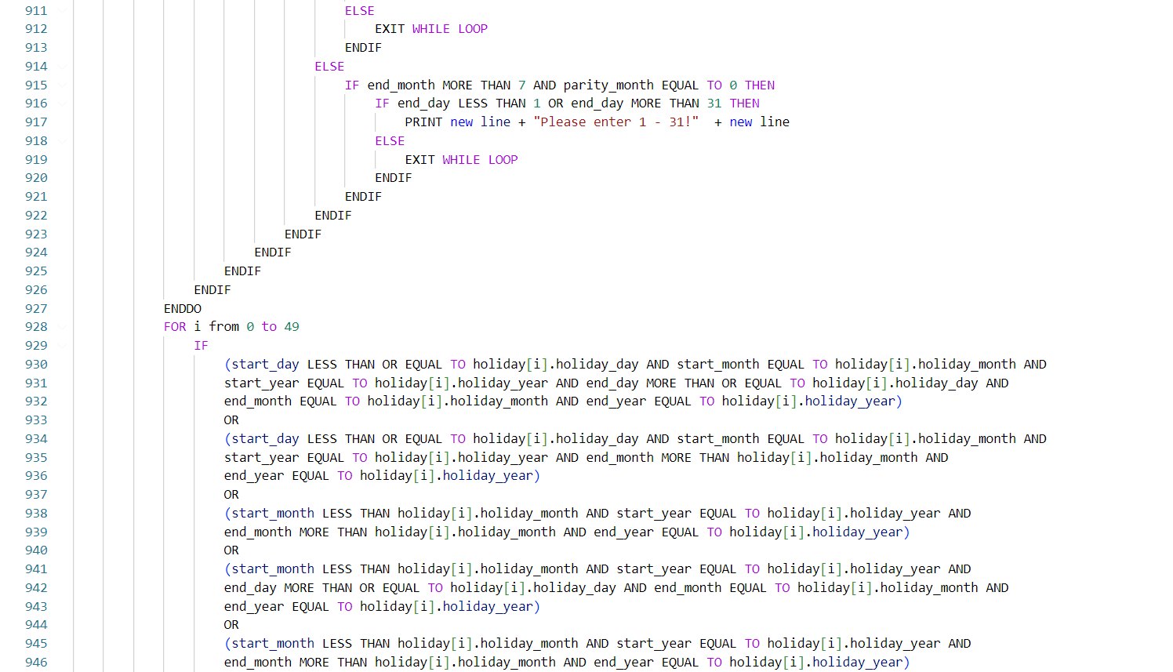 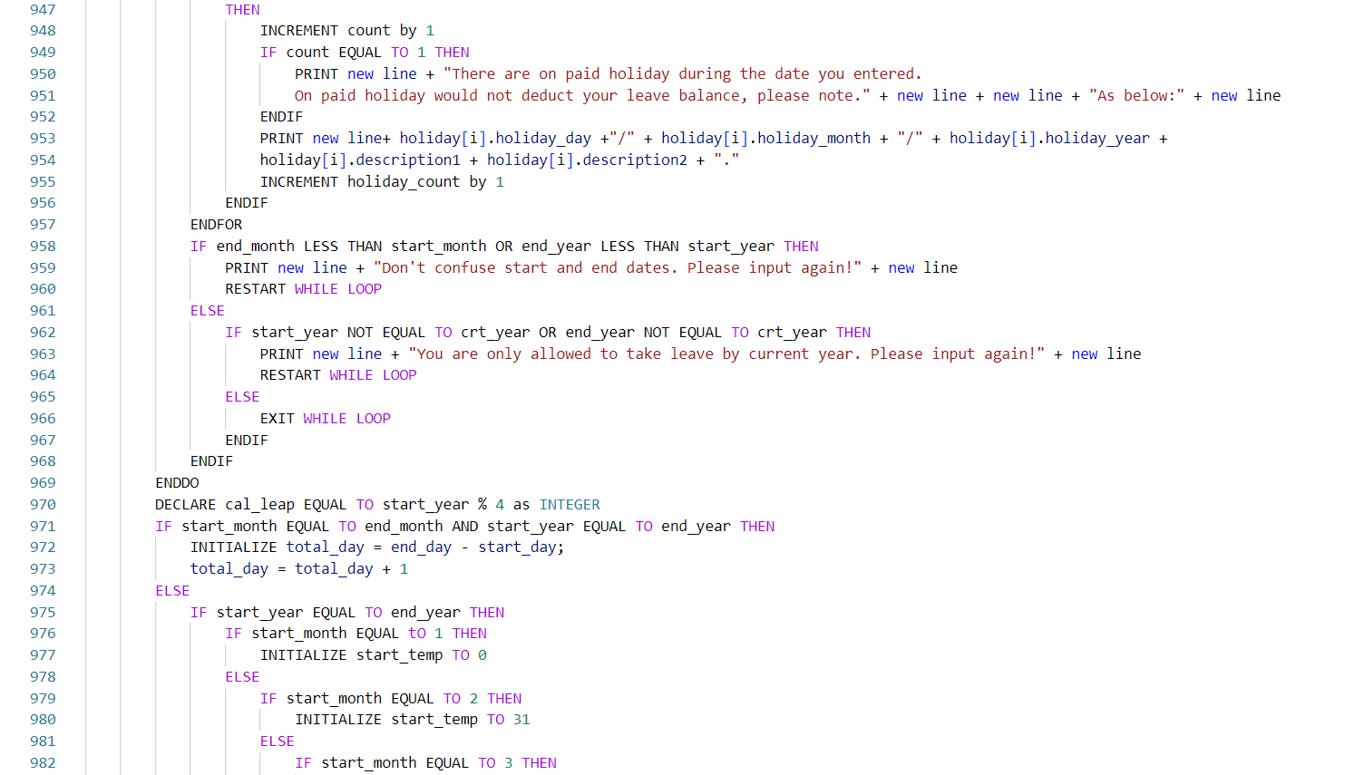 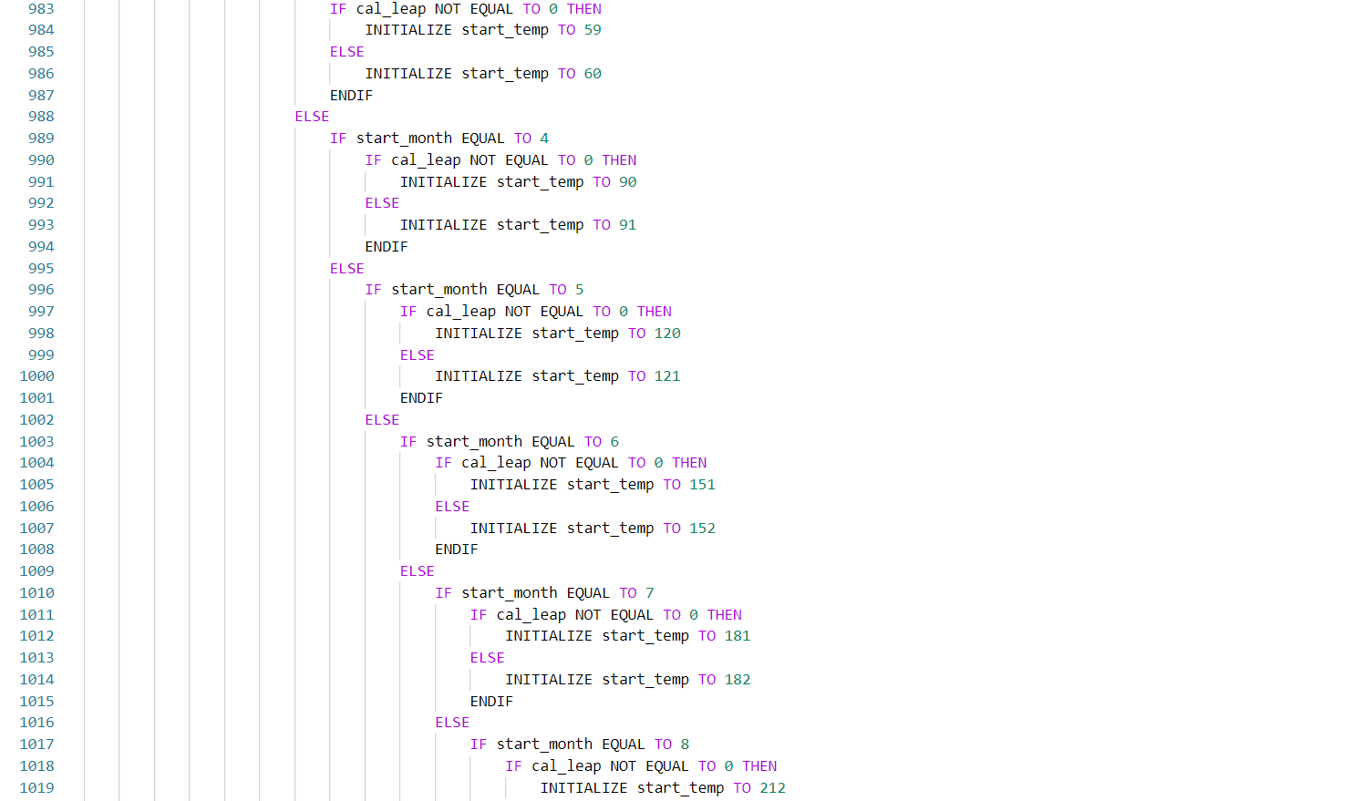

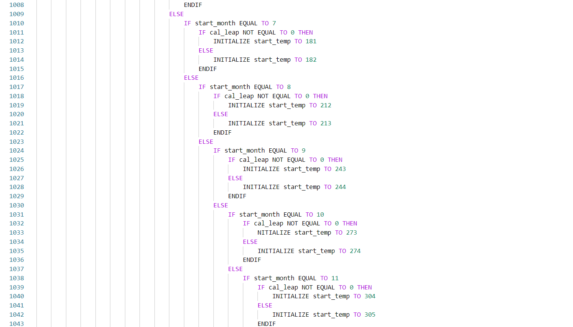 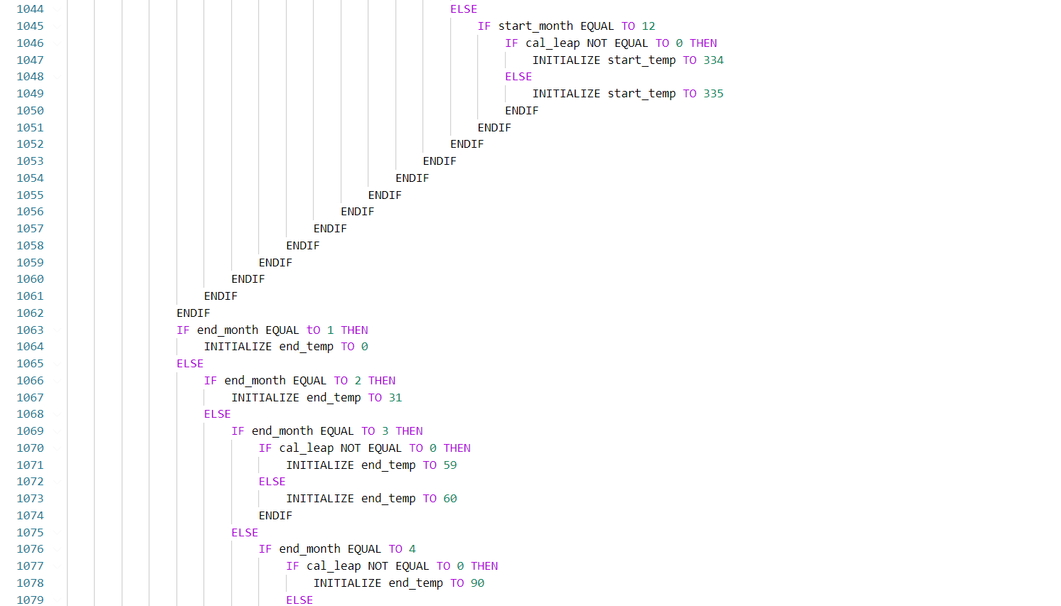 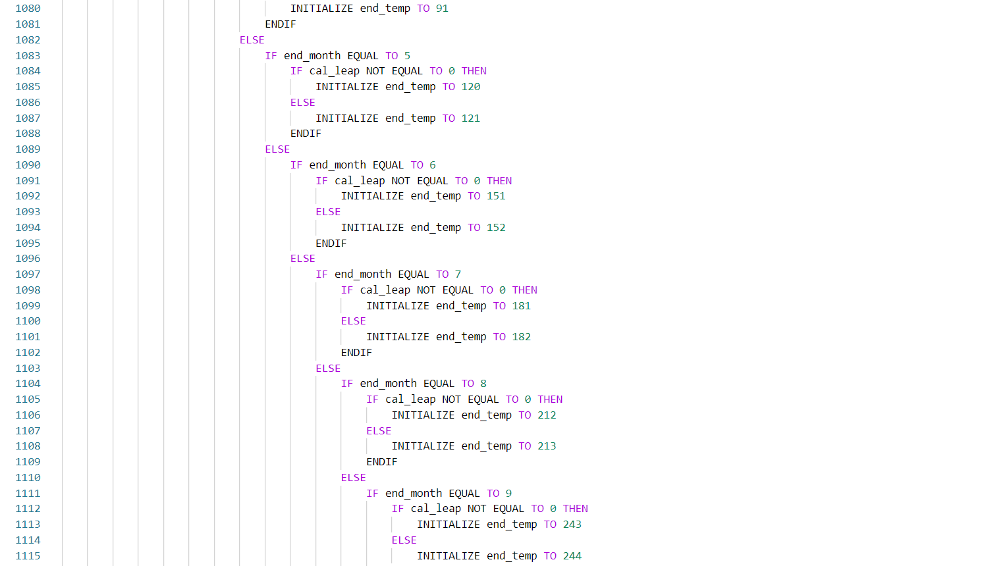

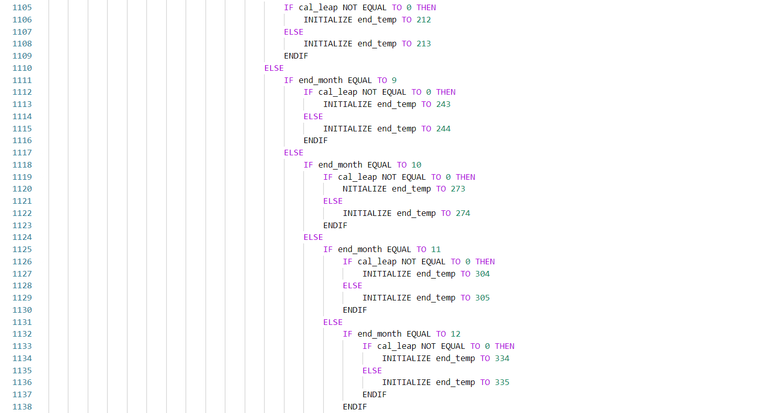 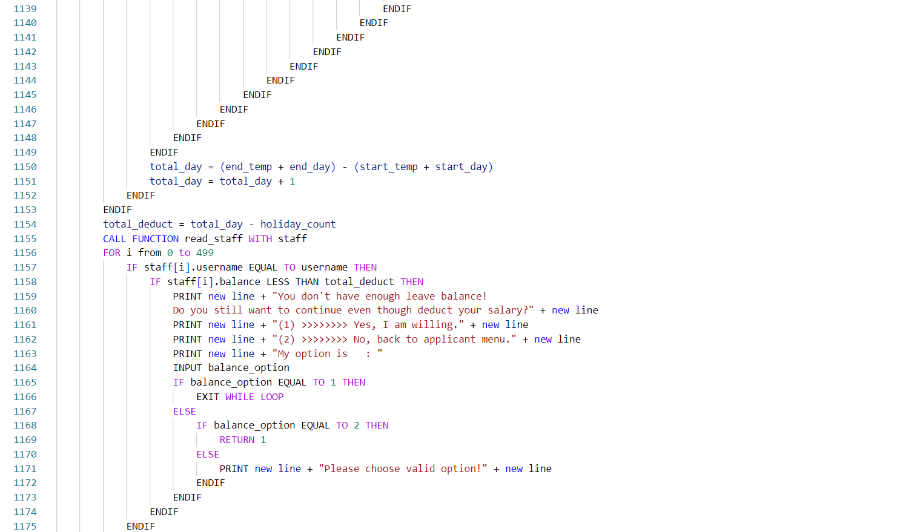 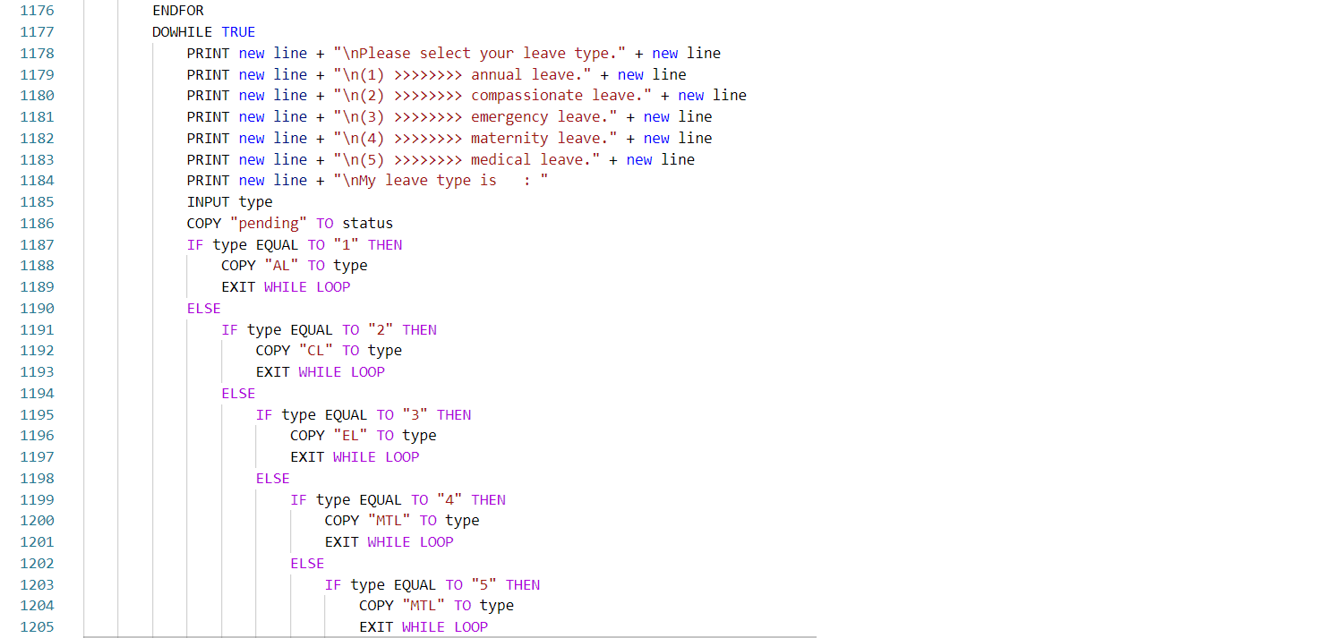

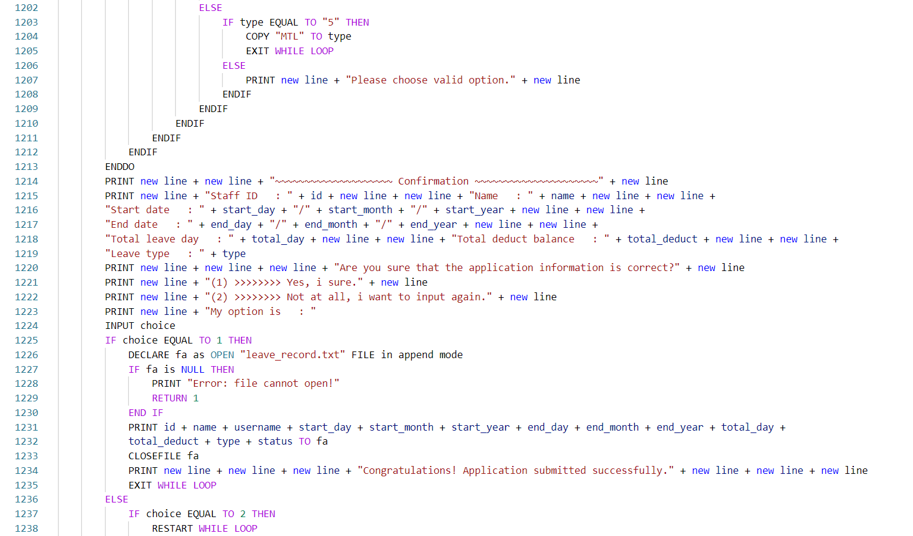 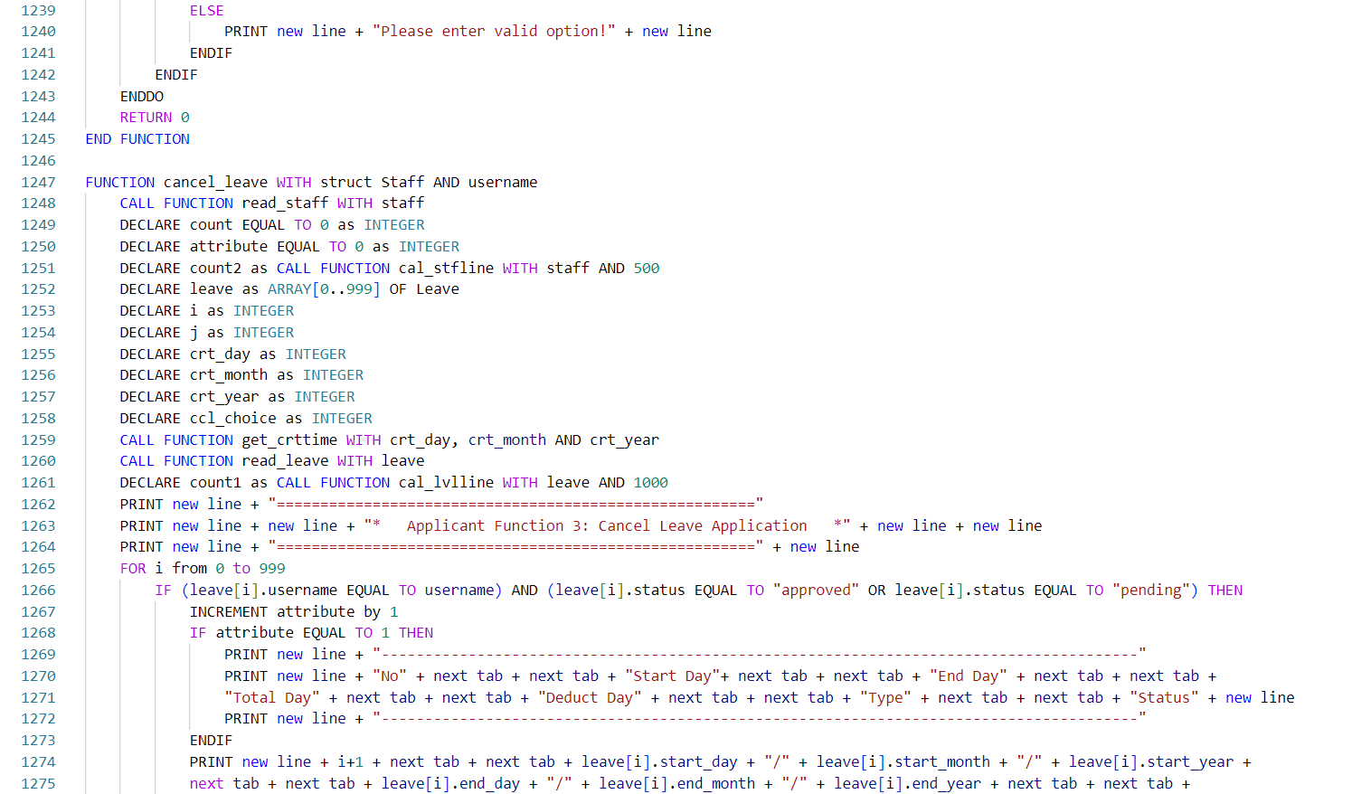

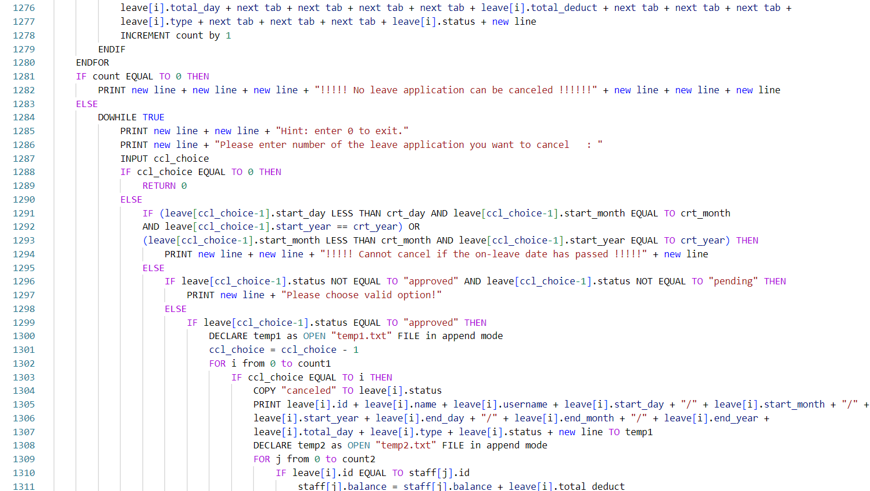

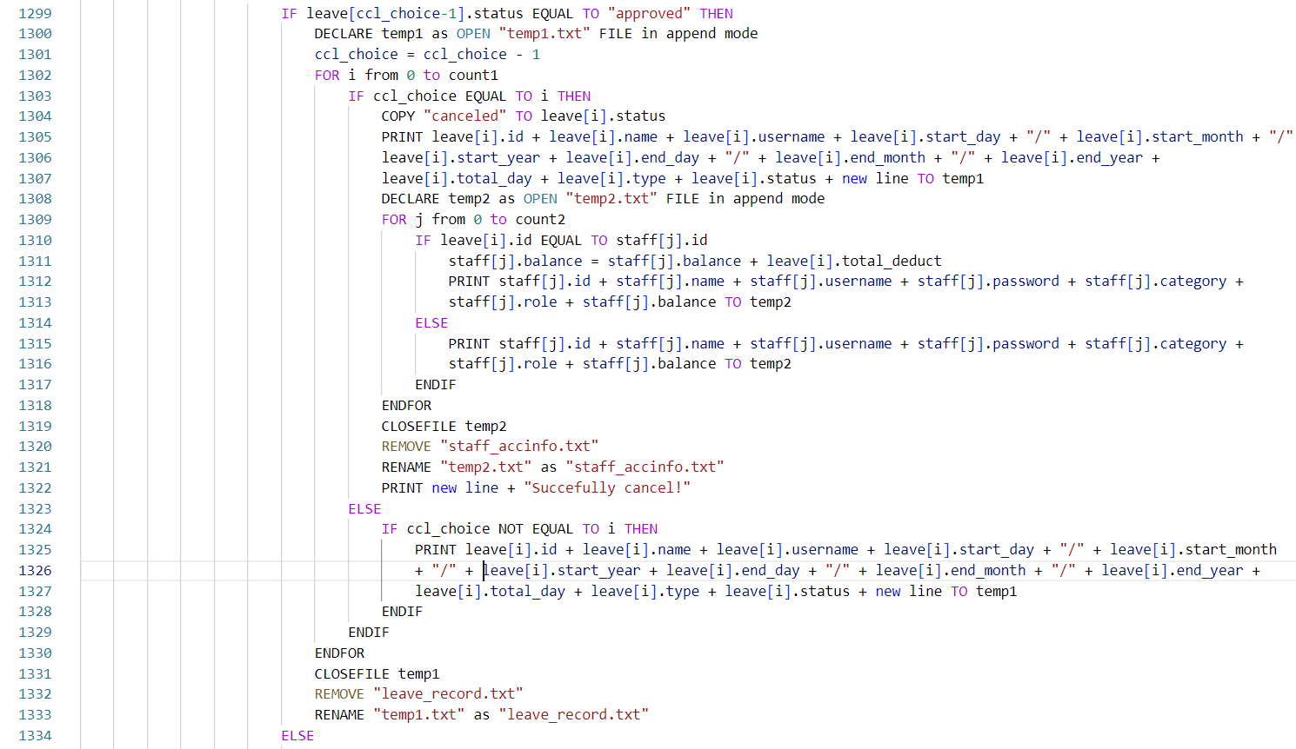 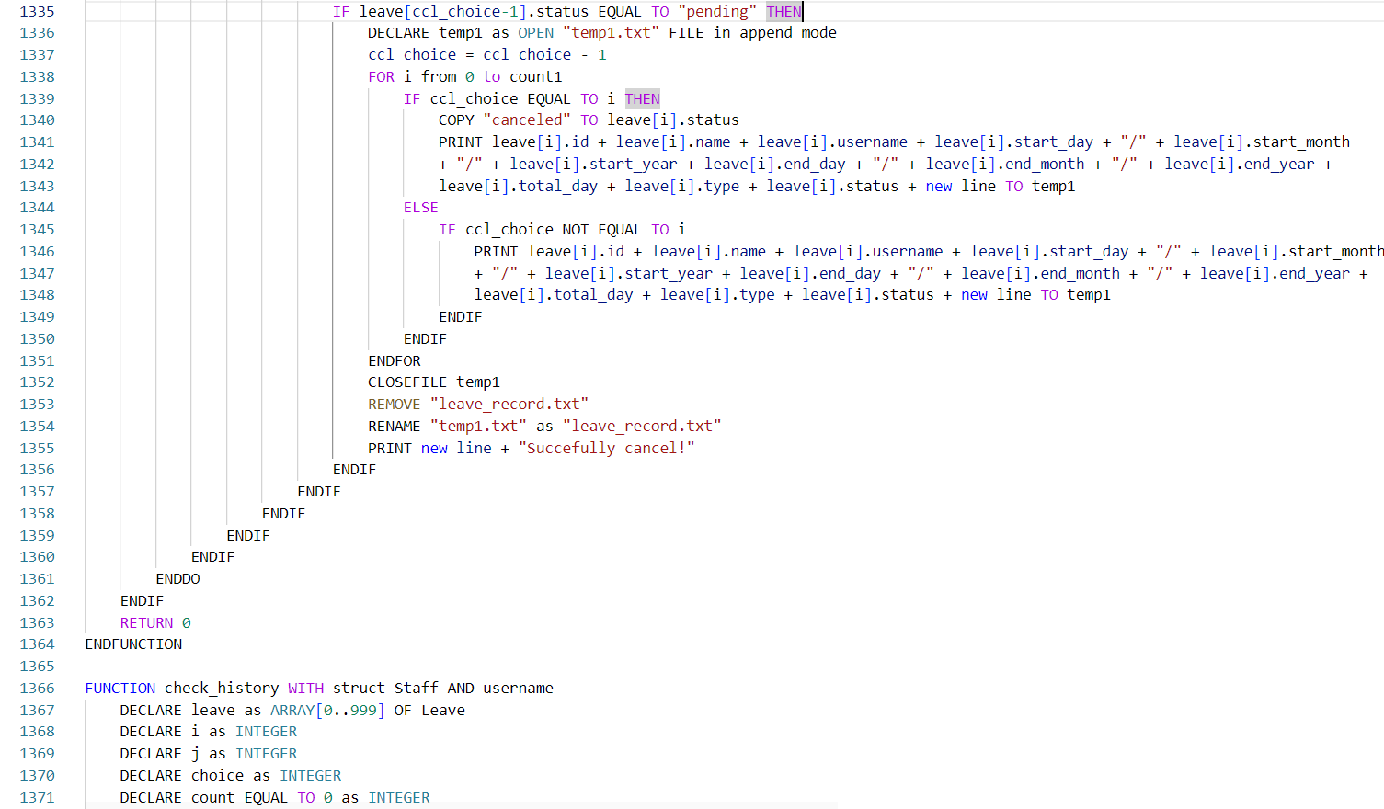 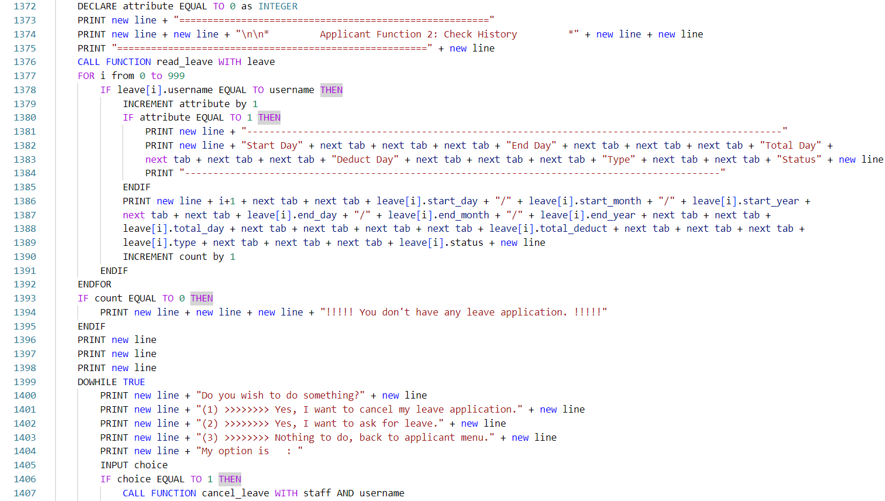

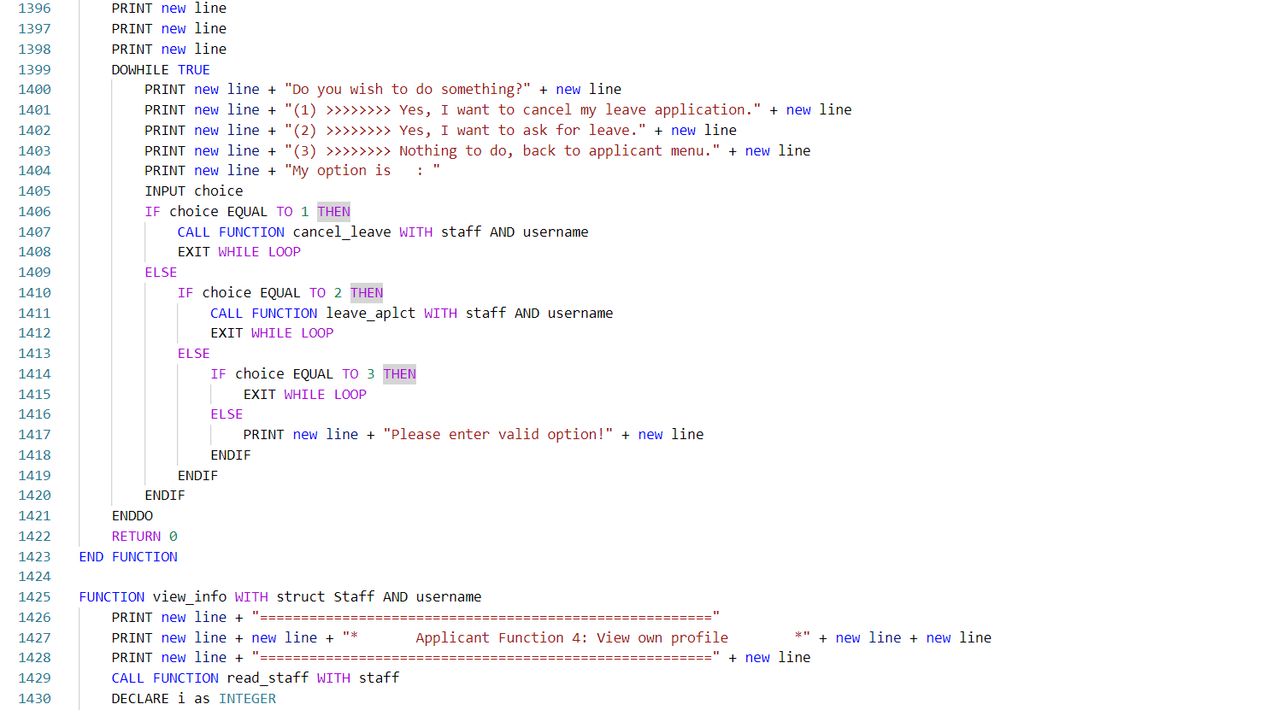 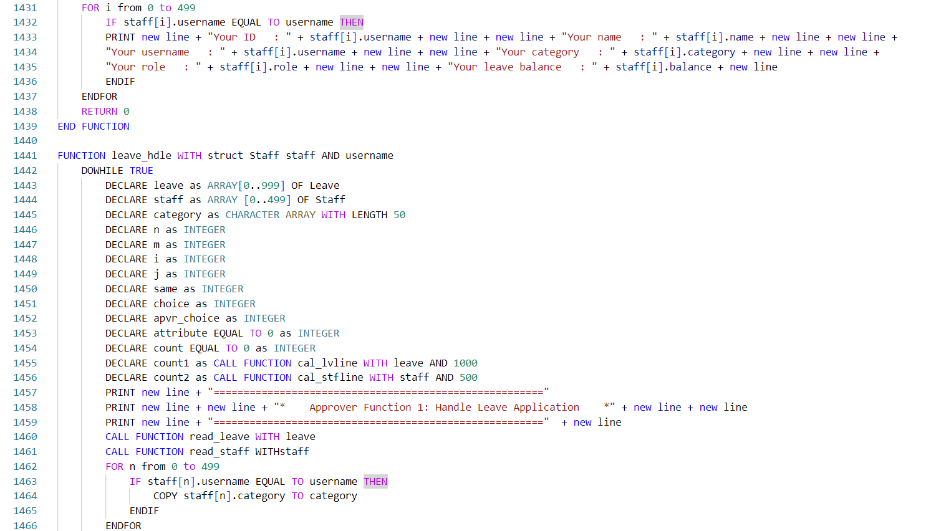 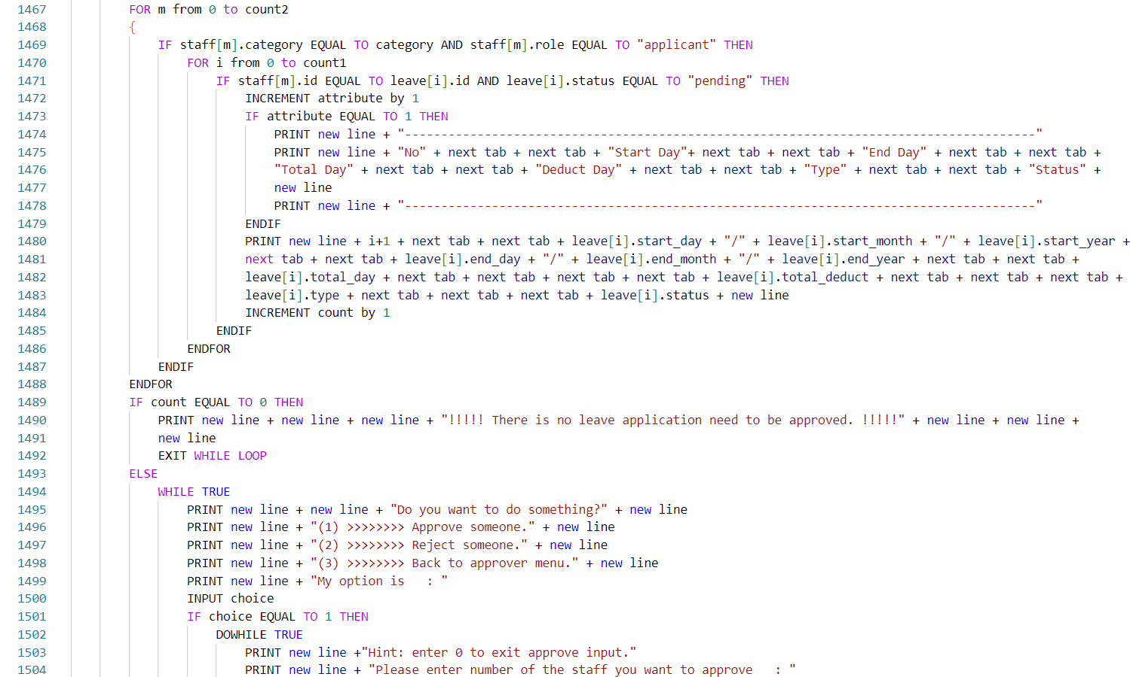

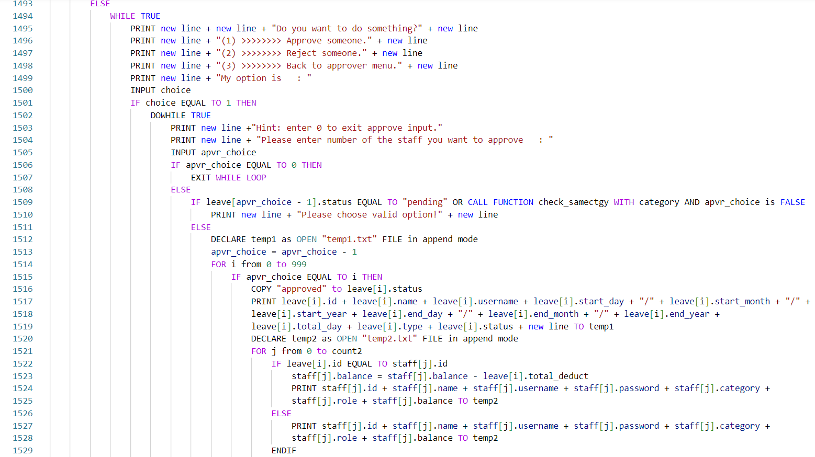 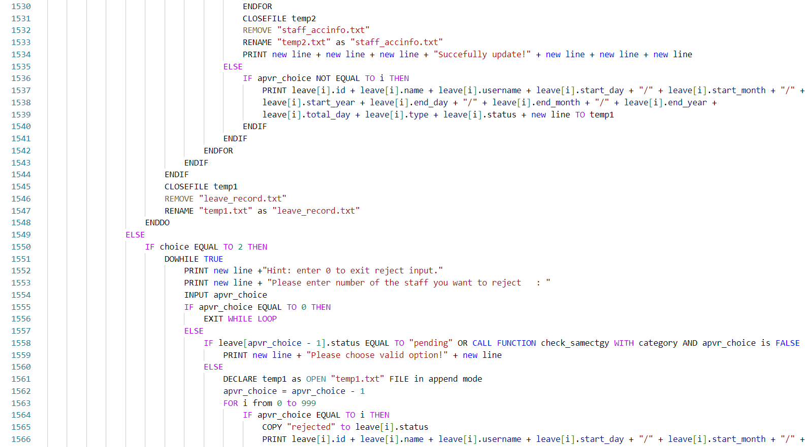 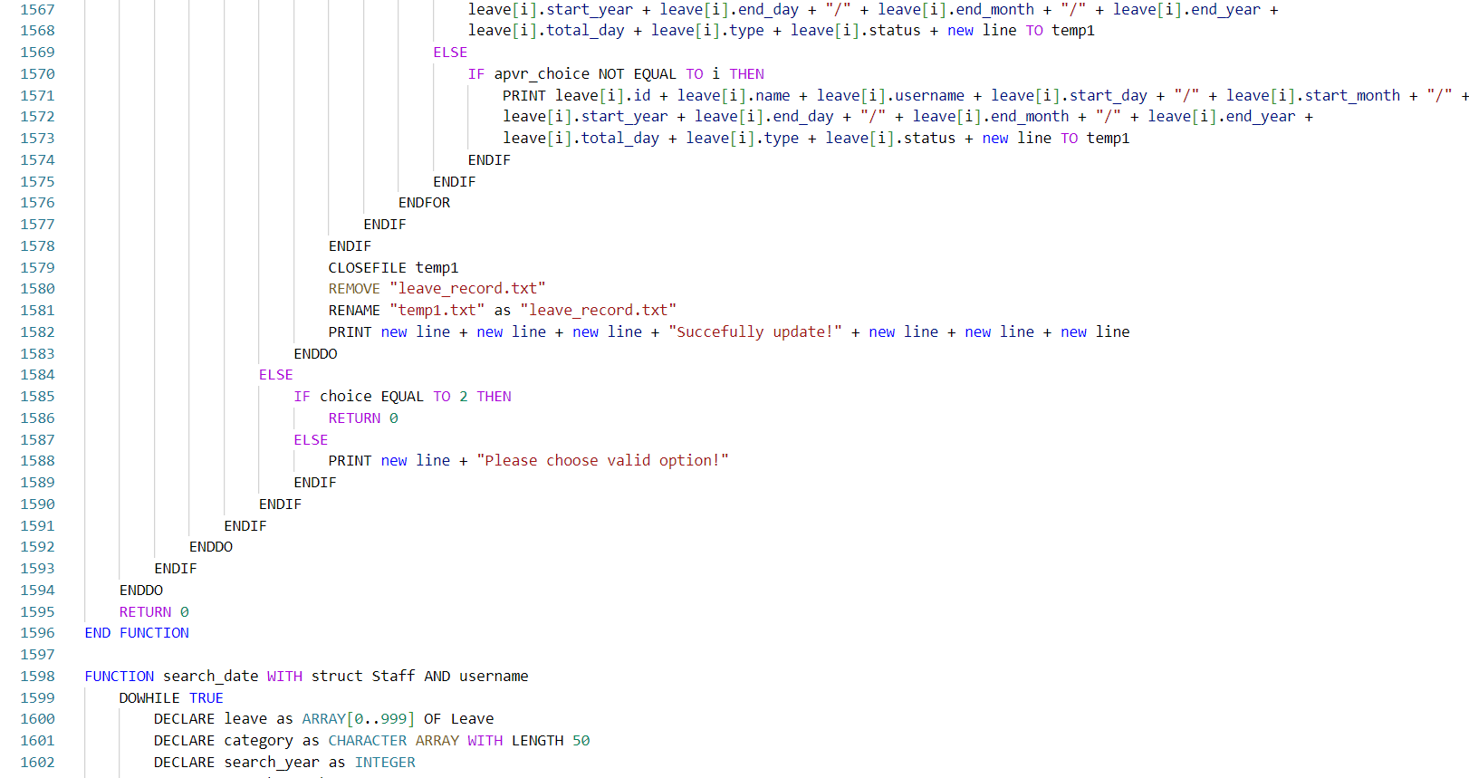

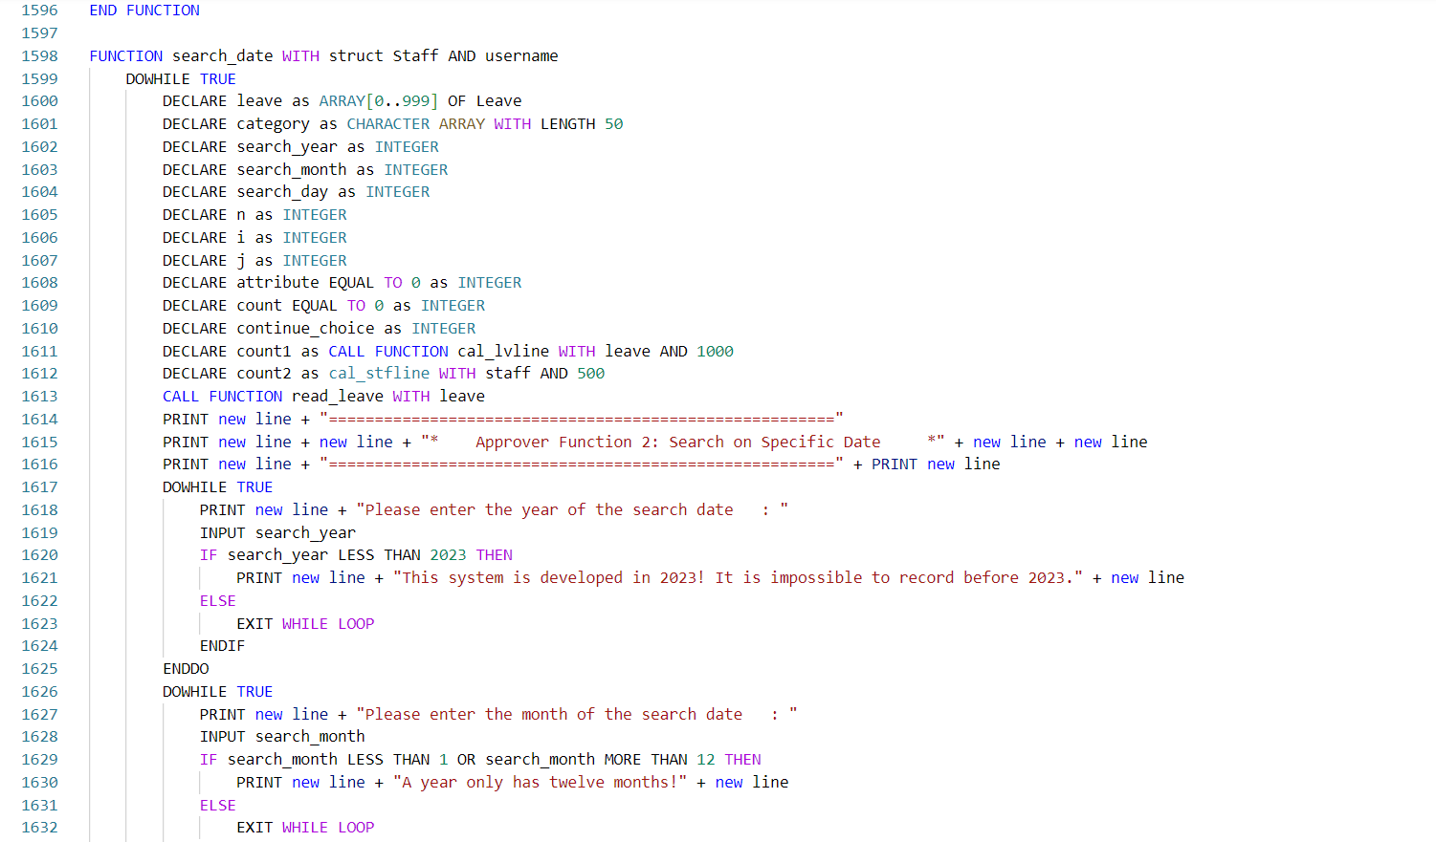 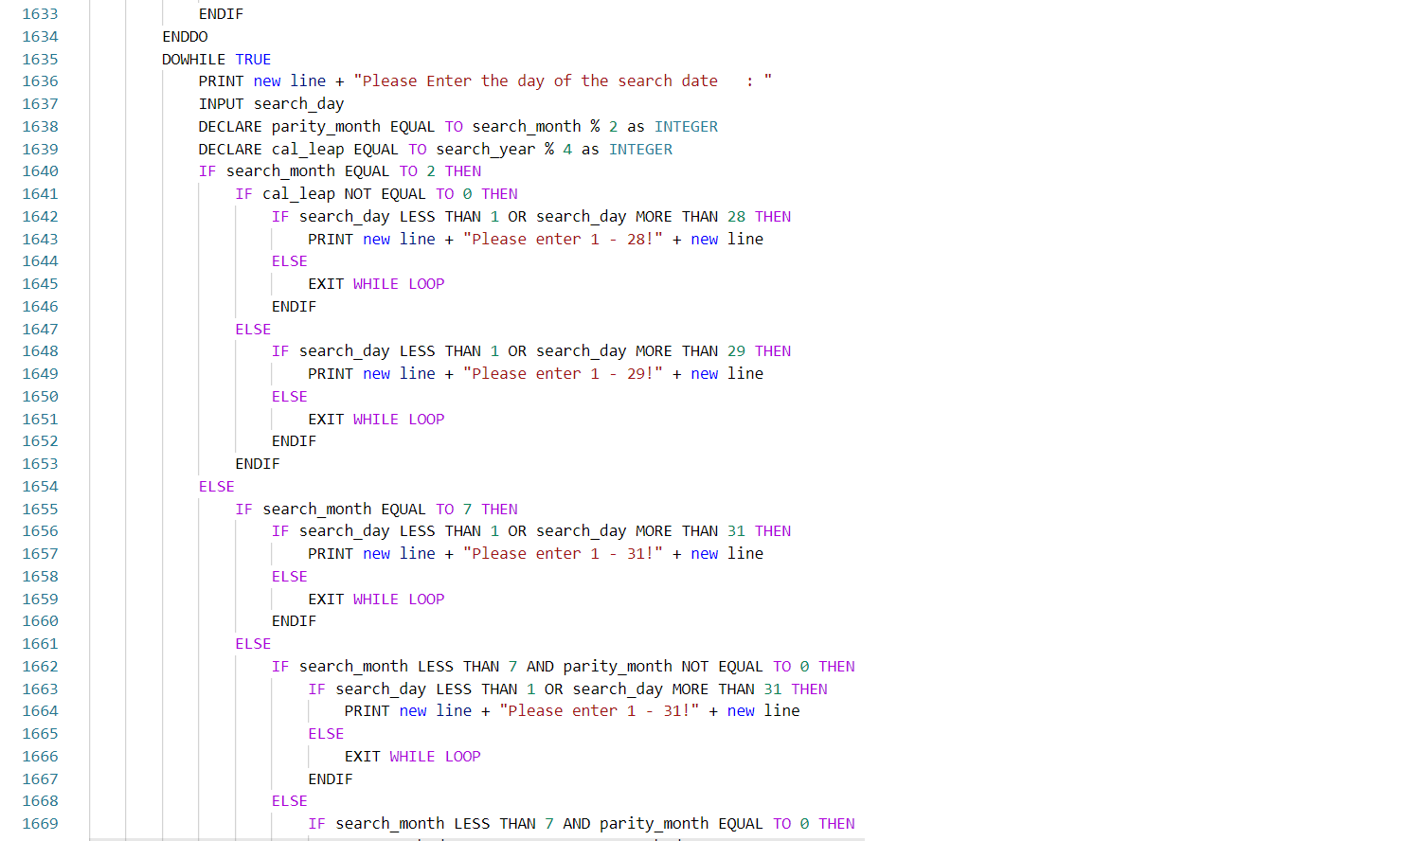 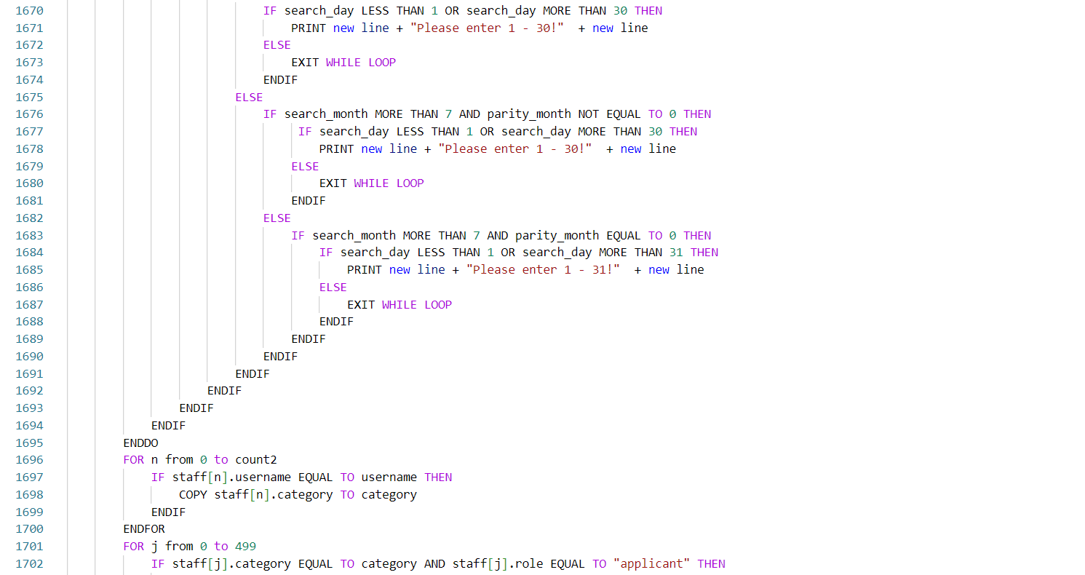

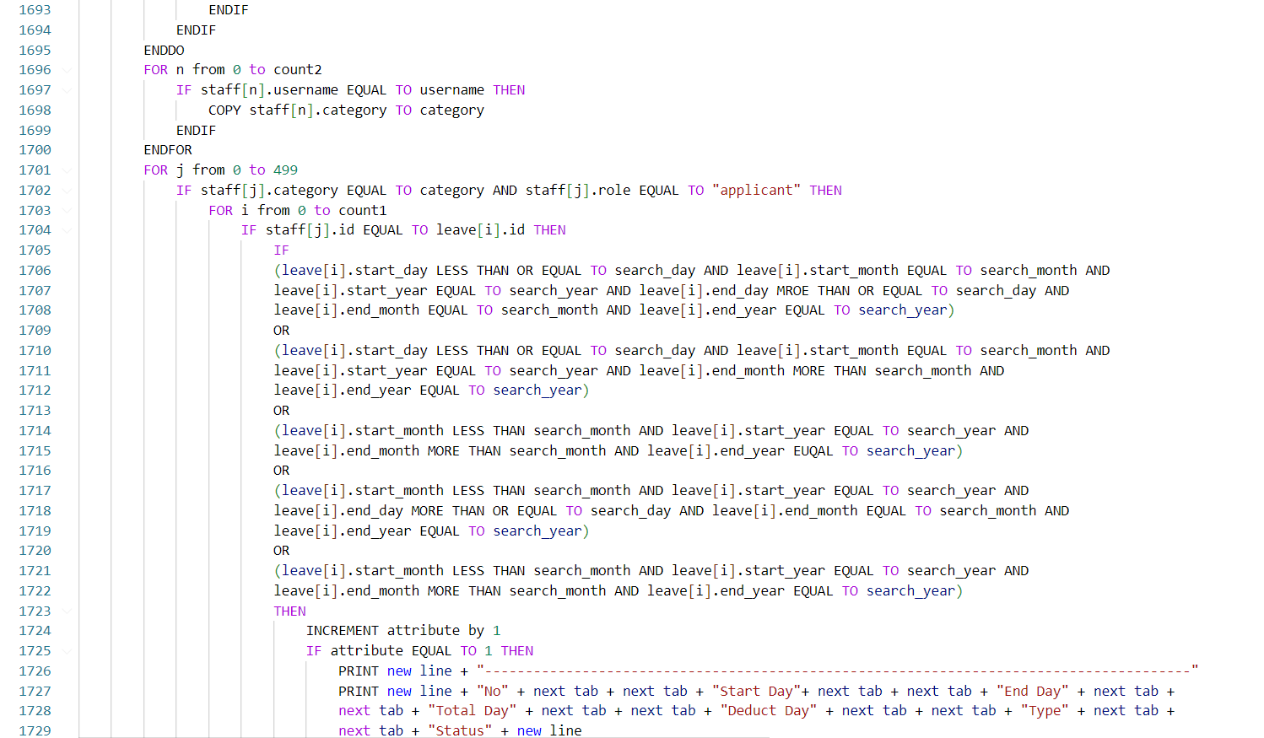 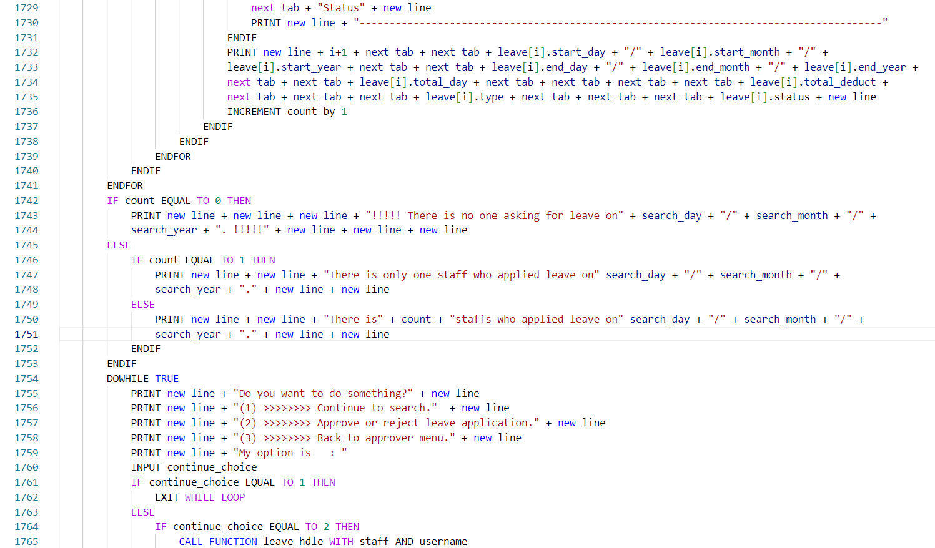 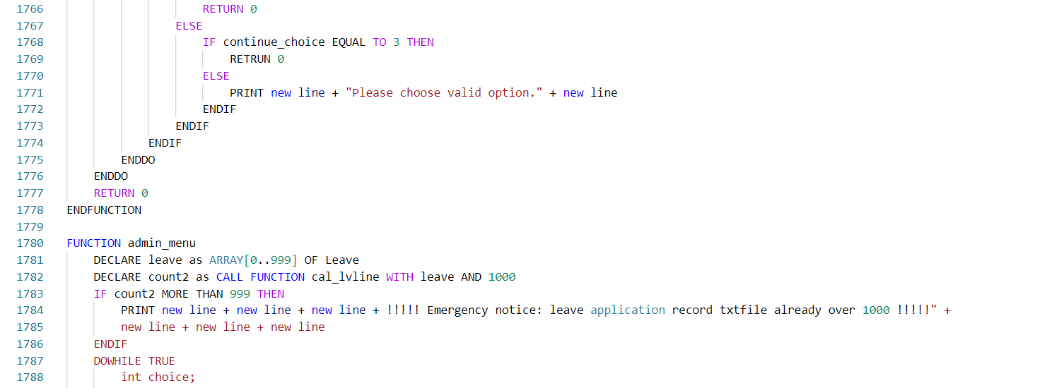

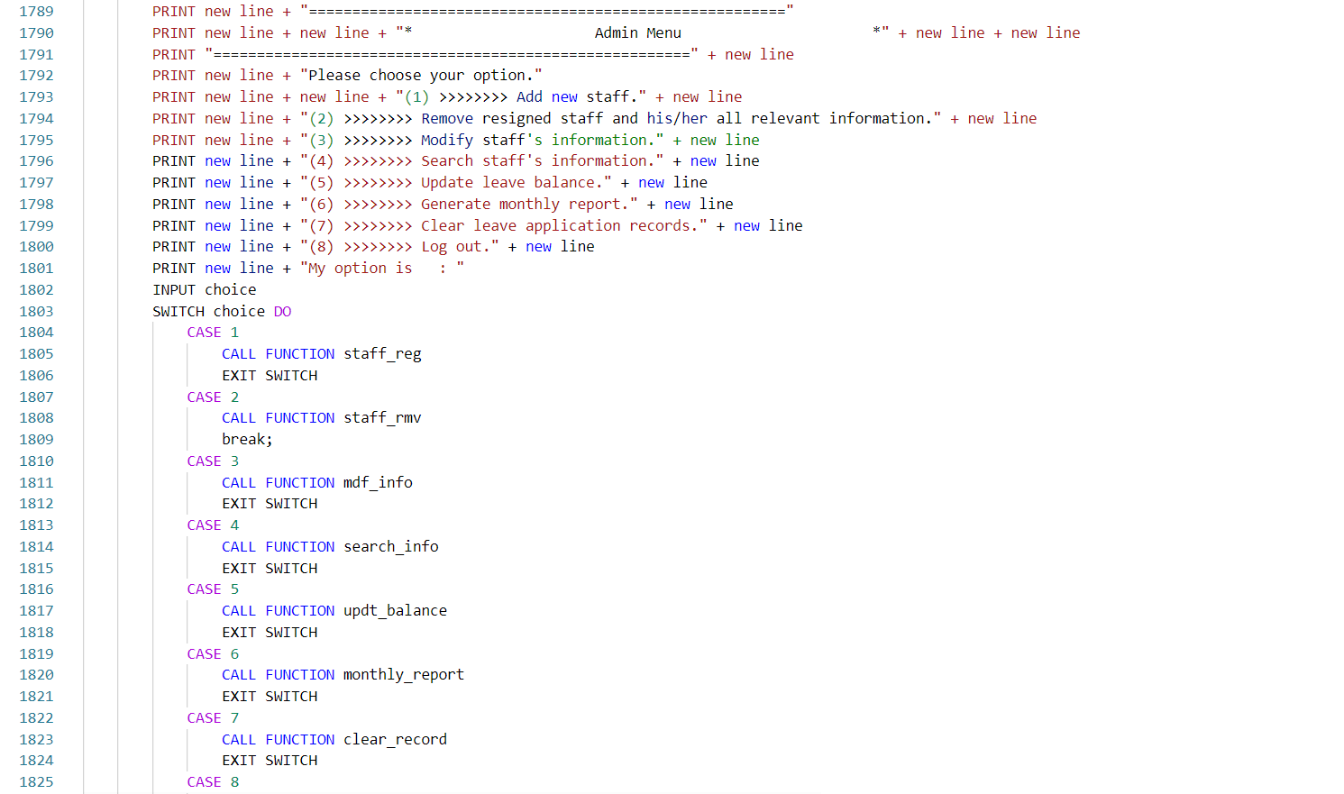 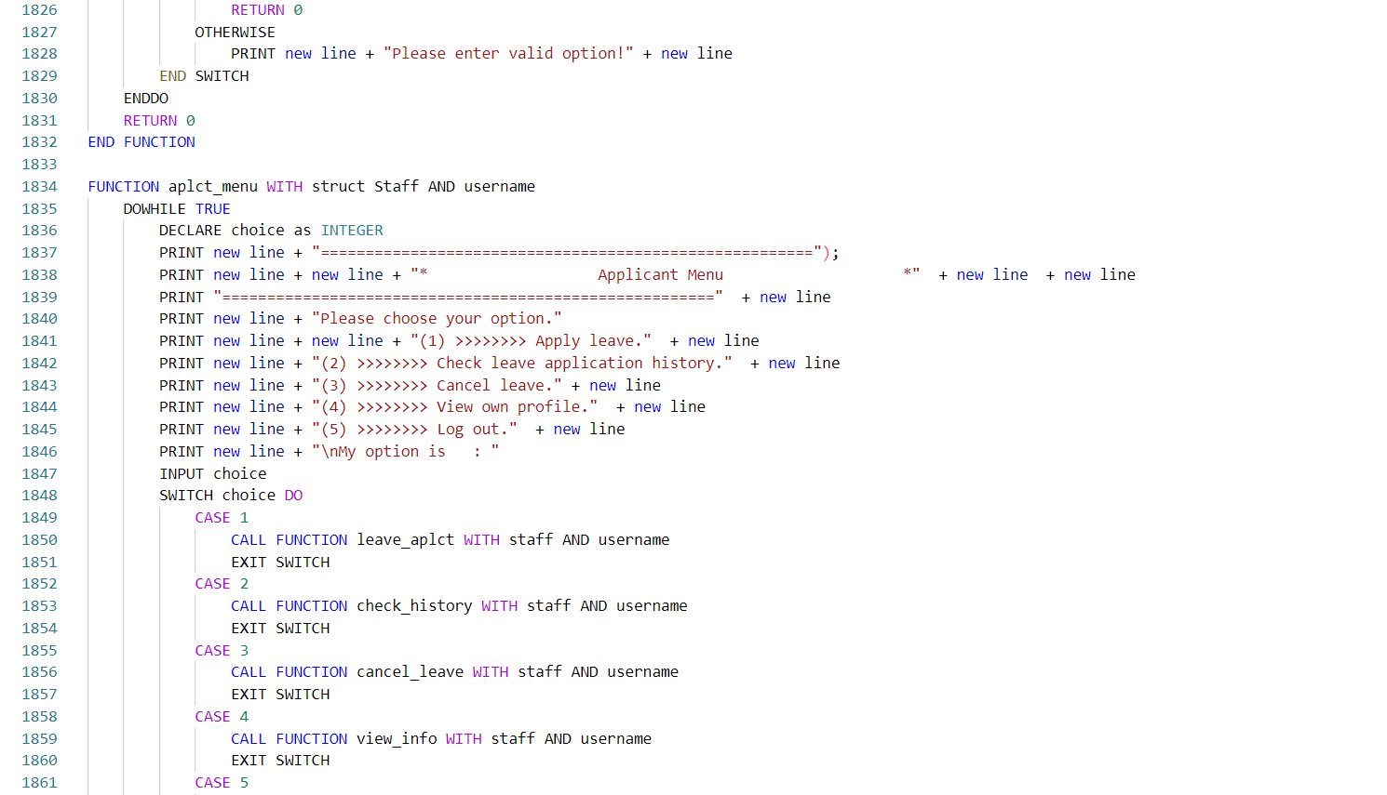 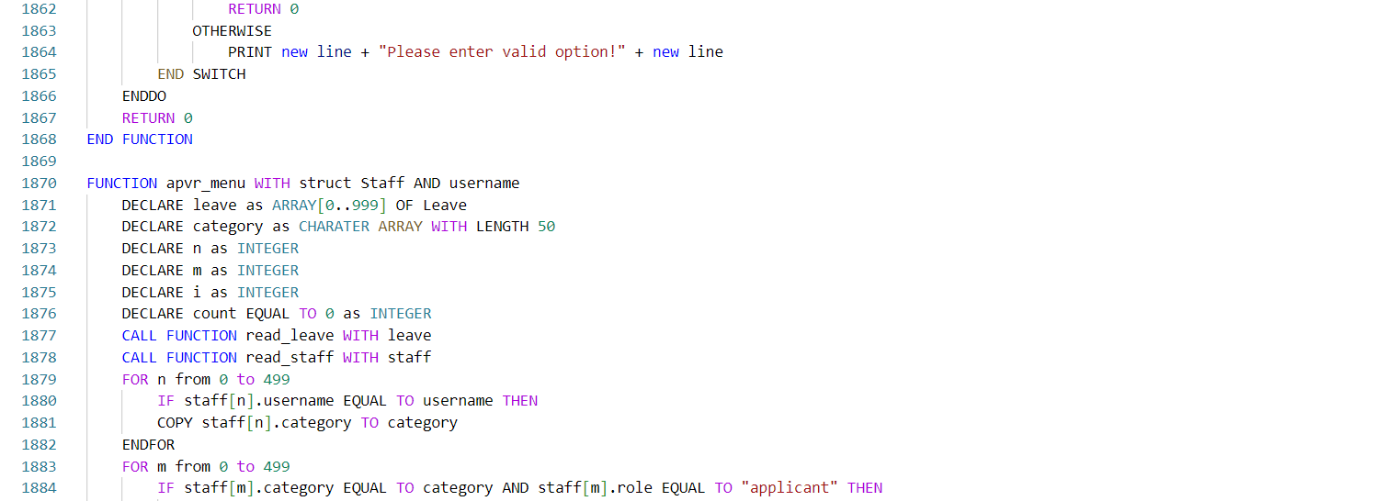

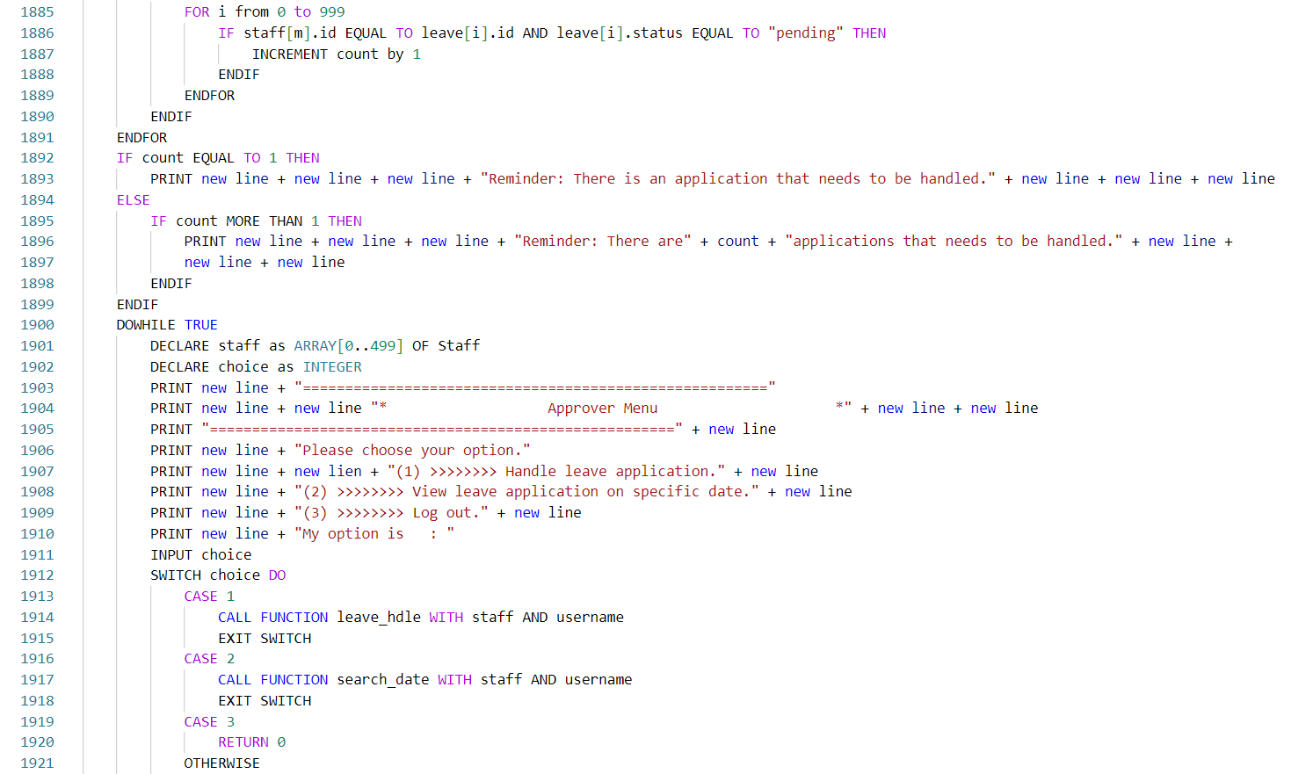 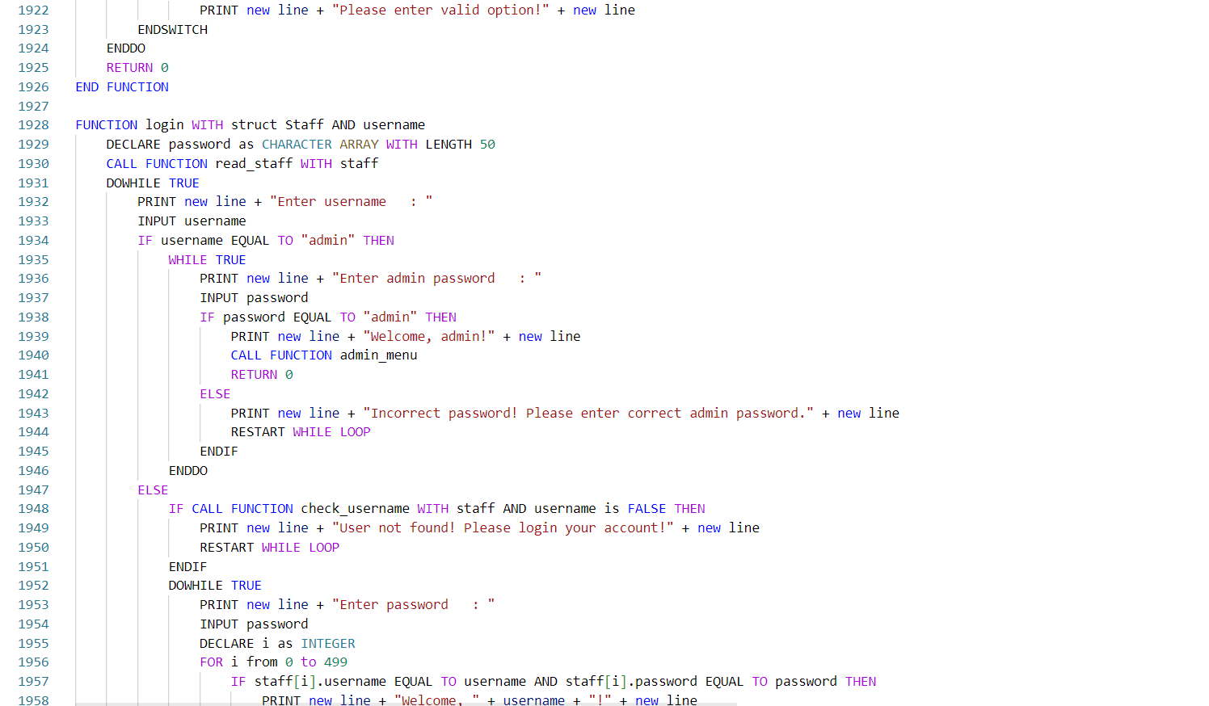 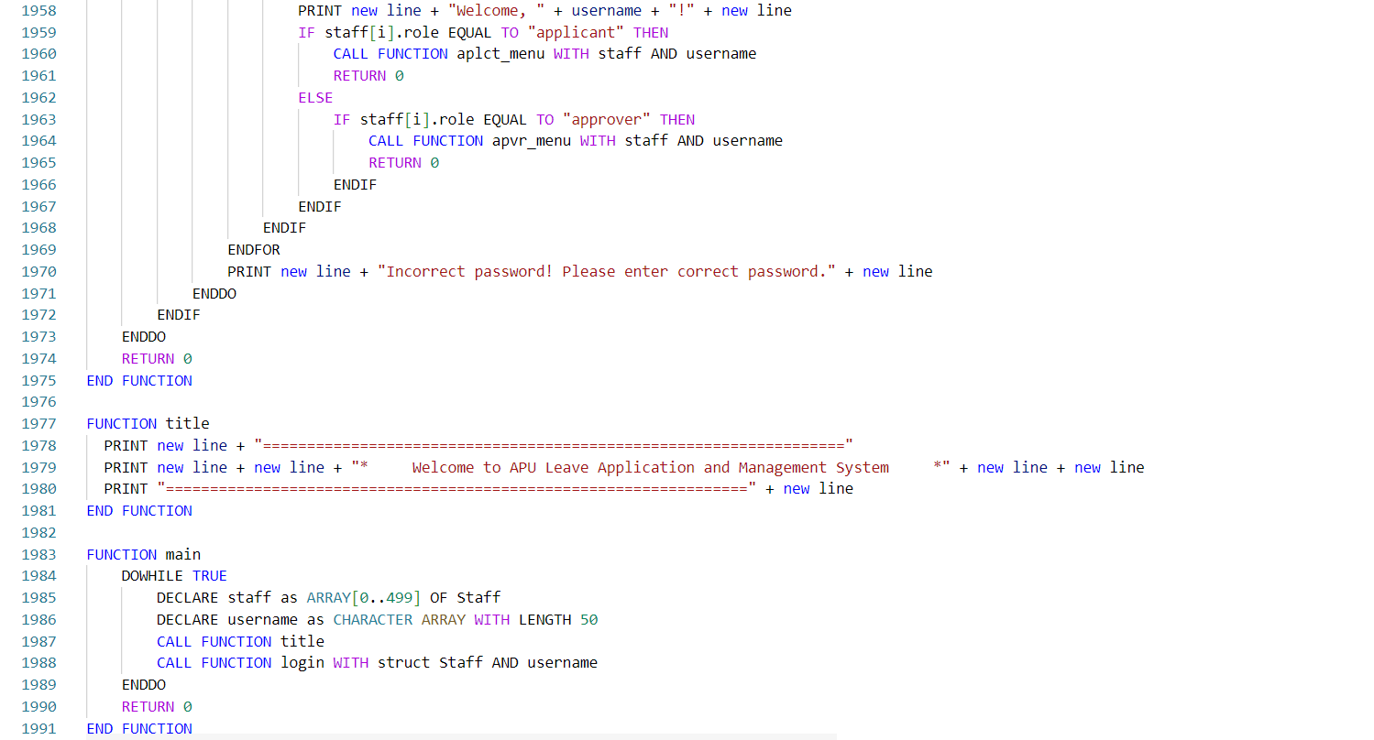

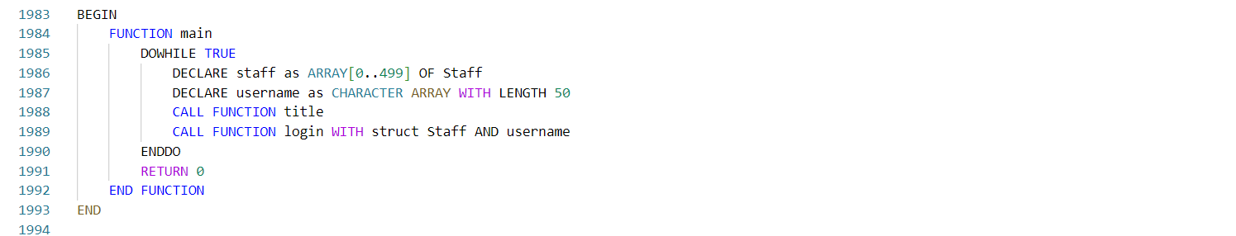

Figure 3.1.5: pseudocode of main.c

# **4.0 Main and Additional Features**

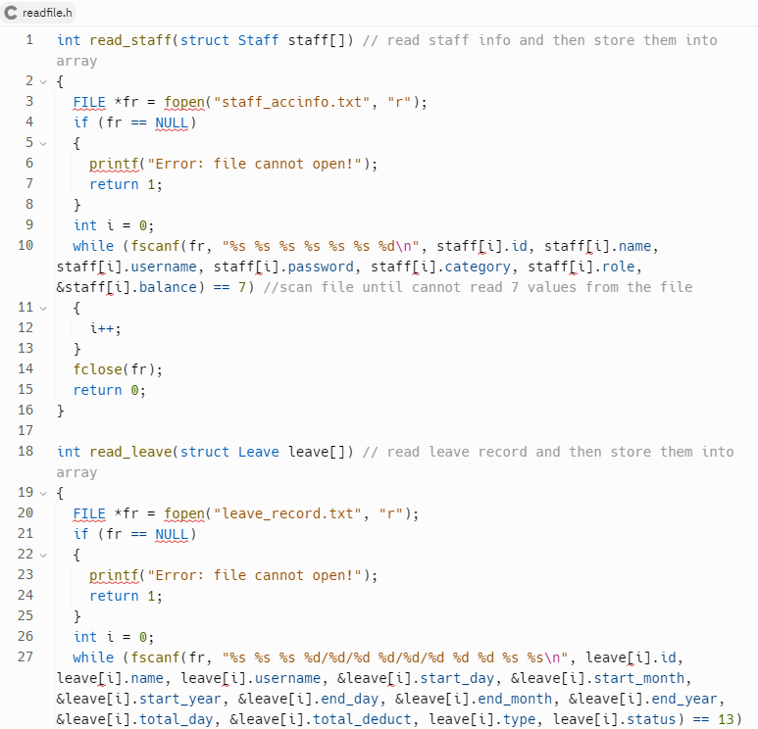 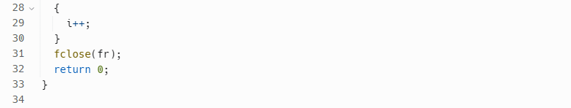

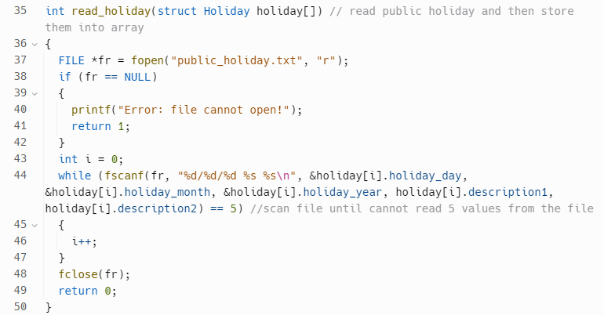



Figure 4.2.1: function within readfile.h

The first function read_staff reads staff information from a file named "staff_accinfo.txt". The second function read_leave reads leave records from a file named "leave_record.txt". The third function read_holiday reads public holiday information from a file named "public_holiday.txt". These functions open the file, read each line of data, and store the values into the corresponding fields of the staff, leave and holiday structure array. It returns 0 if the read was successful, and 1 if it encounters an error opening the file.

All three functions use the fscanf() function to read the values from the files. The format strings for fscanf() are designed to match the format of the data in the files. If the number of values read from the file does not match the expected number of values, the loop terminates and the function returns the error code. Finally, the function closes the file using fclose().

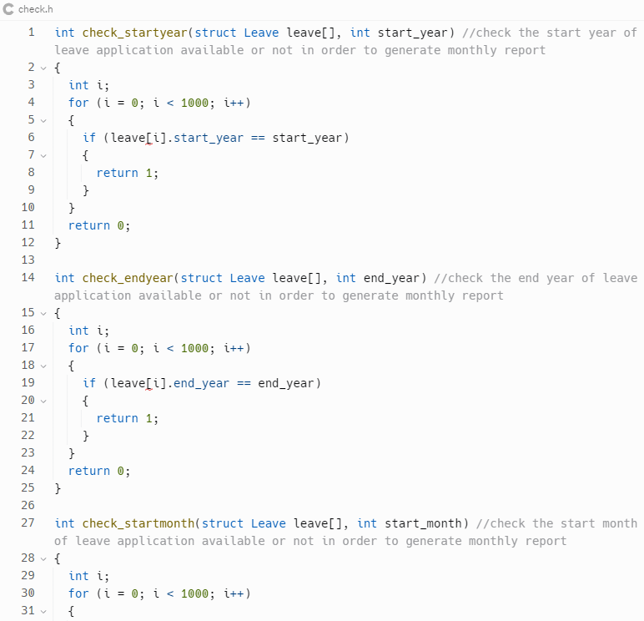 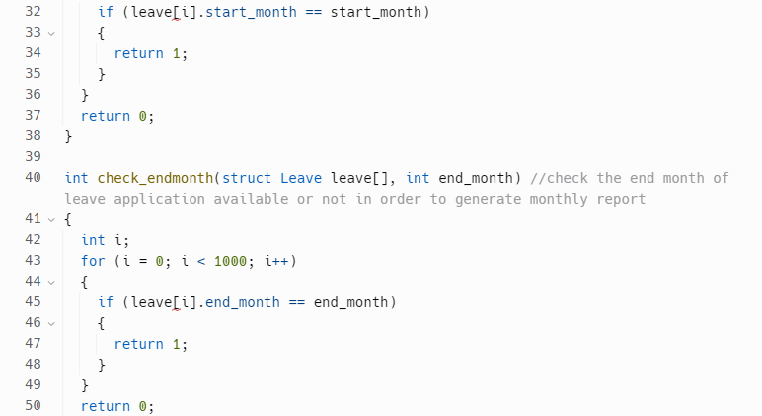

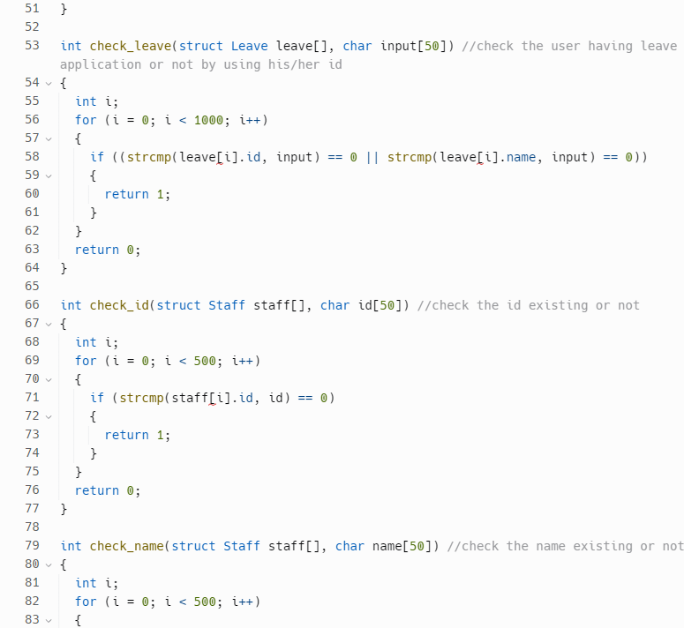 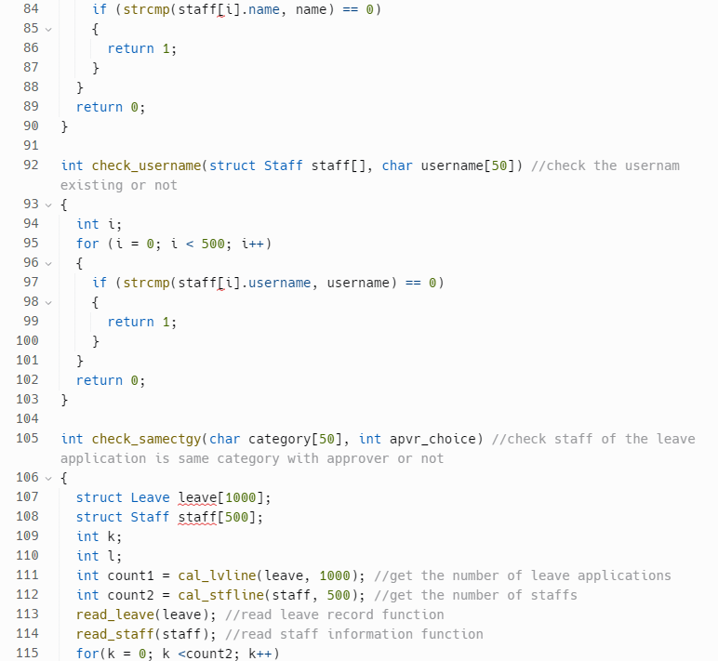

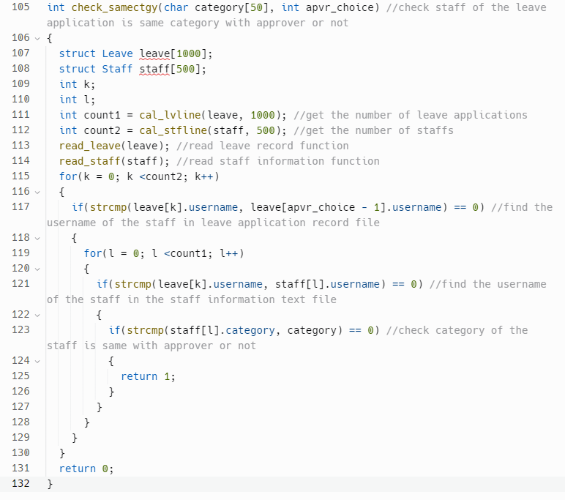

Figure 4.3.1: function within check.h

This code block contains several functions that are used in a larger system to manage leave applications and generate monthly reports. The first four functions are designed to check if a given start year, end year, start month, or end month exists in the leave application records by using the strcmp() functiom. These functions loop through an array of leave applications and compare the desired year or month with the corresponding value in each record. If a match is found, the function returns 1, indicating that the year or month exists in the records. Otherwise, it returns 0.

The next three functions are used to check if a given ID, name, or username exists in the staff records. These functions operate in a similar way to the previous ones, looping through an array of staff records and comparing the desired value with the corresponding field in each record.

The final function is designed to check if the staff associated with a leave application has the same category as the person who will approve their leave. This function first reads the leave and staff records from their respective text files using two other functions. It then finds the staff associated with the leave application by matching the username in the leave record with the username in the staff record. Finally, it checks if the category of this staff is the same as the category of the approver. If it is, the function returns 1; otherwise, it returns 0.

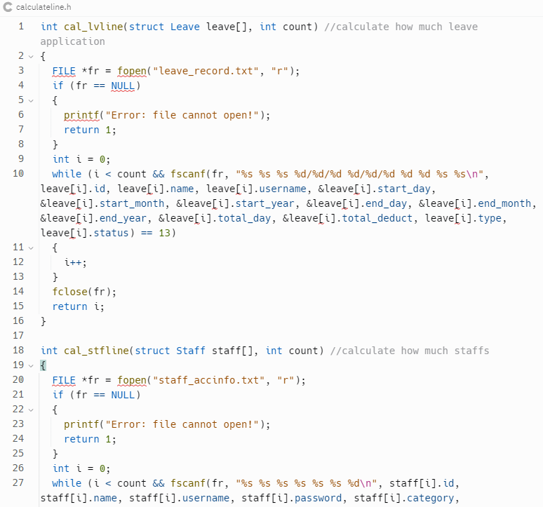 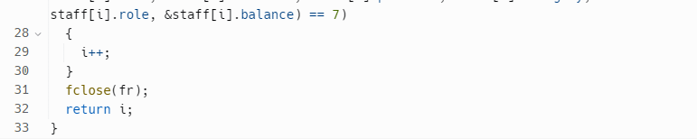

Figure 4.4.1: function within calculate.h

The "cal_lvline" function takes an array of "Leave" structures and an integer "count" as input parameters. It reads data from the "leave_record.txt" file and stores the values in the "Leave" array. The function uses a while loop to read the data until it reaches the end of the file or reads the specified number of records. The function returns the number of records read from the file.

Similarly, the "cal_stfline" function takes an array of "Staff" structures and an integer "count" as input parameters. It reads data from the "staff_accinfo.txt" file and stores the values in the "Staff" array. The function uses a while loop and fscanf() to read the data until it reaches the end of the file or reads the specified number of records. The function returns the number of records read from the file.

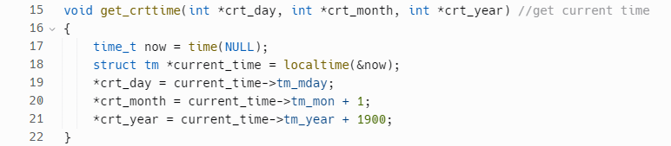

Figure 4.5.1: get_crttime function within main.c

The function first calls the time() function to obtain the current time and then passes this value to the localtime() function to convert it into a more readable format. The function then uses pointers to extract the day, month, and year values from the struct tm returned by localtime() and stores these values in the variables pointed to by "crt_day", "crt_month", and "crt_year".

The variable "now" is of type time_t and is used to store the current time in seconds since January 1, 1970. The struct tm is a built-in structure in C that contains members representing the various components of a date and time. The localtime() function converts the time represented by "now" into a struct tm that represents the local time on the machine running the program.

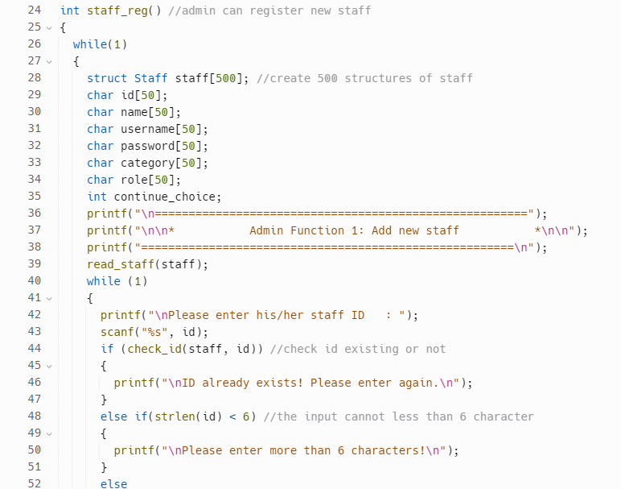 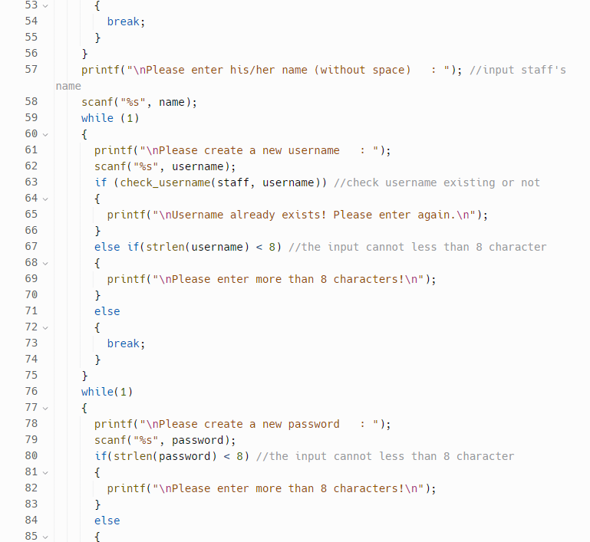 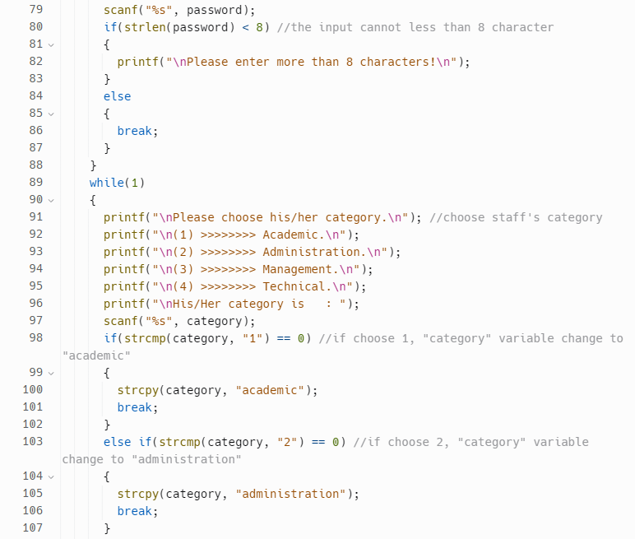 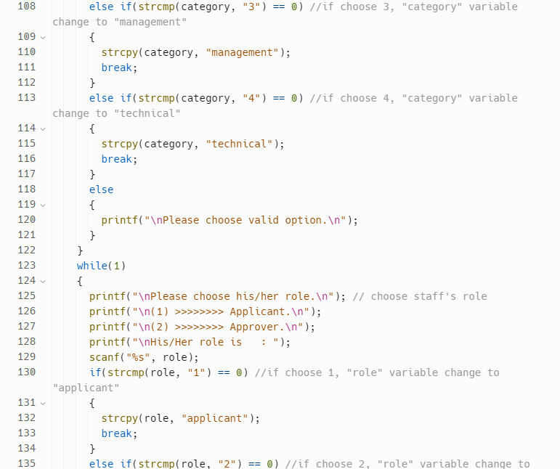 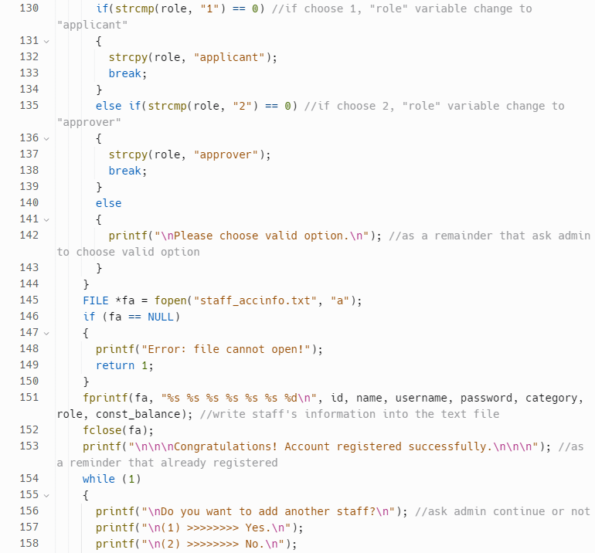 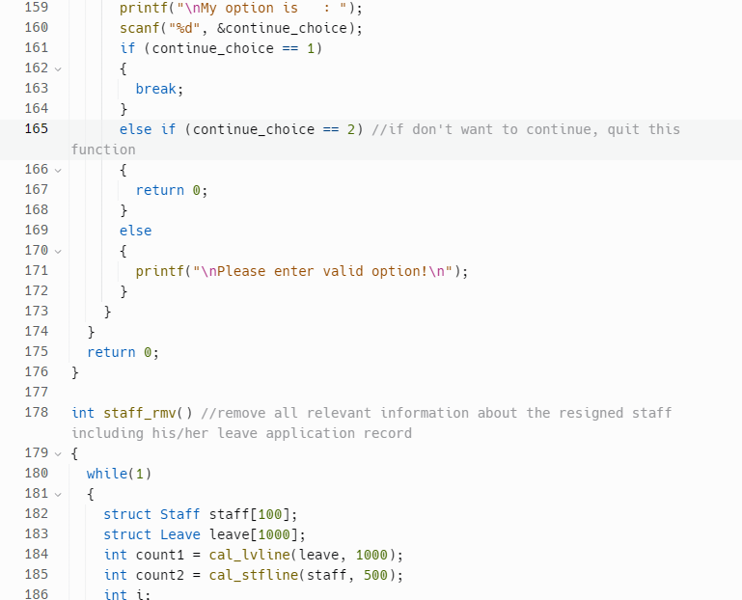 Figure 4.5.2: staff_reg function within main.c

This function allows the admin to register a new staff by entering their details, such as ID, name, username, password, category, and role by using the scanf() function. The function starts with an infinite loop that allows the admin to register multiple staffs. Within the loop, the function prompts the admin to enter the staff's information and checks whether the ID and username already exist or not. If they exist, the function prompts the admin to enter a new ID or username. If they do not exist, the function writes the staff's information to the "staff_accinfo.txt" file and prints a message that the account has been registered successfully.

The function uses a struct to store the staffs' information and creates 500 structures of staff. The function also uses several helper functions, such as "check_id" to check whether the ID already exists, "check_username" to check whether the username already exists, and "read_staff" to read the staff's information from the file.

The function also prompts the admin to choose the staff's category and role from a list of options. If the admin enters an invalid option, the function prompts the admin to enter a valid option.

Finally, the function prompts the admin to choose whether to add another staff or not. If the admin chooses to add another staff, the function repeats the process. If the admin chooses not to add another staff, the function quits.

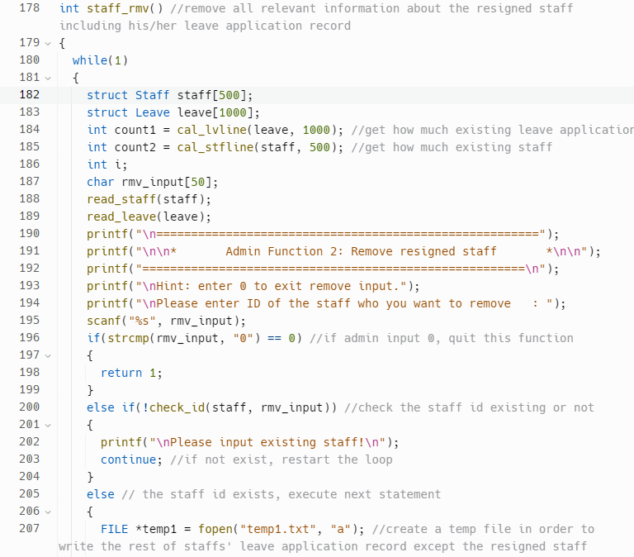 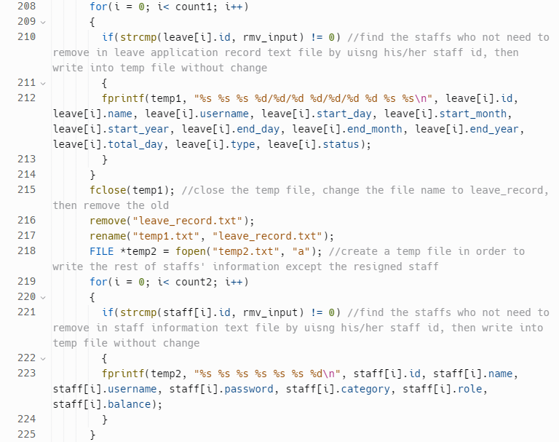 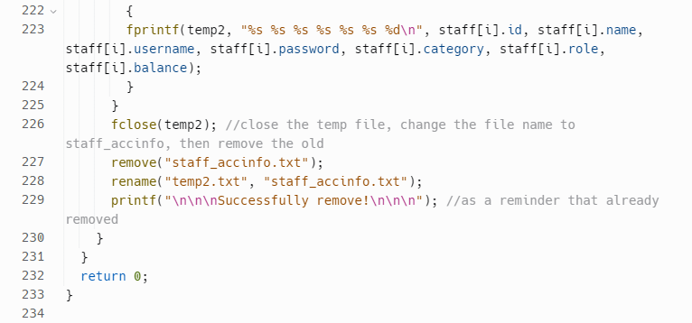

*Figure 4.5.3: staff_rmv function within main.c*

This function allows an admin user to remove a resigned staff from the system, along with all their related leave application records.

The function starts with an infinite loop that runs until the admin user chooses to exit by inputting "0". It then declares two arrays of structs: one for staff and another for leave applications, each with a capacity of 500 and 1000, respectively. The function then calls two helper functions: "cal_lvline" and "cal_stfline" to get the count of existing leave applications and staff records, respectively.

Next, the function reads the staff and leave records from their respective text files using the "read_staff" and "read_leave" functions. It then prompts the admin user to enter the ID of the staff they want to remove, with a hint that they can enter "0" to exit the function. The user input is stored in a character array called "rmv_input".

If the user enters "0", the function returns 1, indicating that the user has chosen to exit the function. Otherwise, the function calls the "check_id" function to check if the entered staff ID exists in the system. If the ID does not exist, the function outputs an error message and restarts the loop to prompt the admin user to enter a valid ID. If the ID exists, the function proceeds with removing the staff from the system.

To remove the staff, the function creates two temporary files: "temp1.txt" and "temp2.txt". The first file is used to write all the leave applications of the staffs, except the one being removed. The second file is used to write all the staff records except the one being removed. The function then reads through the existing leave and staff records and writes all records that don't match the ID of the staff being removed into the respective temporary files.

Once all the relevant records have been written to the temporary files, the function closes them and renames them to overwrite the original text files. The function then outputs a success message to the console as a reminder that the staff has been successfully removed from the system.

Finally, the loop restarts to allow the admin user to remove another staff or exit the function by inputting "0". The function returns 0, indicating that it has completed successfully.

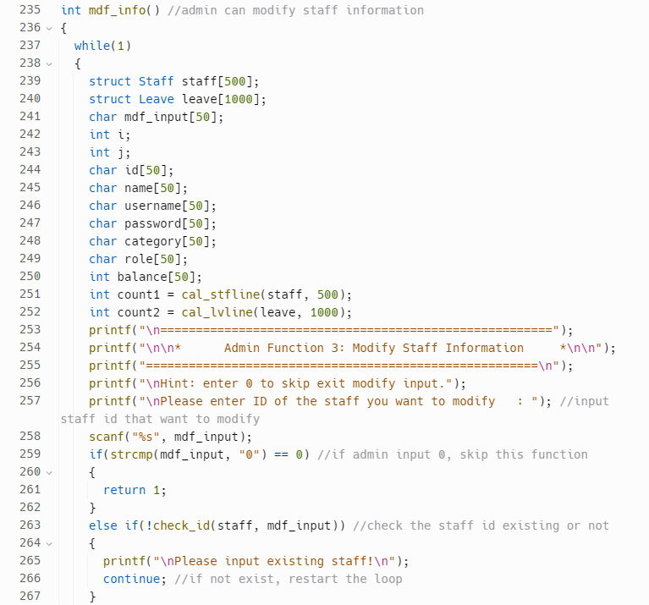 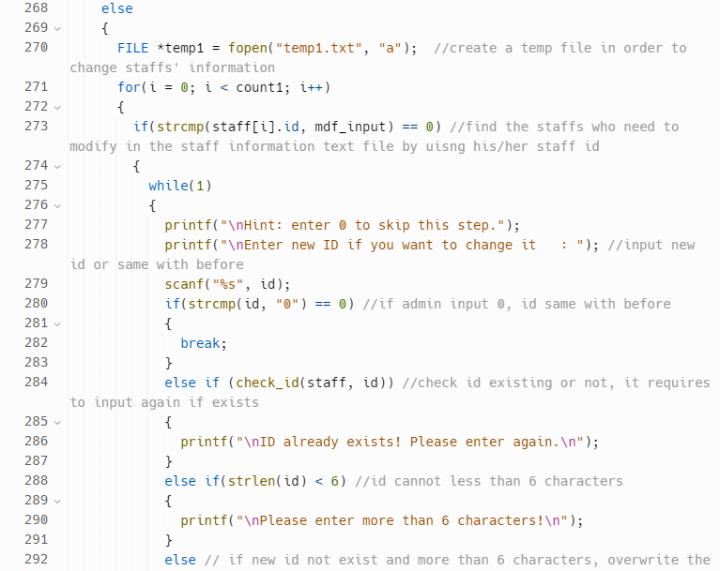 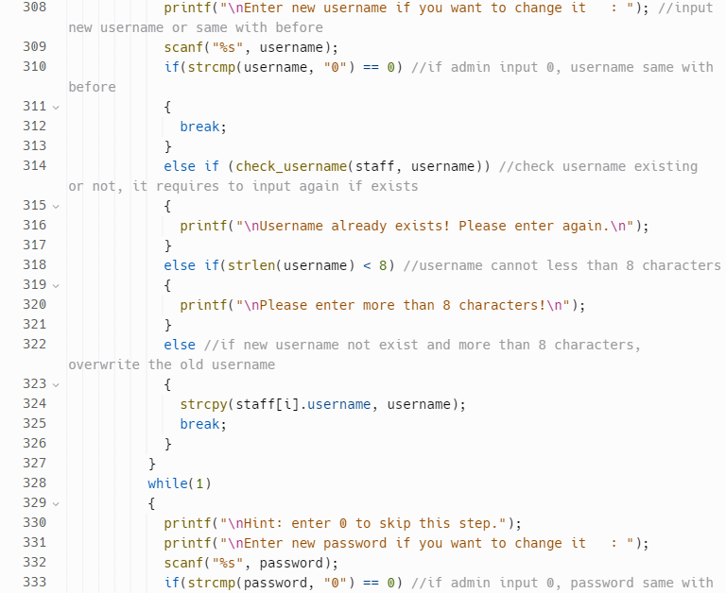 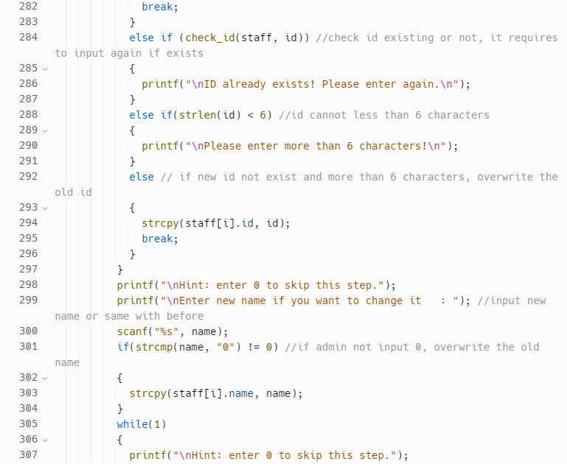 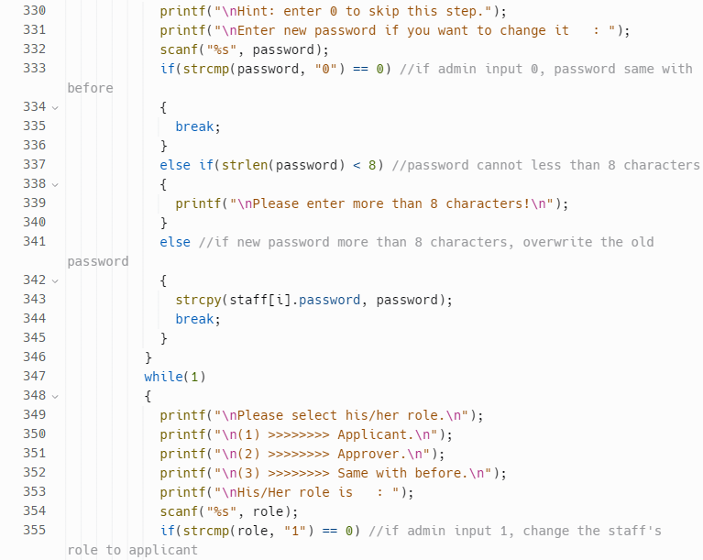 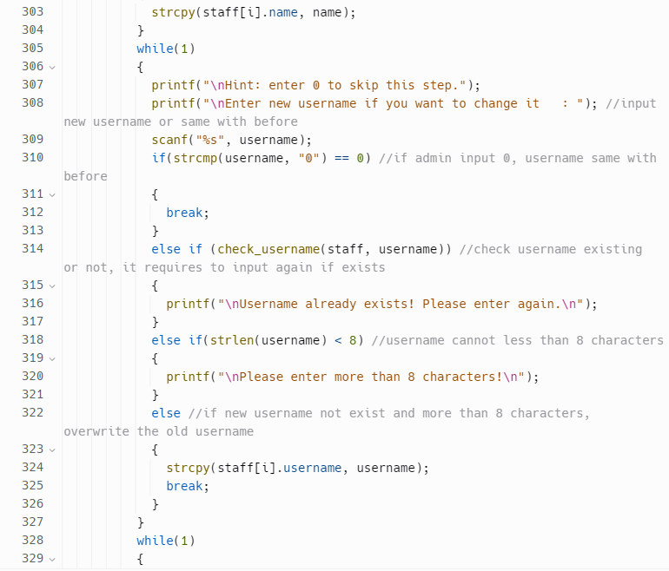 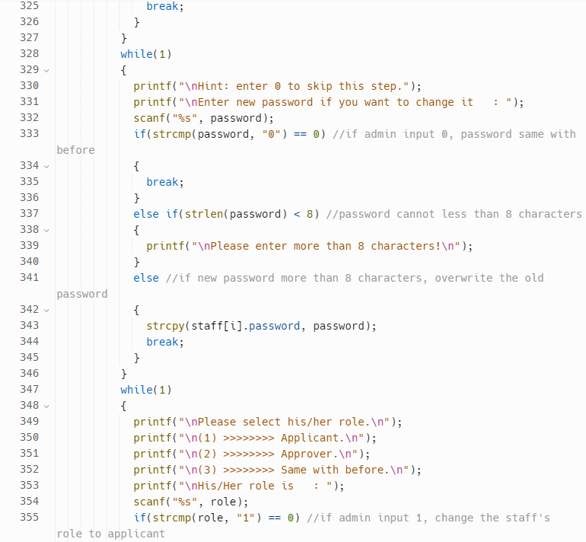 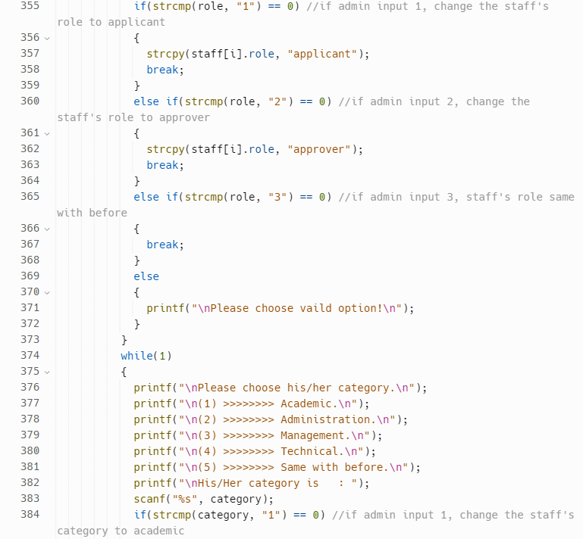 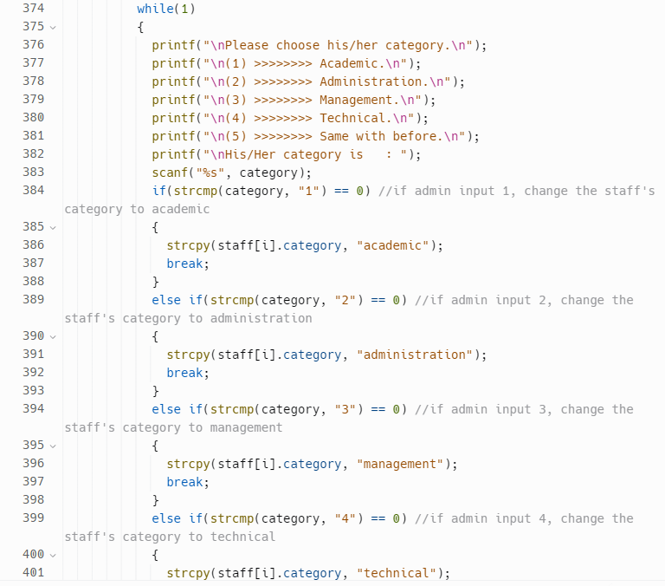 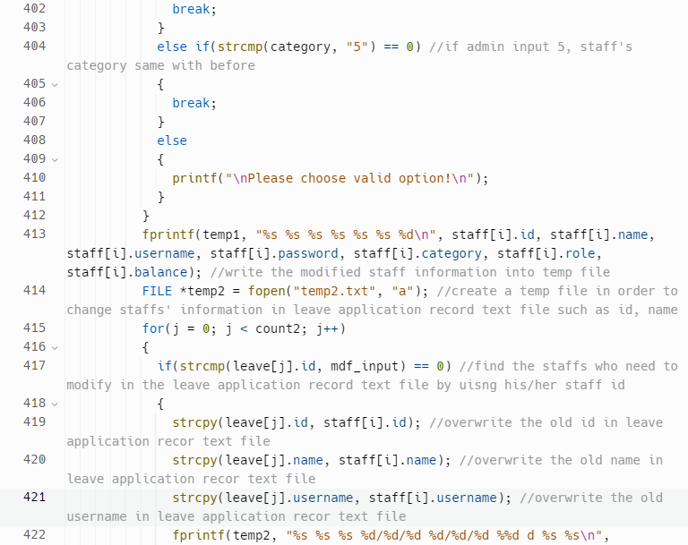 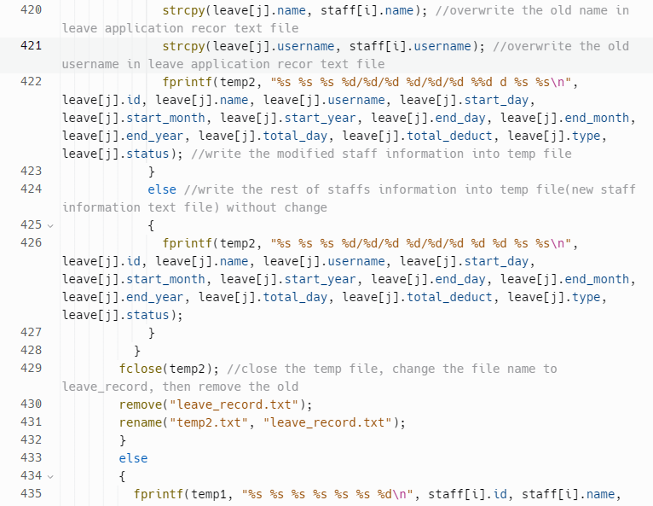 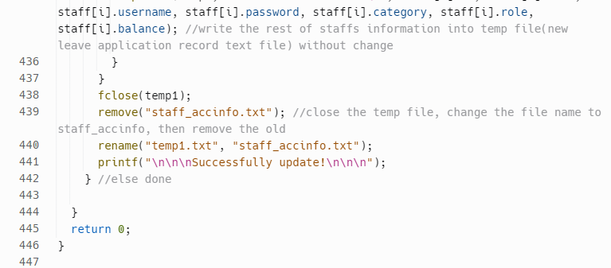

*Figure 4.5.4: mdf_info function within main.c*

The code is a function that allows an admin to modify staff information. The function prompts the admin to input the ID of the staff they want to modify and then allows the admin to modify different fields such as the name, username, password, category and role of the staff.

The function also includes input validation to ensure that the admin enters valid input such as checking if the ID exists in the system, if a new ID or username already exists, and if the password is more than 8 characters.

The function uses a while loop to continuously prompt the admin for input until they enter "0" in the input of selecting modify staff to exit the function. It also uses a temporary file to store the modified staff information and use fprintf() to write it . Afterward, the system will change the name of the file according to its content.

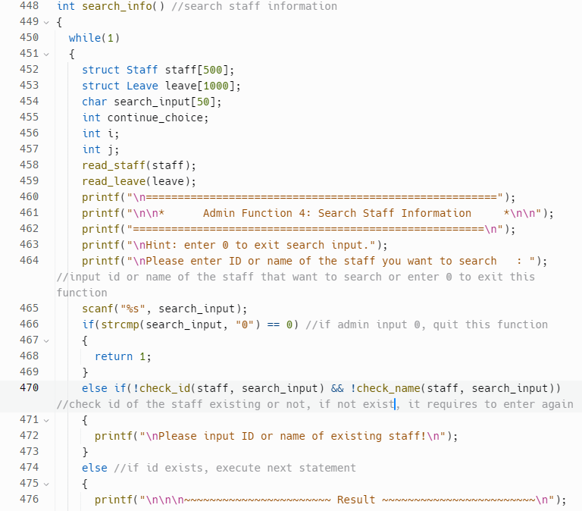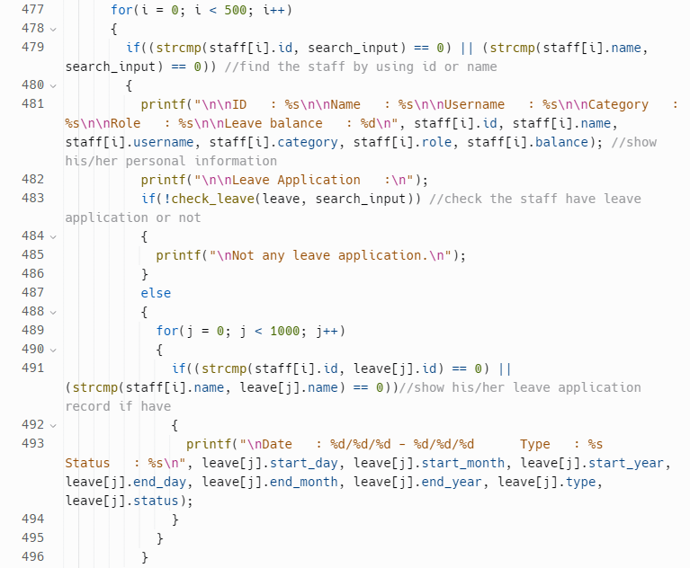

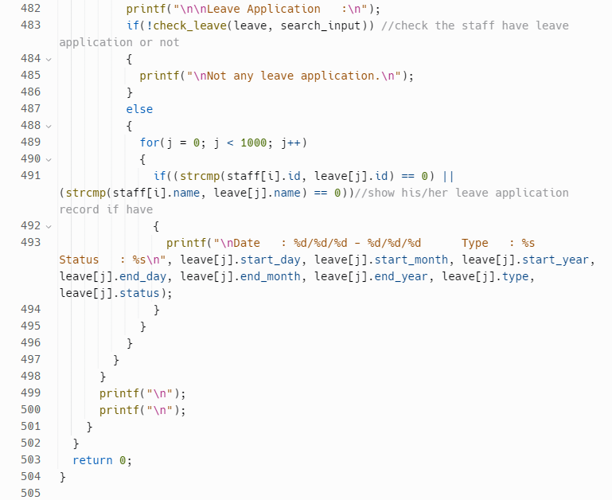

*Figure 4.5.5: search_info function within main.c*

This is a function that allows an admin to search for staff information. The function contains a while loop that runs indefinitely until the admin chooses to exit the function.

The function then prompts the admin to enter the ID or name of the staff they want to search for. If the admin enters '0', the function returns 1 and exits. Otherwise, the function checks if the input matches any staff's ID or name. If not, the function prompts the admin to enter a valid input again.

If the input matches a staff's ID or name, the function prints out the personal information of that staff, including their ID, name, username, category, role, and leave balance. It then checks if the staff has any leave application records. If not, the function prints a message saying that the staff has not applied for any leave. If the staff has leave application records, the function prints out the start and end dates of the leave, the type of leave, and the status of the leave.

The function then repeats the loop, allowing the admin to search for another staff's information. If the admin chooses to exit, the function returns 1 and exits. If not, the loop continues.

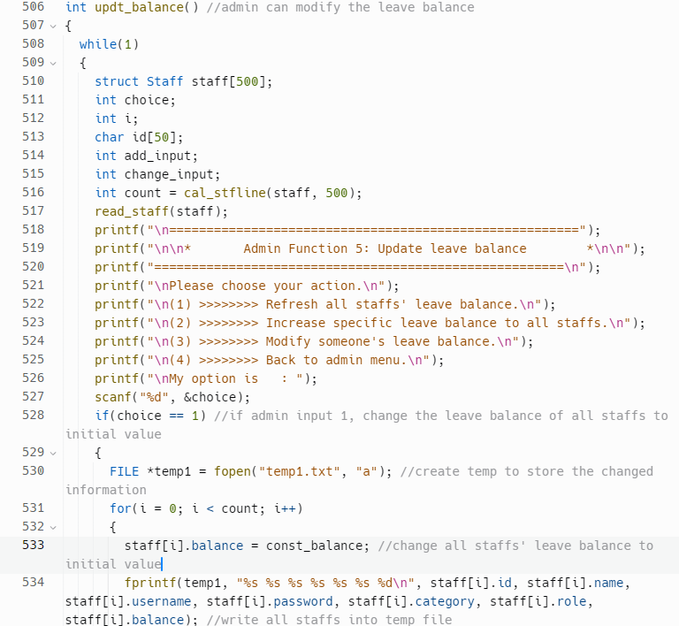 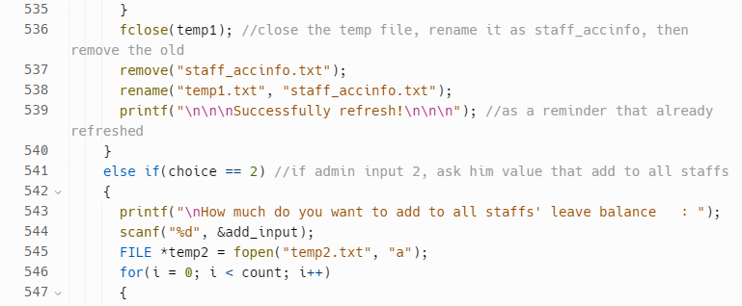 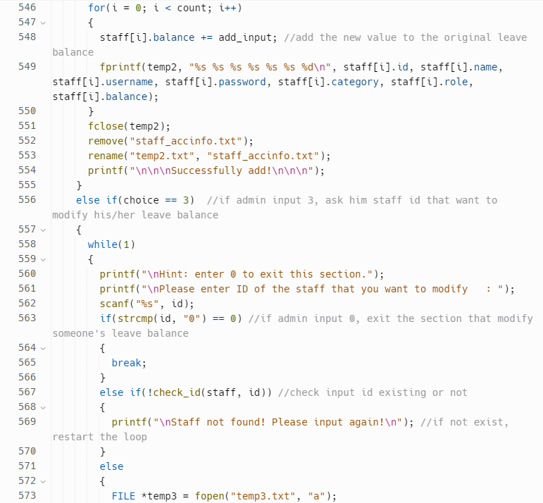 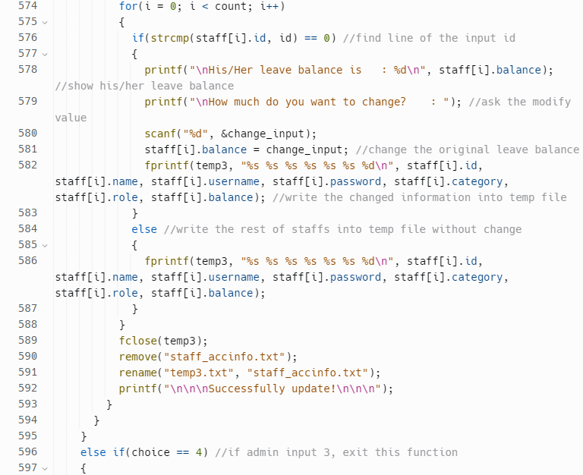 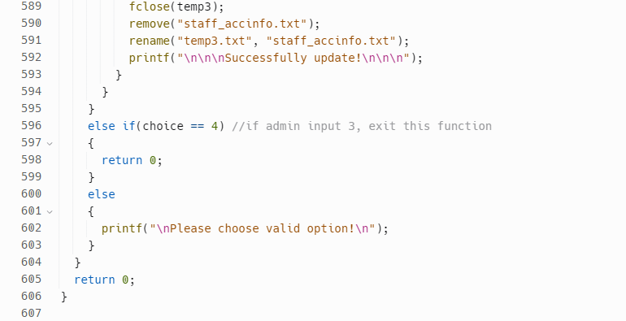

*Figure 4.5.6: updt_balance function within main.c*

This is a function that allows an admin to modify the leave balance of staffs in a system. The function starts by declaring a while loop that will continue running until the admin chooses to exit the function.

The function displays a menu of four options for the admin to choose from. If the admin chooses option 1, the function sets the leave balance of all staffs to a constant value, writes the modified information to a temporary file, renames the temporary file to staff_accinfo.txt, and removes the old staff_accinfo.txt file. If the admin chooses option 2, the function prompts the admin to enter a value to add to all staffs' leave balances. It then adds this value to each staff's balance, writes the modified information to a temporary file, renames the temporary file to staff_accinfo.txt, and removes the old staff_accinfo.txt file. If the admin chooses option 3, the function prompts the admin to enter the ID of the staff whose leave balance they want to modify. If the ID is found in the staff array, the function displays the current leave balance of the staff and prompts the admin to enter a new value for the leave balance. It then modifies the staff's leave balance, writes the modified information to a temporary file, renames the temporary file to staff_accinfo.txt, and removes the old staff_accinfo.txt file. If the admin chooses option 4, the function returns 0, exiting the while loop and the function.

If the admin inputs an invalid option, the function displays an error message and prompts the admin to choose a valid option.

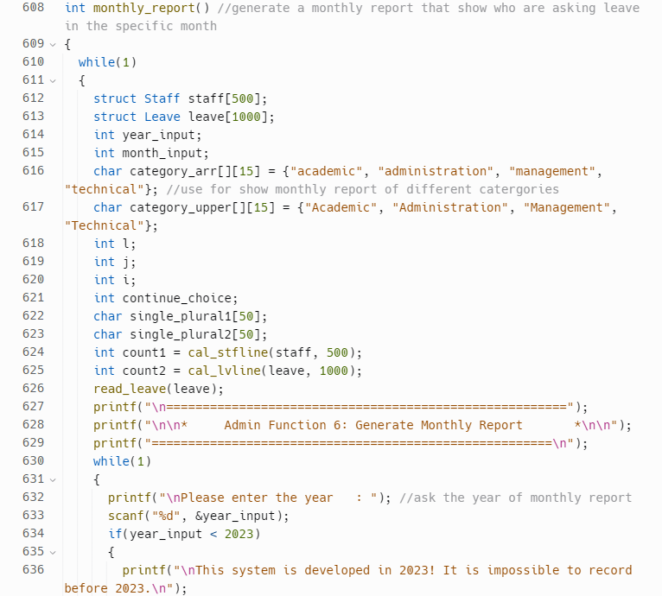 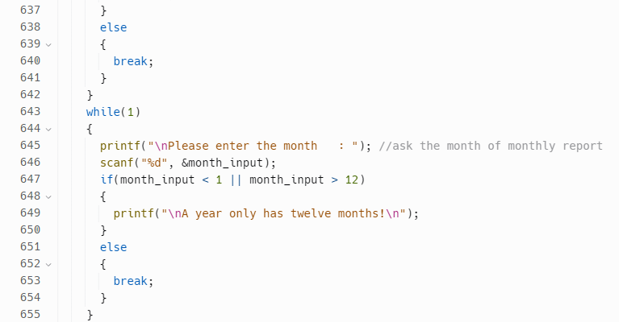 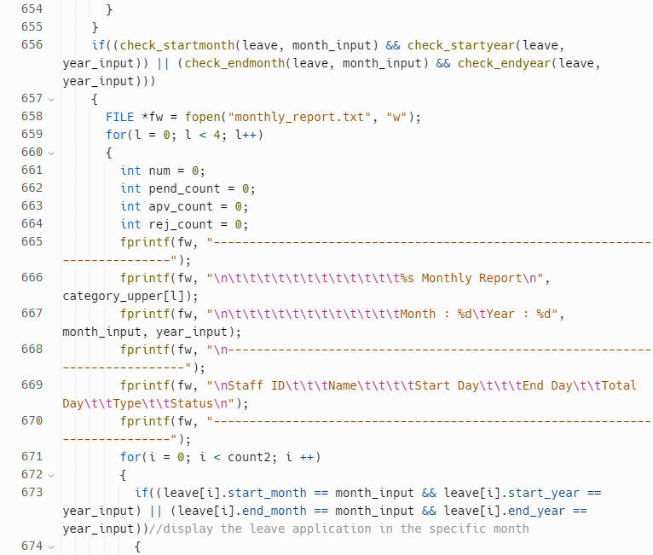 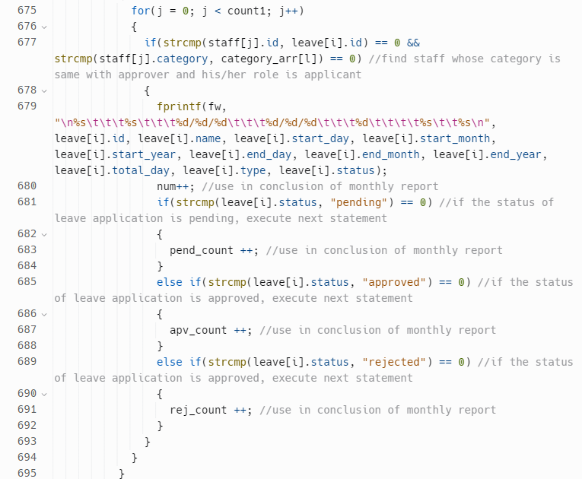 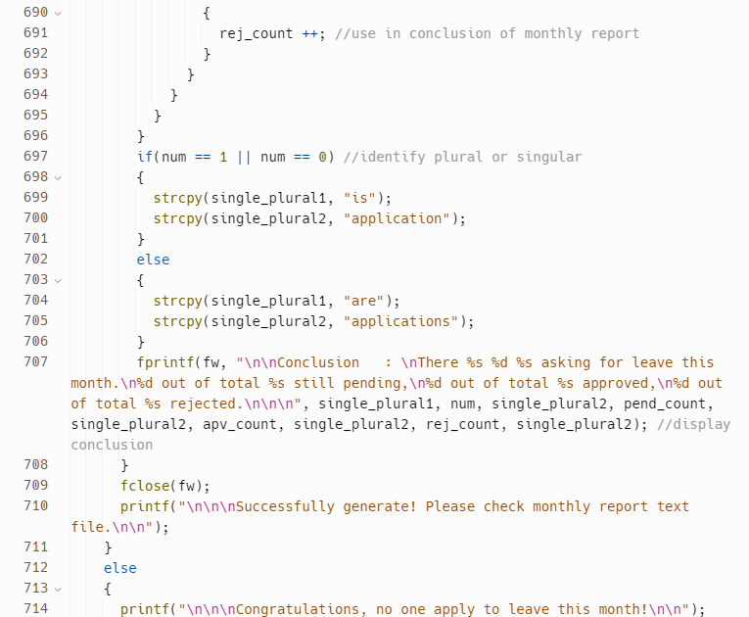 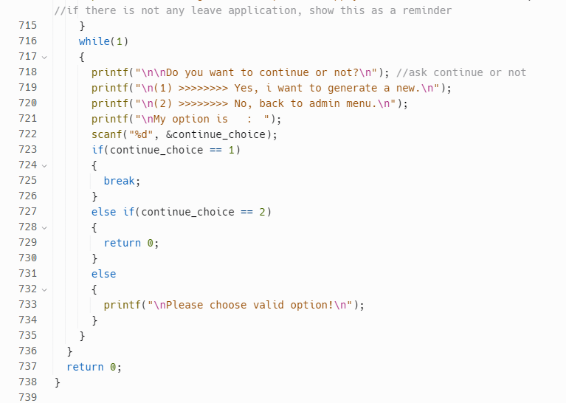 *Figure 4.5.7: monthly_report function within main.c*

This function generates a monthly report that shows who is asking for leave in a specific month. The function has a while loop that allows the user to generate multiple reports until admin decides to quit.

The function then prompts the user to input the year and month for the report and checks to ensure that the input is valid. It then checks whether any leave applications are involved in the specified month and year. If there are any leave applications in that month and year, the function creates a new text file named monthly_report.txt.

The function then loops through the different categories and writes to the text file the details of the leave applications for each category. For each leave application, the function finds the corresponding staff and writes their information to the file as well. Finally, the function writes a conclusion to the file that summarizes the number of leave applications that are still pending, approved, and rejected.

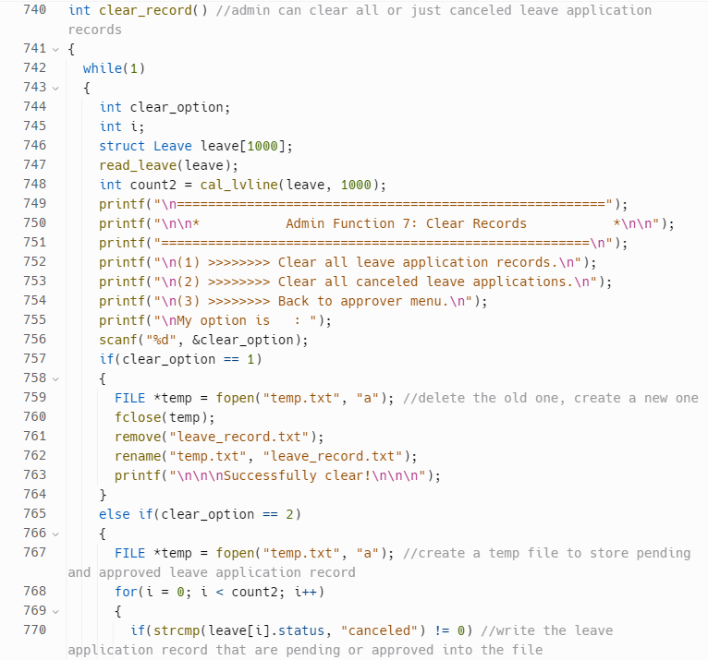 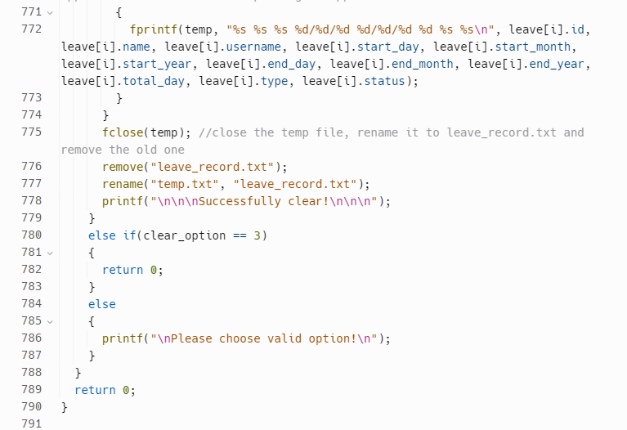

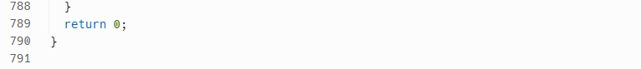

*Figure 4.5.8: clear_record function within main.c*

This function provides admin to clear leave application records either all records or only the canceled leave application records.

The function begins by creating a loop that will continue until the admin chooses to return to the approver menu. Next, the function displays a menu of options for the admin to choose from using printf statements. The admin can choose to clear all leave application records, clear all canceled leave applications, or go back to the approver menu.

If the user chooses option 1, the function creates a new, empty file called "temp.txt" using the fopen function and then closes it using fclose. It then deletes the original "leave_record.txt" file using the remove function and renames the new "temp.txt" file to "leave_record.txt" using the rename function. This effectively clears all leave application records.

If the user chooses option 2, the function creates a new, empty file called "temp.txt" using the fopen function. It then loops through each leave record in the "leave" array and writes any leave application record that is not canceled to the new "temp.txt" file using fprintf function. After writing all applicable records, the function closes the "temp.txt" file and deletes the original "leave_record.txt" file using the remove function. Finally, it renames the new "temp.txt" file to "leave_record.txt" using the rename function. This effectively clears all canceled leave application records.

If the admin chooses option 3, the function returns 0, which will cause the calling function to return to the approver menu. If the admin chooses an invalid option, the function displays a message asking the user to choose a valid option.

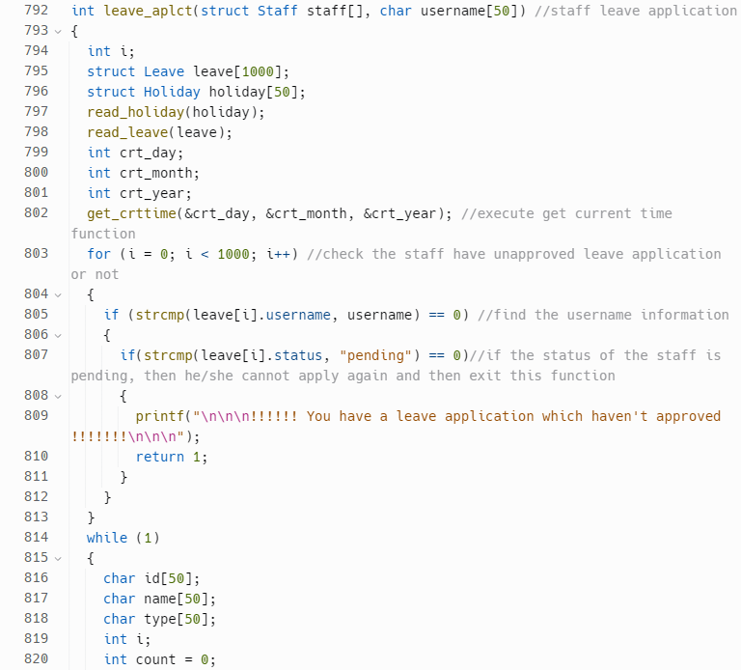 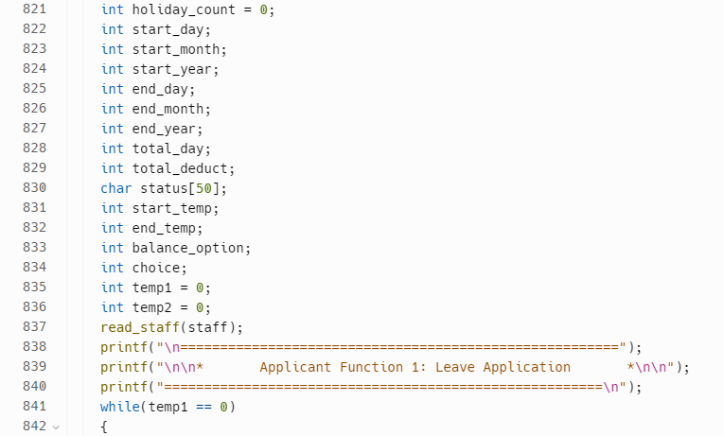 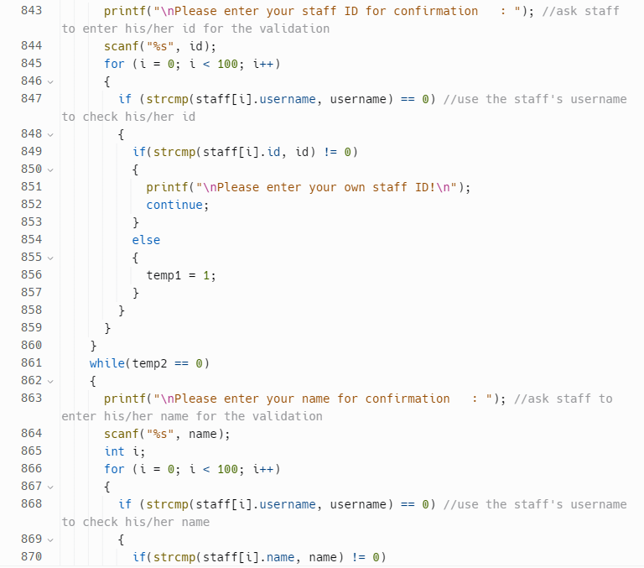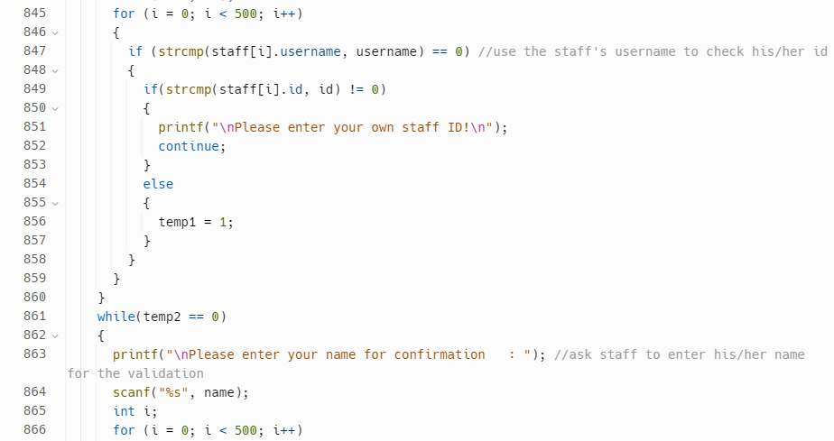 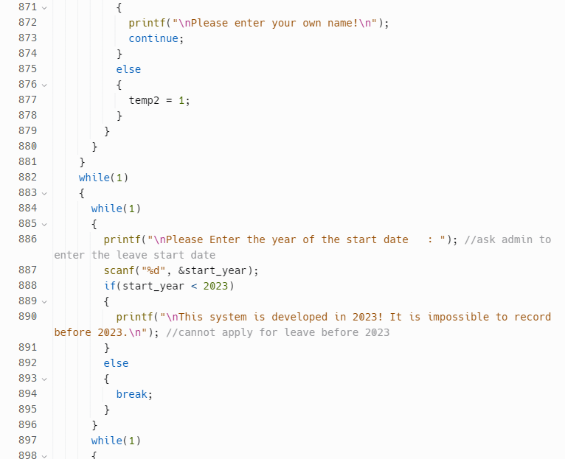 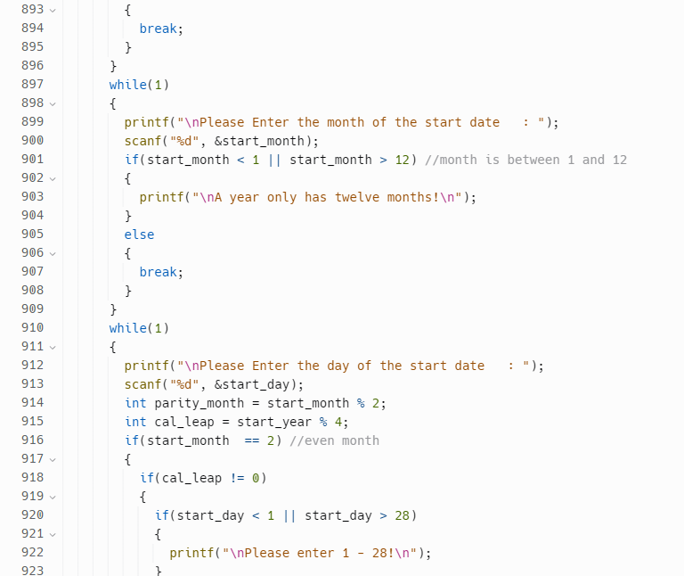 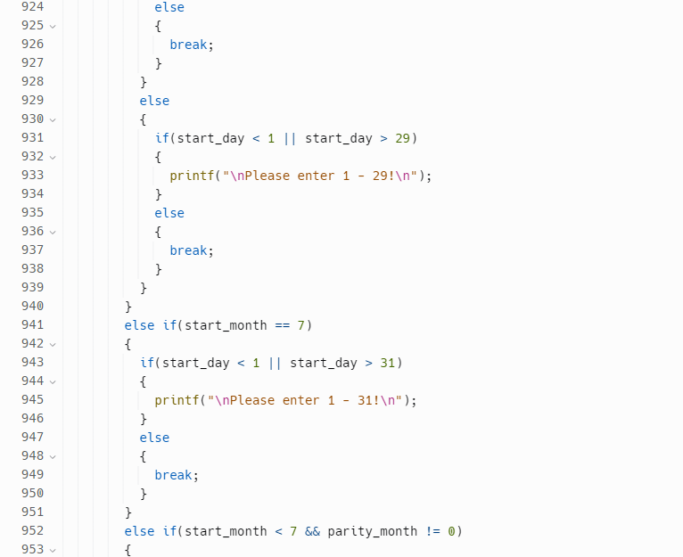 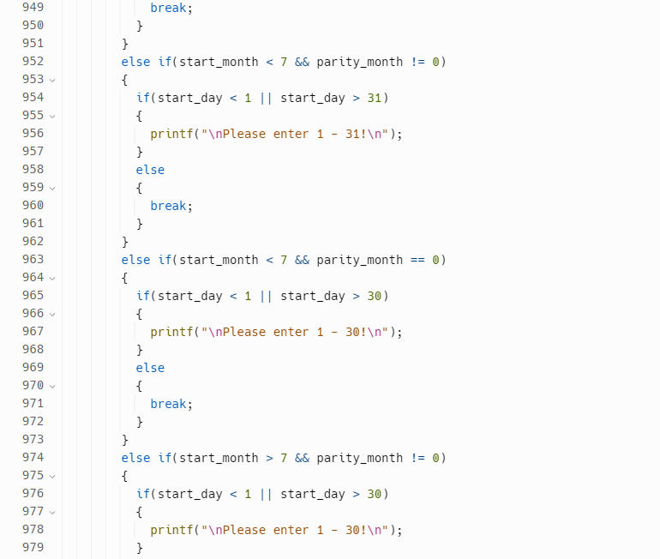 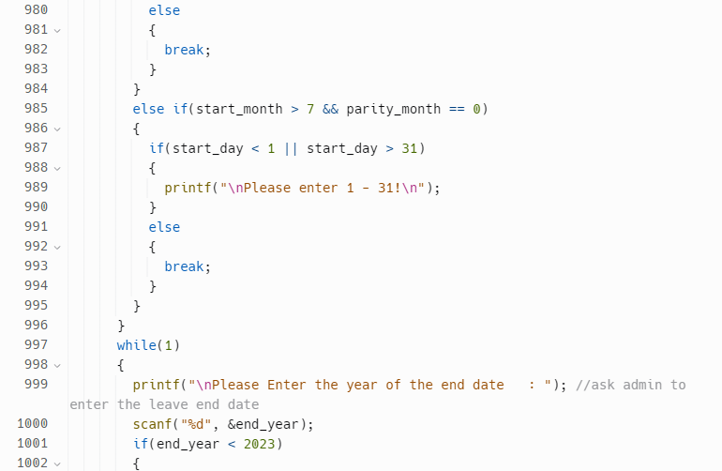 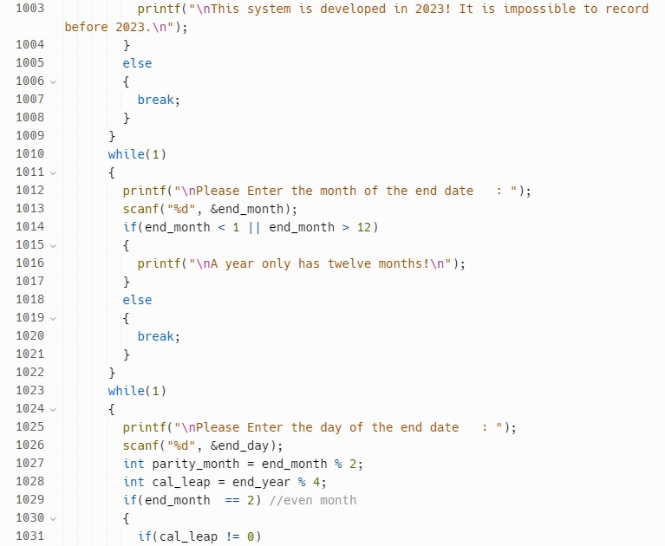 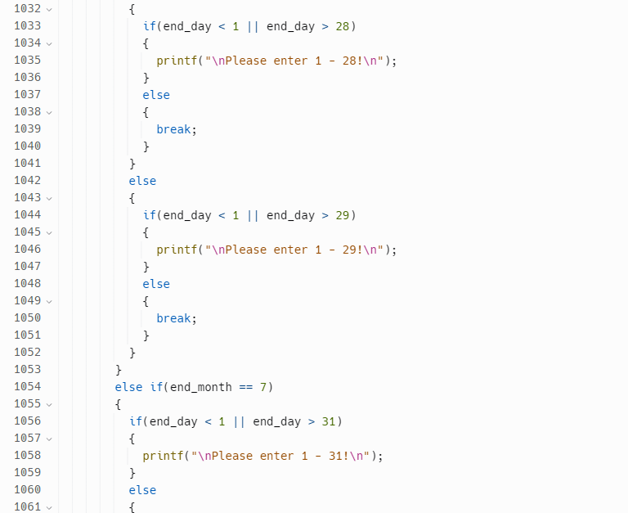 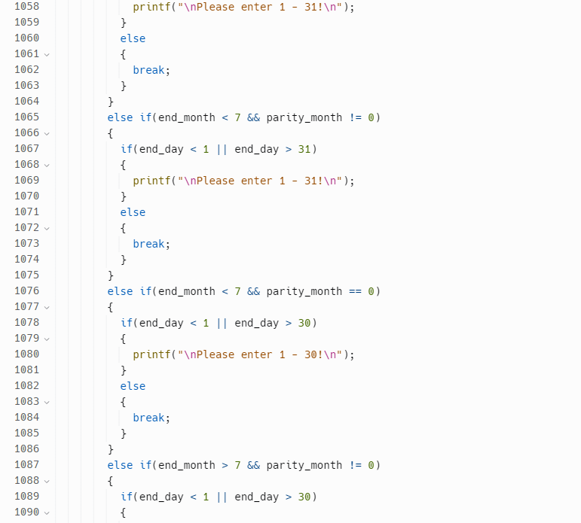 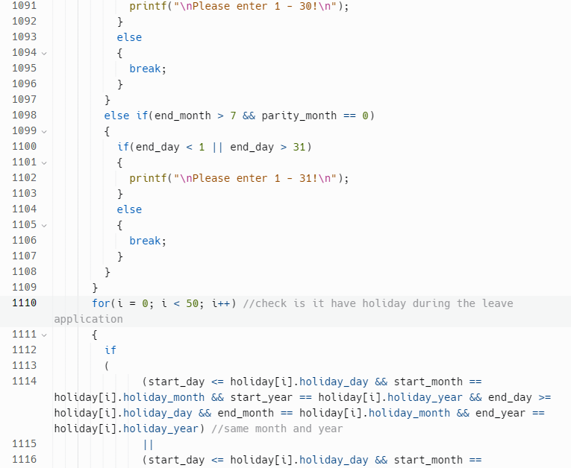 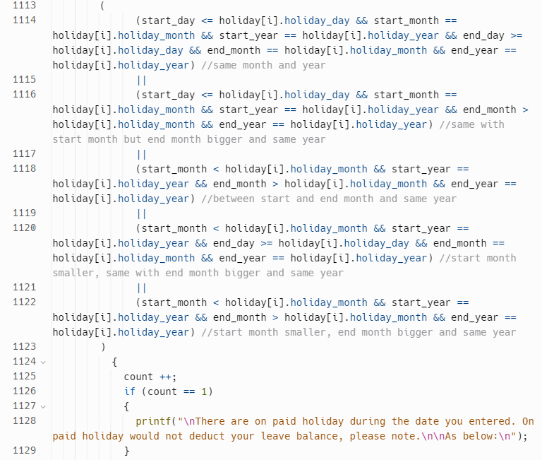 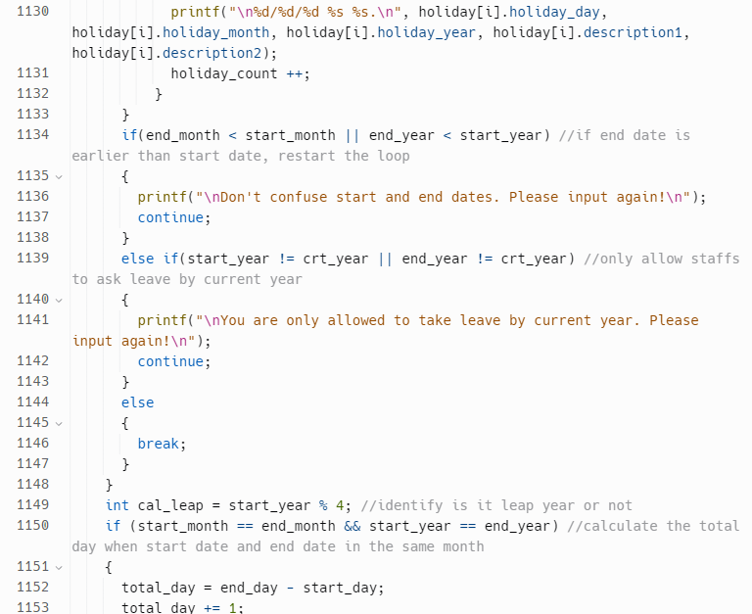 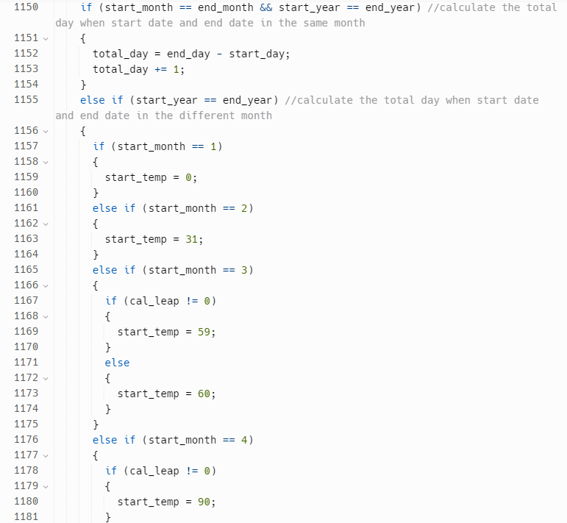 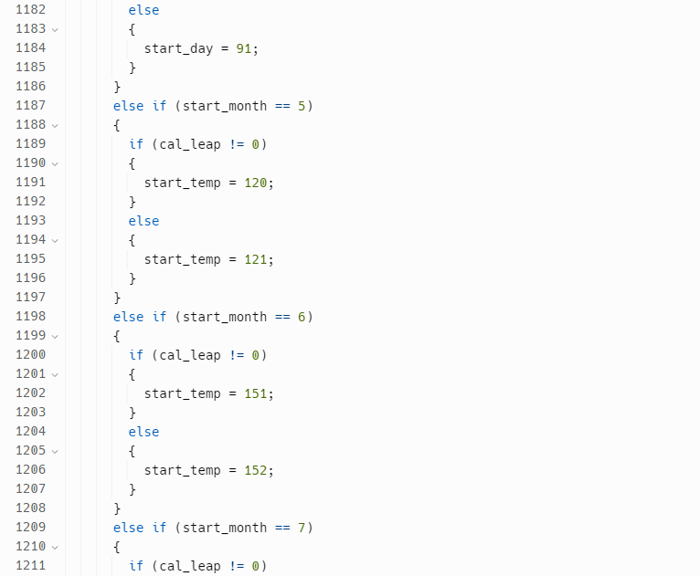 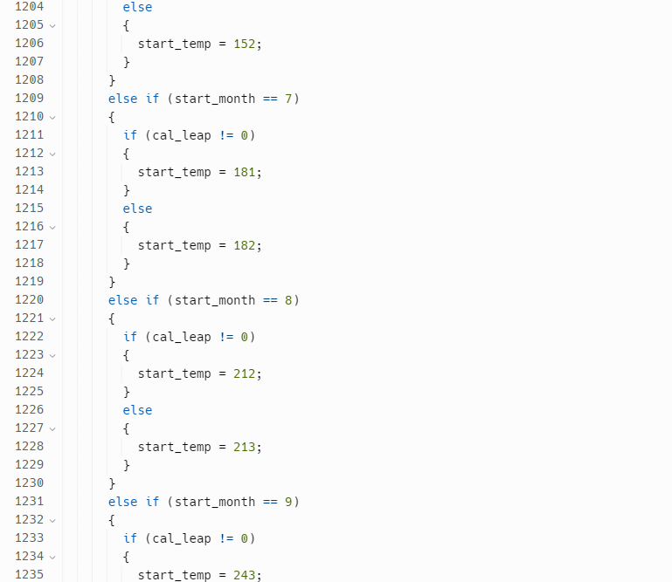 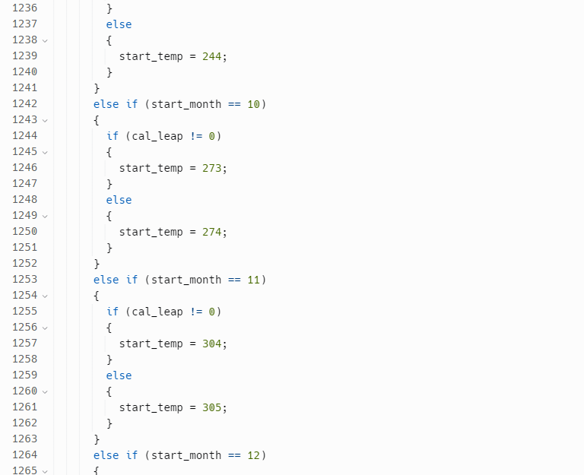 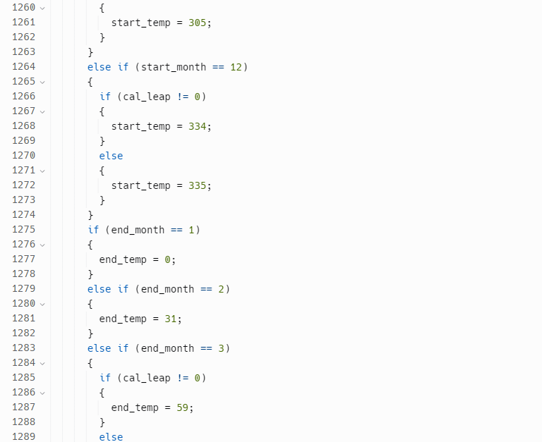 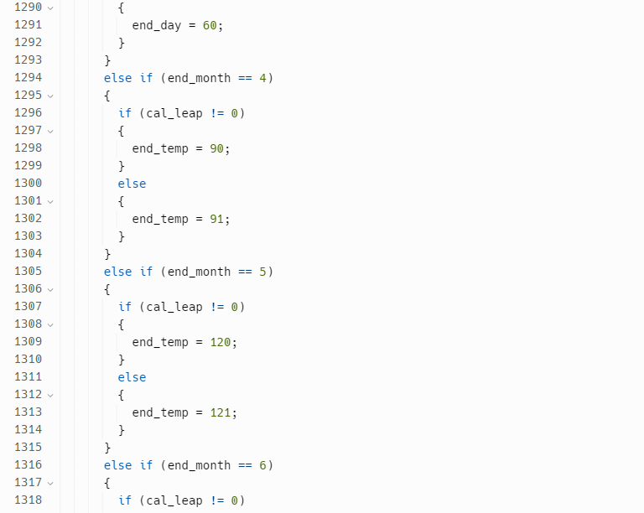 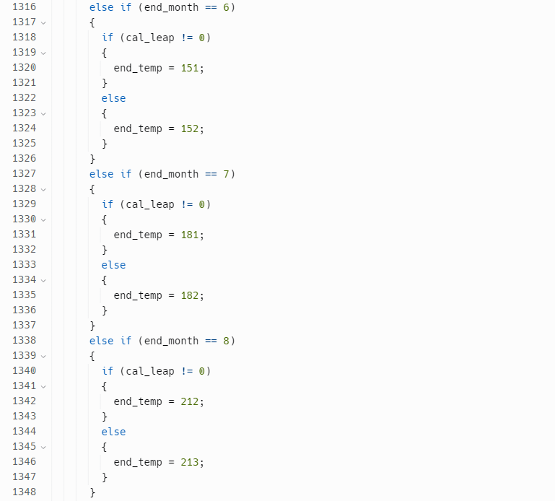 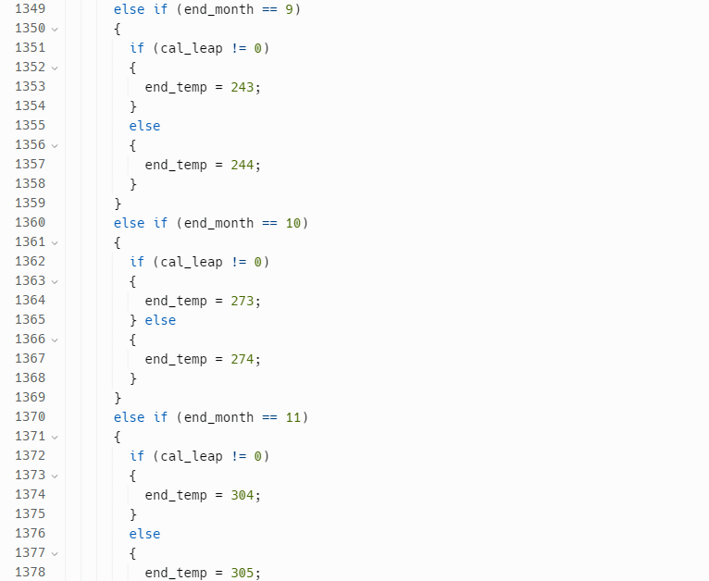 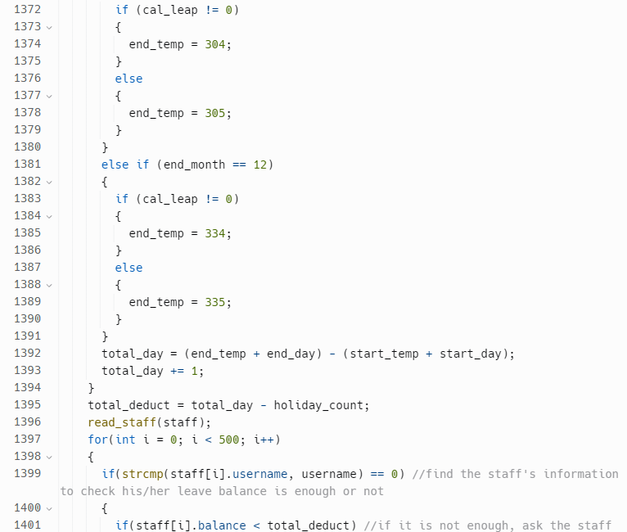 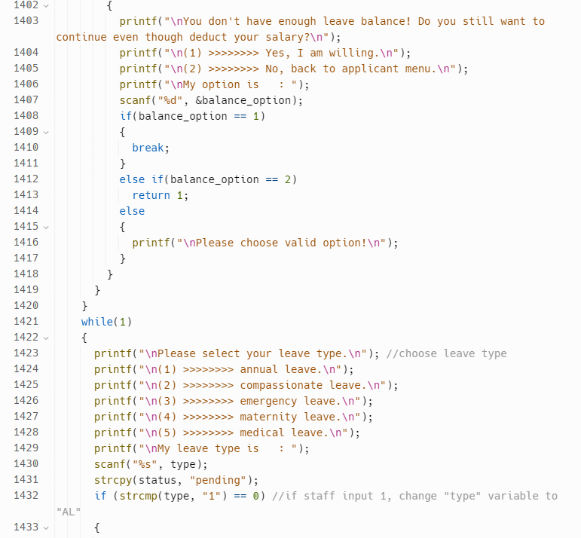 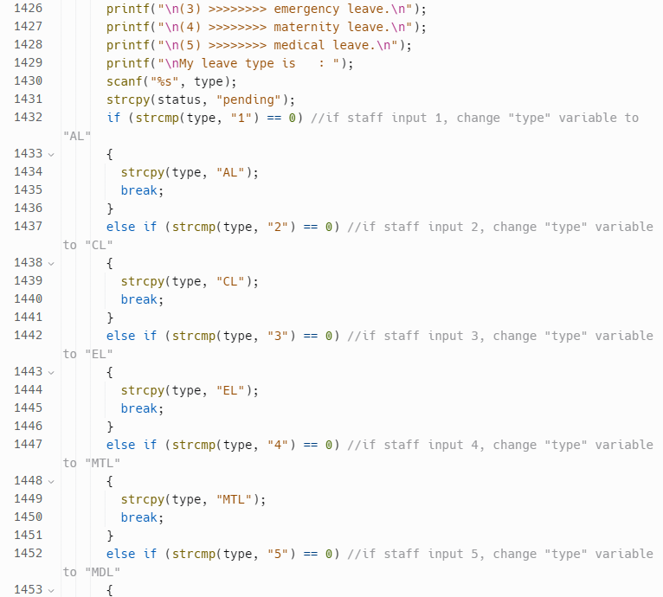 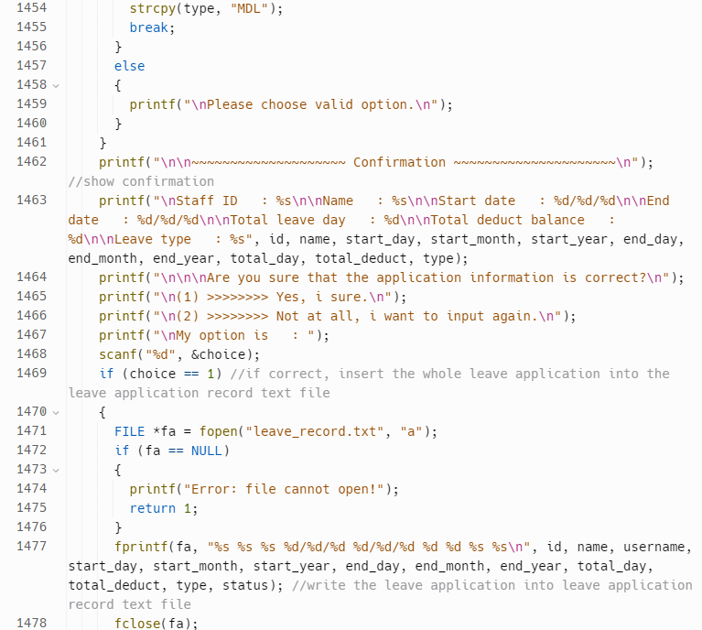 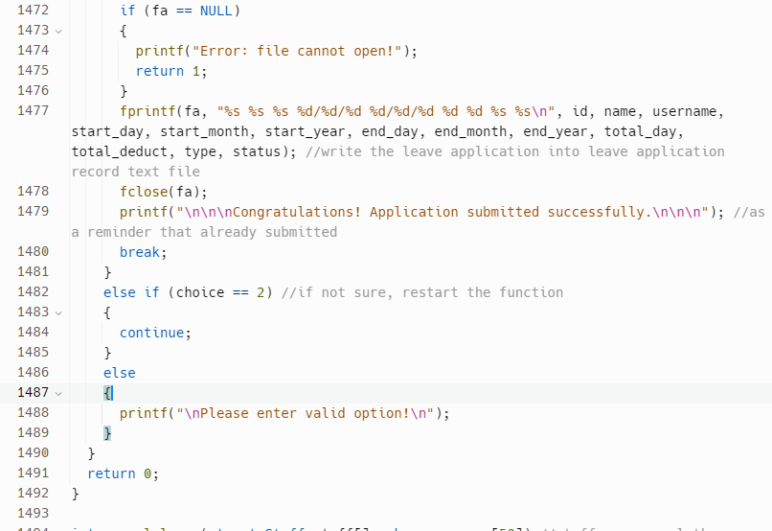 *Figure 4.5.9: leave_aplct function within main.c*

This function allows staffs to apply for leave. Firstly, it searches for any unapproved leave applications for the given staff username by iterating through the leave array and checking the status field. If a pending leave application is found, the function prints a message and returns 1, then exits the function.

If there are no unapproved leave applications, the function prompts the staff to enter their ID and name for confirmation. It then asks the staff to enter the start date for the leave, performing various checks to ensure that the date is valid. After the start date is entered, the function prompts the staff to enter the end date for the leave. It performs similar checks on the end date to ensure that it is valid.

The function calculates the total number of holidays that fall within the leave period by iterating through the holiday array and checking whether each leave day falls within the leave period. Afterward, It calculates the total number of days that need to be deducted from the staff's leave balance. Next, the function prompts the staff to select a leave type.

Finally, the function asks the staff to confirm their leave information. If it is correct, it will write the updated leave array to the file and back to applicant menu.

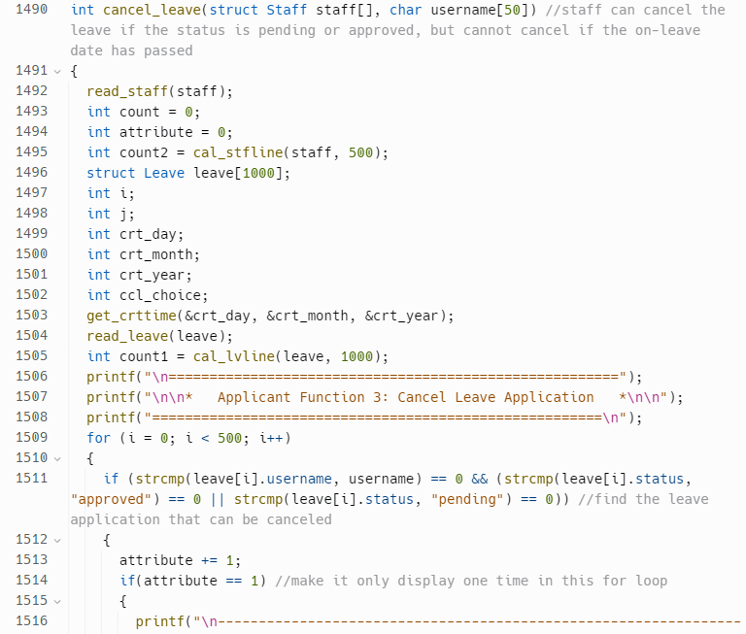 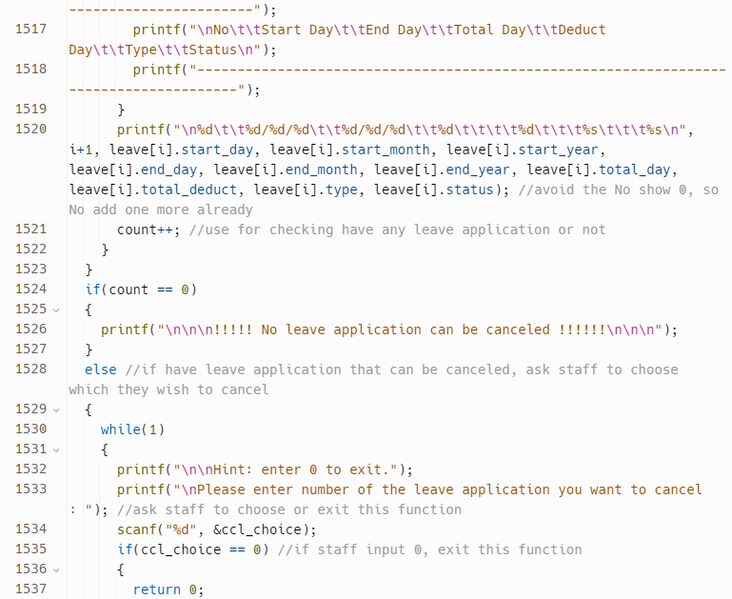 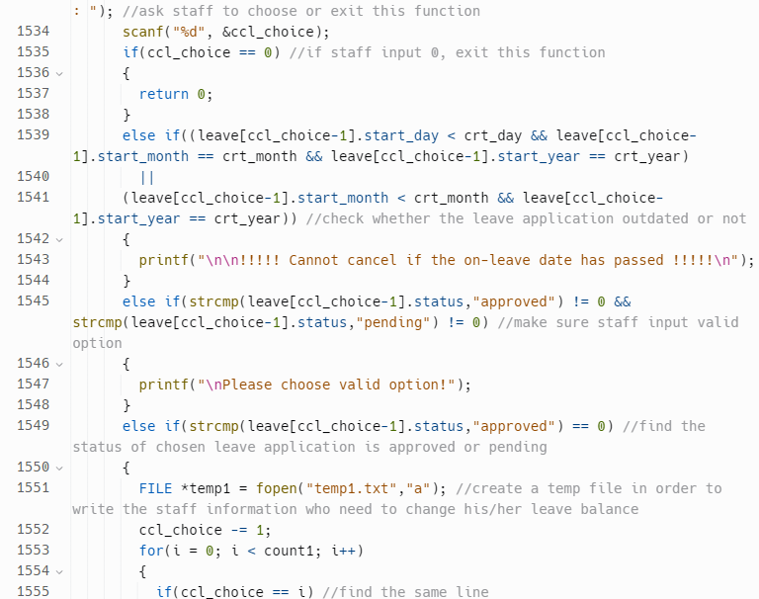 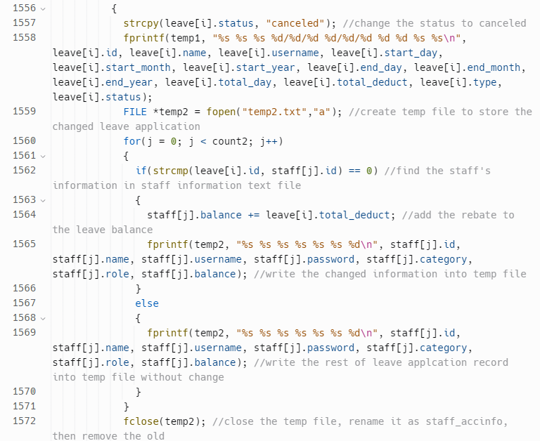 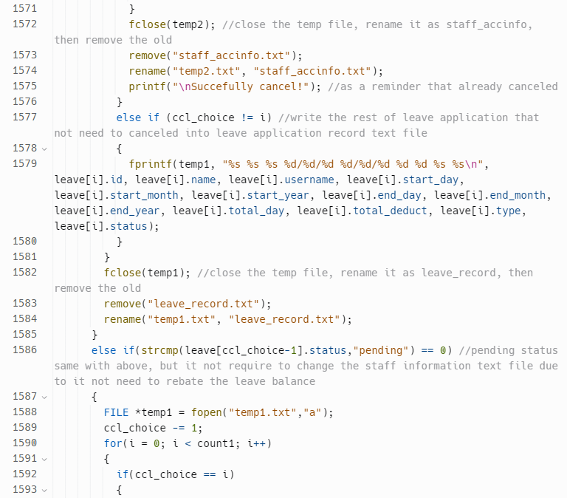 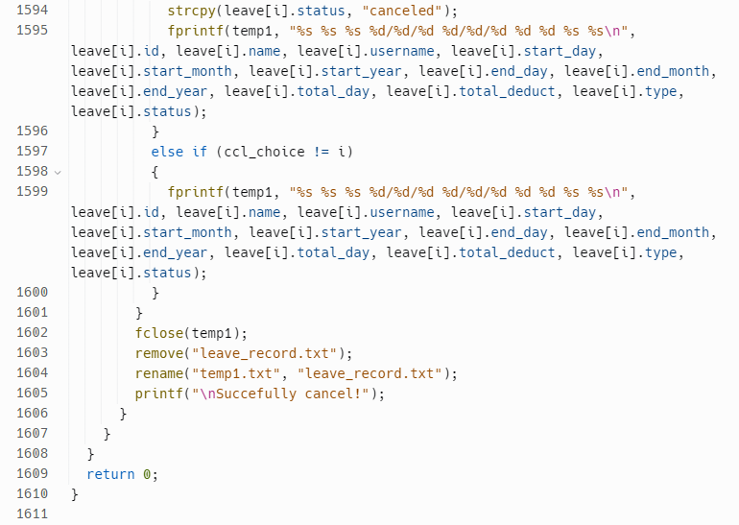 

*Figure 4.5.10: cancel_leave function within main.c*

This function appears to allow staff to cancel their leave application. It searches the leave application data for any applications that can be canceled by the staff and displays them.

If there are no applications that can be canceled, it prints a message to inform the staff. In contrast, it prompts the staff to choose an application to cancel.

If the user chooses an invalid option, the program prompts the user to choose again. If the user chooses a valid application, the program changes the status of the leave application to "canceled" and deducts the appropriate amount from the staff's leave balance. It then writes the updated information to two temporary text files and overwrites the original files with the contents of the temporary files.

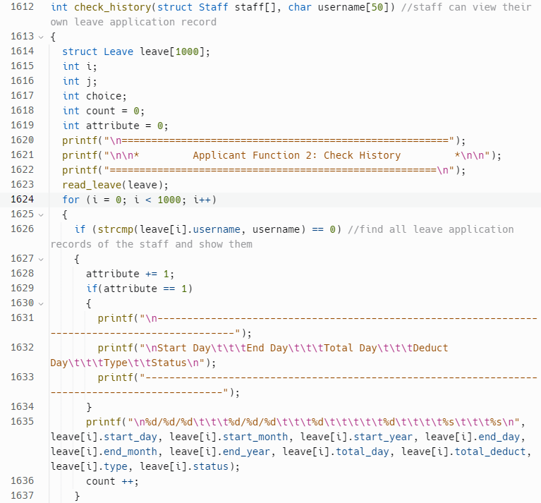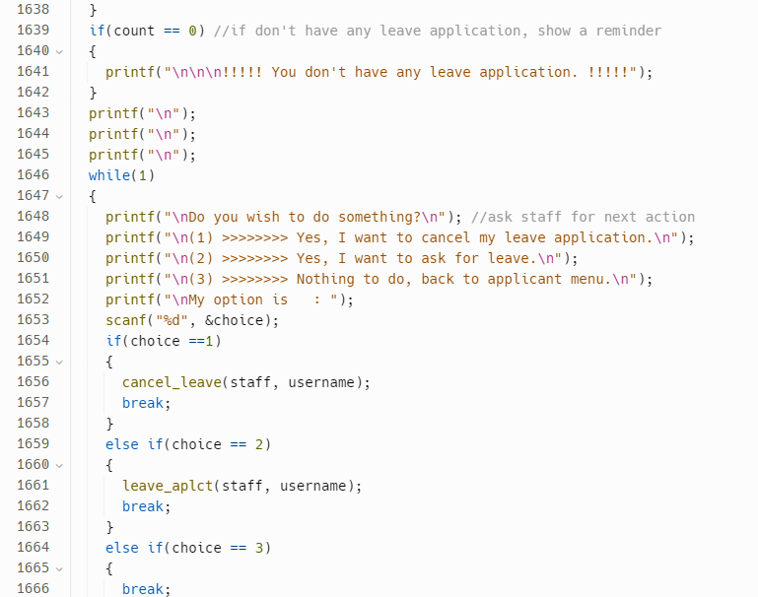 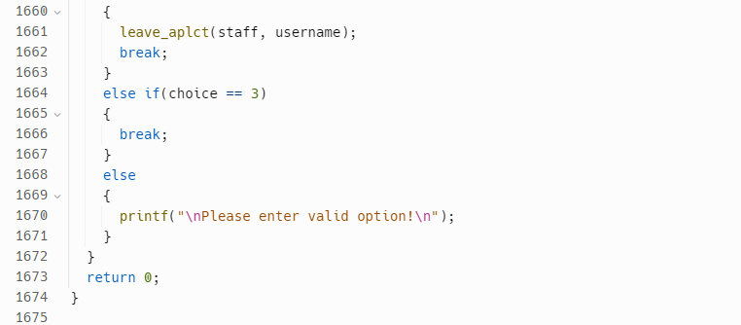

*Figure 4.5.11: check_history function within main.c*

This is a function that allows staff to view their own leave application records. It calls the read_leave() function to read all leave applications from a file into the Leave struct array. Then, it loops through the first 1000 leave applications and checks if the username of each leave application matches the given username. If it does, it displays the details of that leave application, including the start day, end day, total days, deduct days, type of leave, and status. If the staff has no leave applications, it shows a reminder message.

After displaying the leave application records, the function asks the staff if they want to cancel or ask for leave, or if they want to go back to the applicant menu. Depending on the staff's choice, the function either calls the cancel_leave() or leave_aplct() function to allow the staff to cancel or ask for leave respectively.

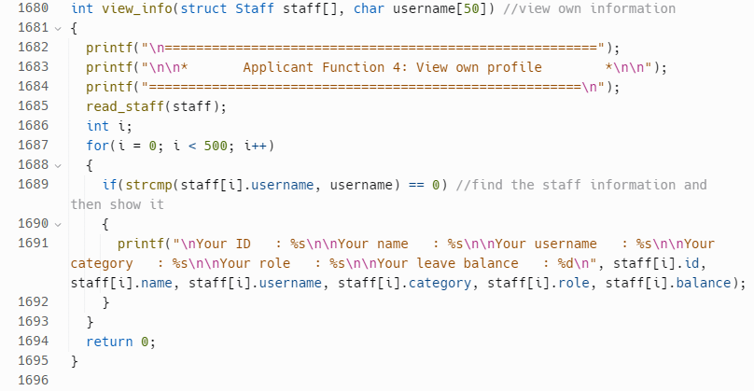

*Figure 4.5.12: view_info function within main.c*

The function then loops through the staff array to find the struct object with the matching username. Once the object is found, the function prints out the staff's ID, name, username, category, role, and leave balance using printf statements.

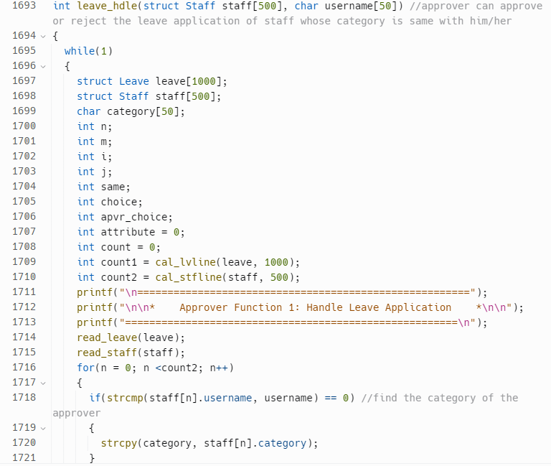 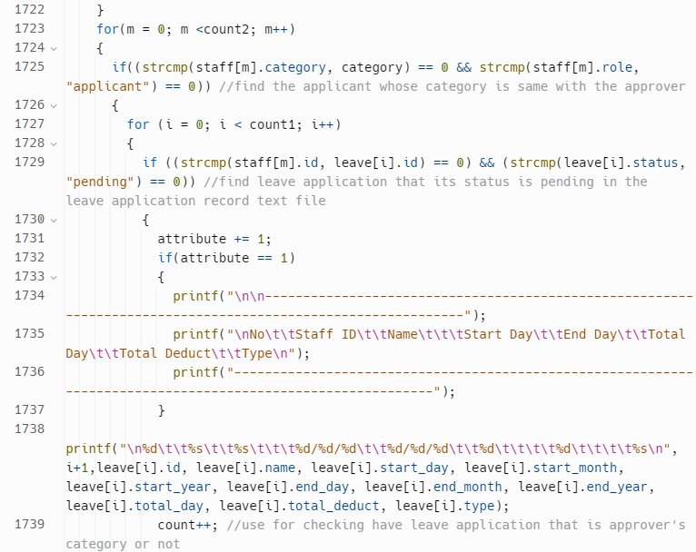 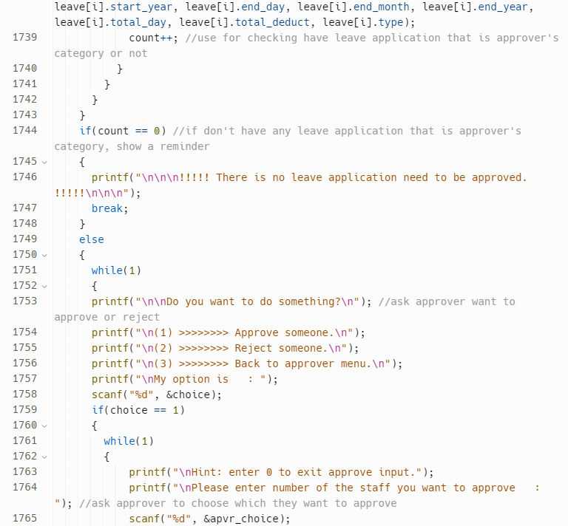 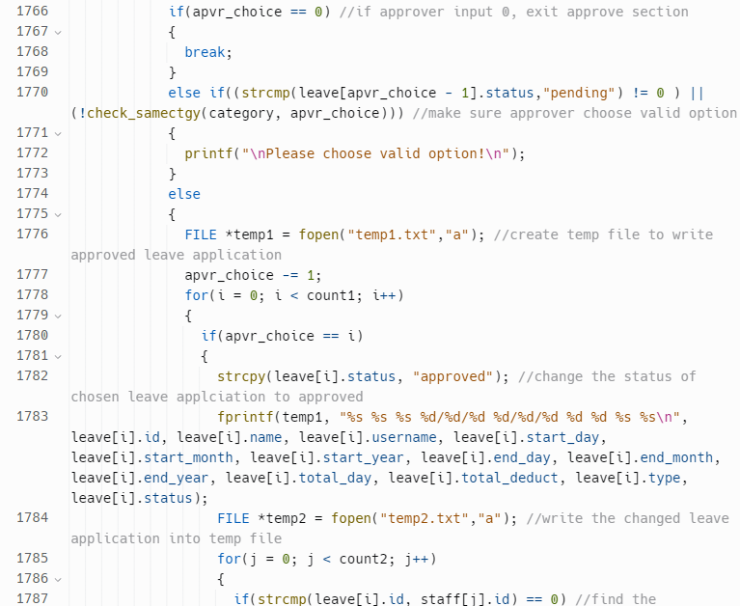 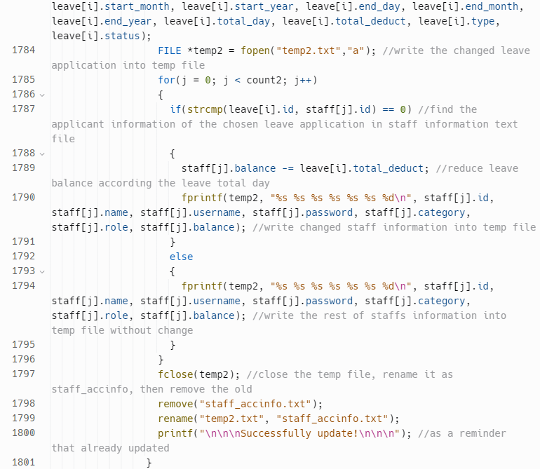 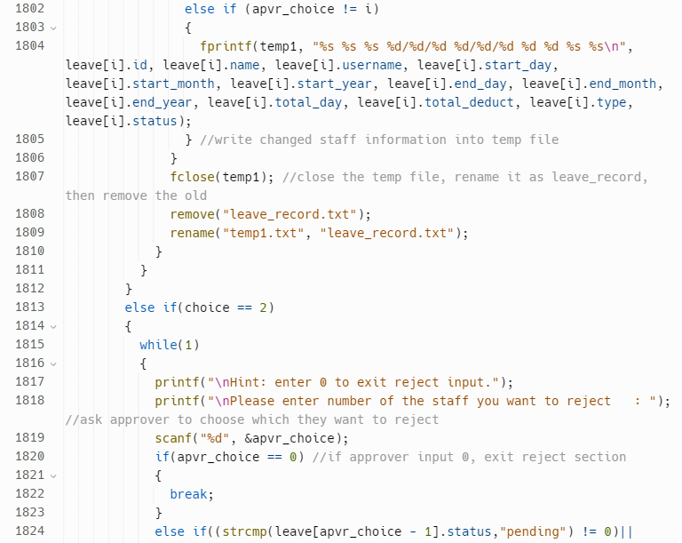 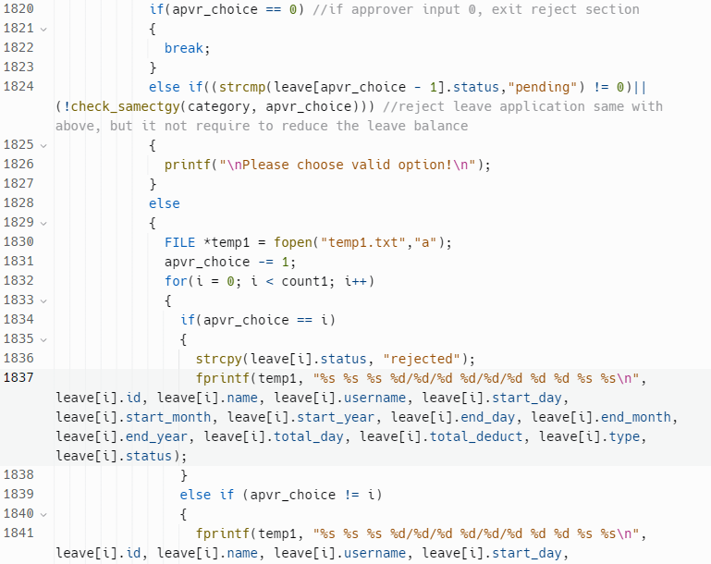 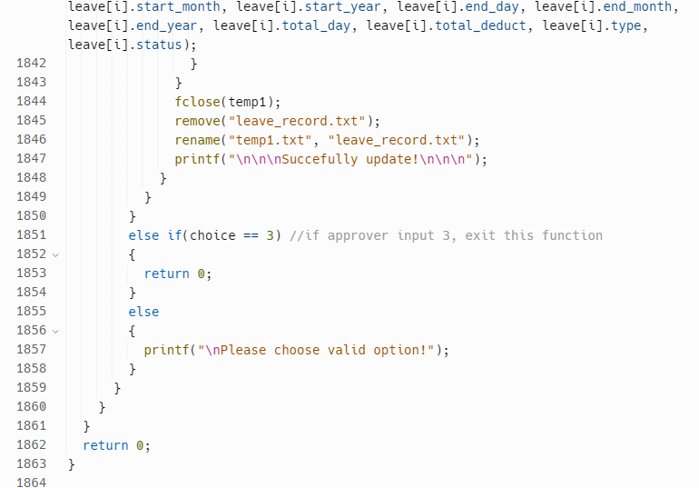 *Figure 4.5.13: leave_hdle function within main.c*

This is a function that handles the leave applications of staff whose category is the same as the approver. The program allows the approver to approve or reject a leave application.

The function reads staff and leave information from text files and displays the leave applications that need to be approved. The approver can then choose to approve or reject a leave application. If the approver chooses to approve a leave application, the program changes the status of the leave application to "approved," and the program reduces the leave balance of the staff who applied for the leave. If the approver chooses to reject a leave application, the program changes the status of the leave application to "rejected."

The function also creates temporary text files to write the updated leave and staff information, which are then used to update the original text files.

The program uses a while loop to continuously display the leave applications that need to be approved and to prompt the approver to choose to approve or reject a leave application. The program also uses nested loops to iterate over the staff and leave information to find the category of the approver, the applicants whose category is the same as the approver, and the leave applications that are pending and need to be approved.

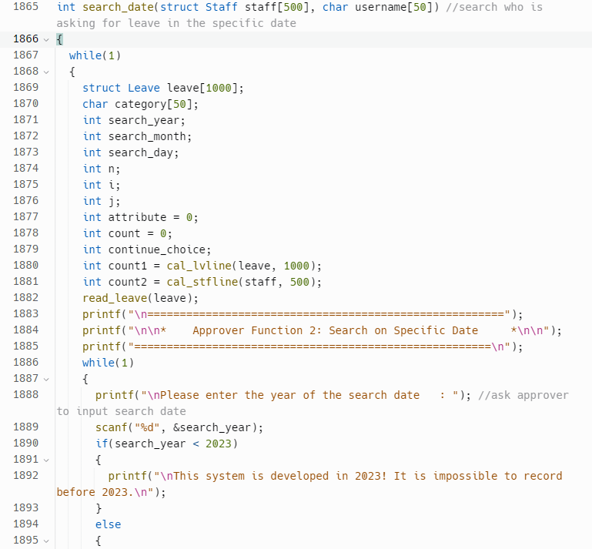 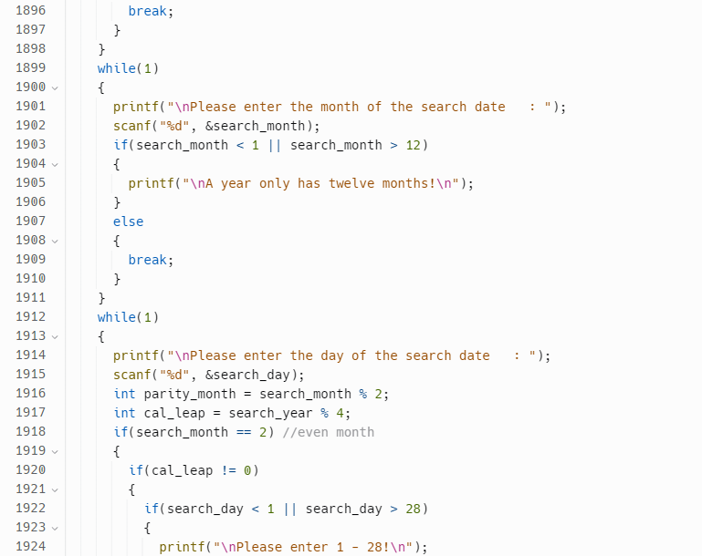 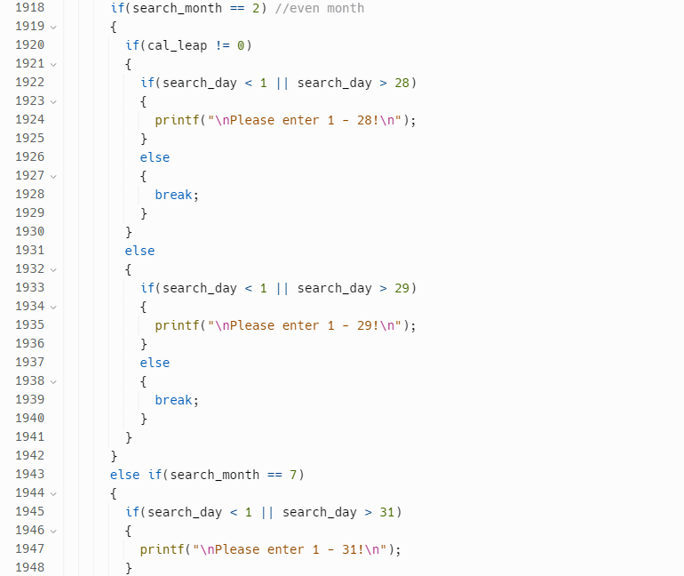 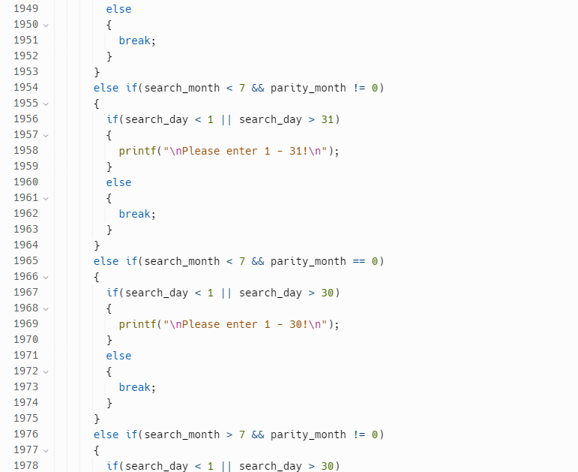 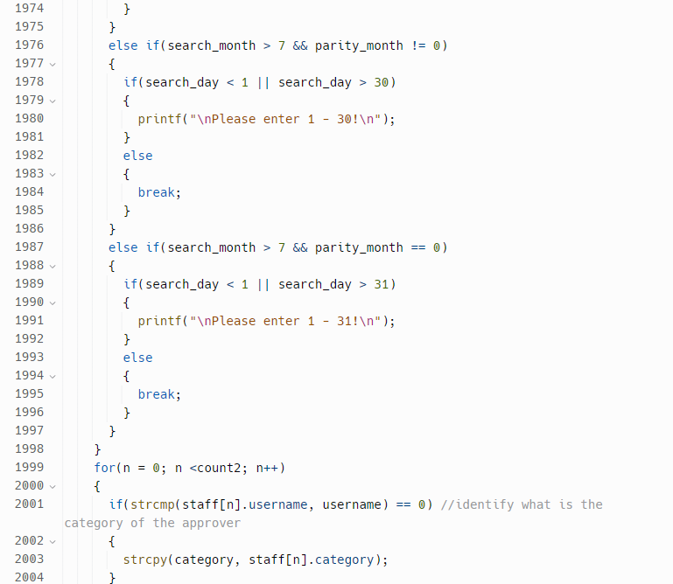 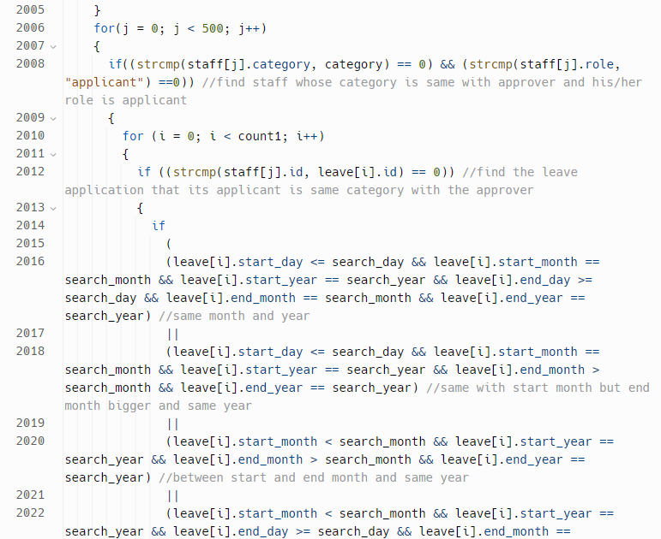 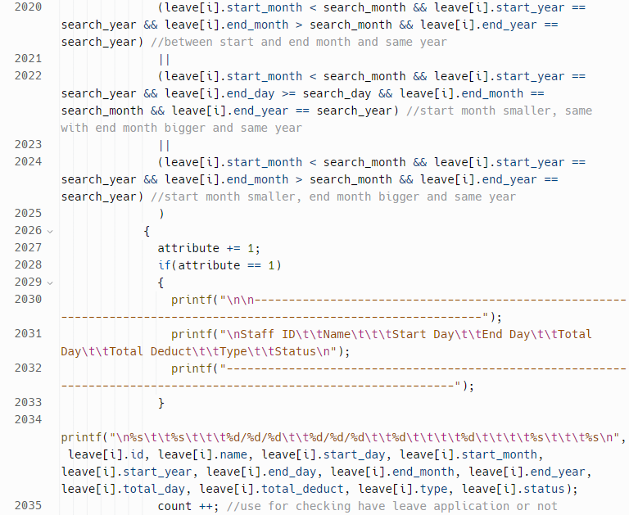 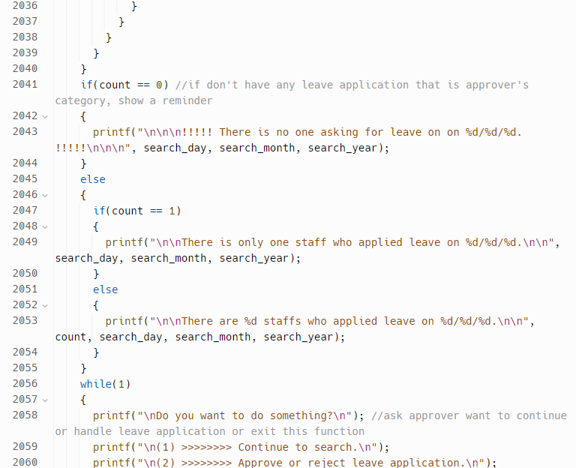

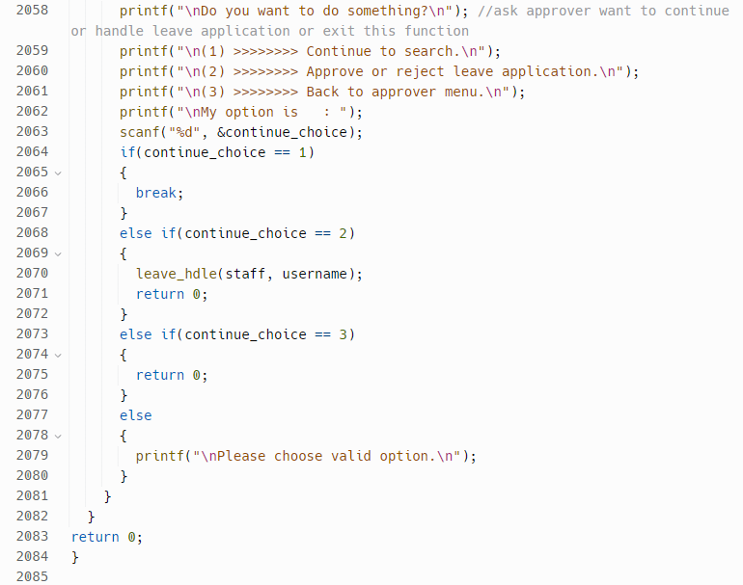

*Figure 4.5.14: search_date function within main.c*

This function can search for leave applications on a specific date that belong to staffs who have the same category as the approver, and whose role is applicant.

The function reads the search year, month, and day from the approver and validates them. It then finds the category of the approver by matching the username argument with the username field in the staff array.

Next, it loops through the staff array to find all staffs with the same category as the approver and whose role is "applicant". For each applicant found, it loops through the leave array to find all leave applications that belong to that applicant. It then checks if the leave applications are involved with the specific date being searched for, and if so, increments the count variable in order to show how much staff applied for that day.

After that, it requires the approver to choose for the next section, such as continue to search, handle leave application, and back to the approver menu.

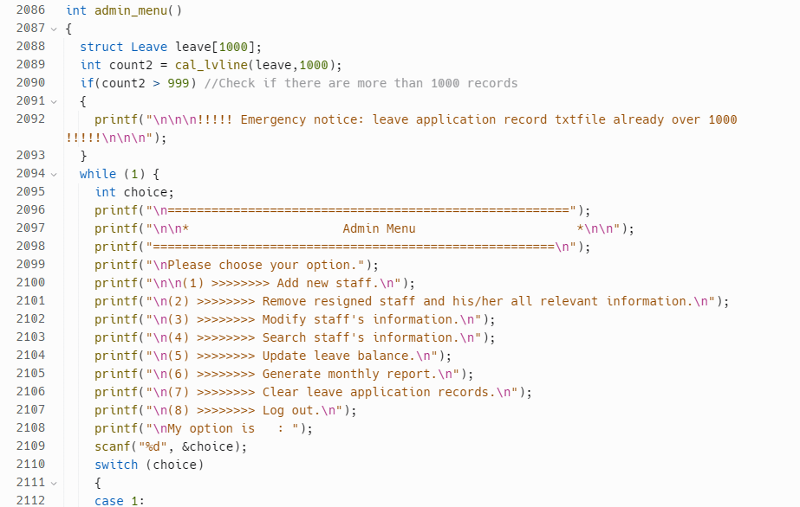 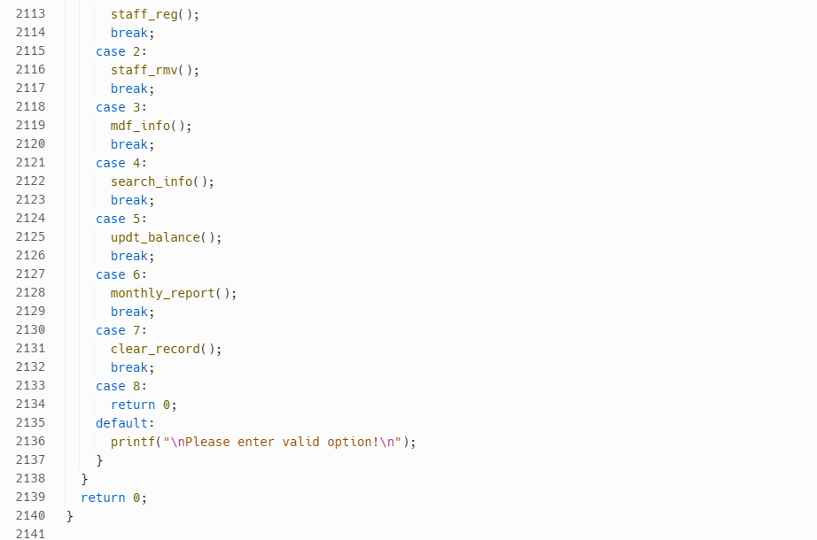

*Figure 4.5.15: admin_menu function within main.c*

This code defines a function named admin_menu() which provides a menu-driven interface for admin. It calculates the number of leave applications in the leave array and stores the result in count2.If count2 is greater than 999, a warning message is displayed to alert the administrator that the leave application record file has reached its capacity.

Afterward, it enters an infinite loop and displays a menu with various options, including adding a new staff, removing a resigned staff, modifying staff information, searching staff information, updating leave balances, generating monthly reports, clearing leave application records, and logging out.

The function waits for the admin to enter their choice and uses a switch statement to determine which action to take based on the admin's choice. If the user enters an invalid choice, a message is displayed informing them to enter a valid option. If the admin chooses to log out, the function returns 0 and exits the loop.

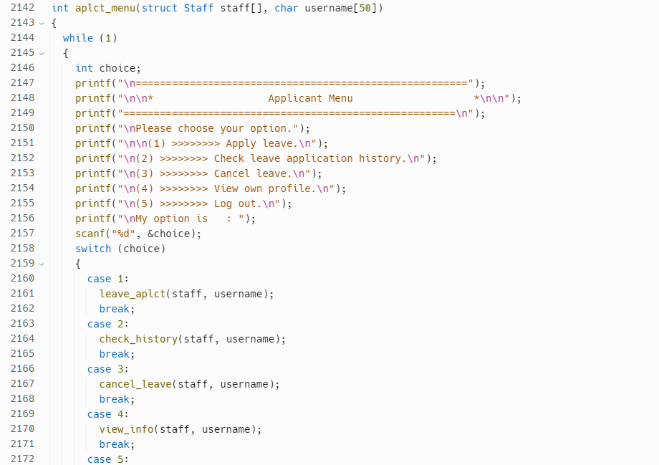 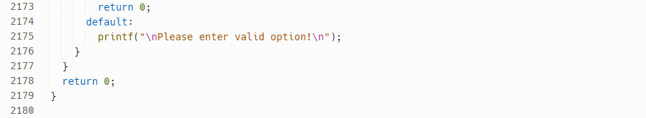

*Figure 4.5.16: aplct_menu function within main.c*

This code defines a function named aplct_menu() which provides a menu-driven interface for applicant. It enters an infinite loop and displays a menu with various options, including applying leave, checking own leave application history, canceling leave, viewing own profile, and logging out of the system.

The function waits for the applicant to enter their choice and uses a switch statement to determine which action to take based on the applicant 's choice. If the applicant enters an invalid choice, a message is displayed informing them to enter a valid option. If the applicant chooses to log out, the function returns 0 and exits the loop.

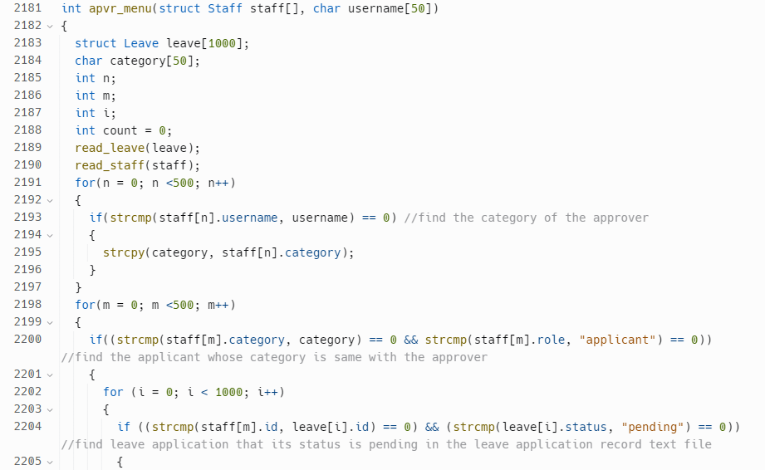

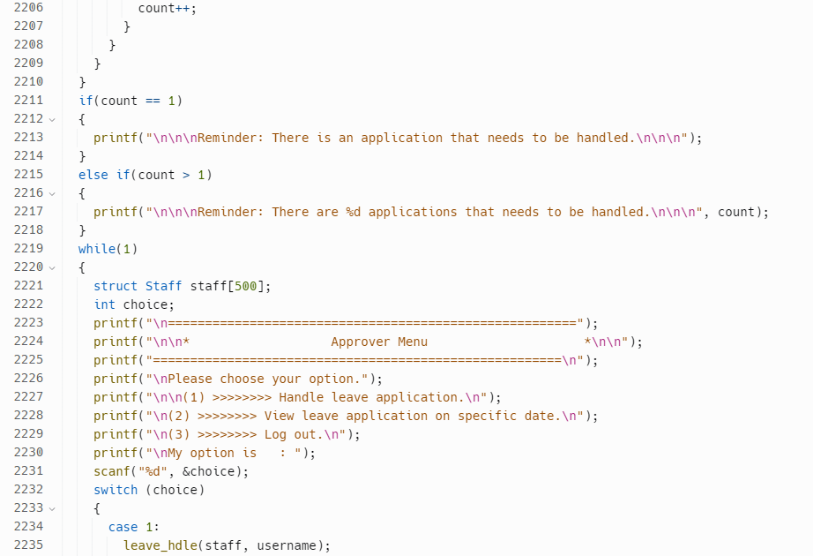

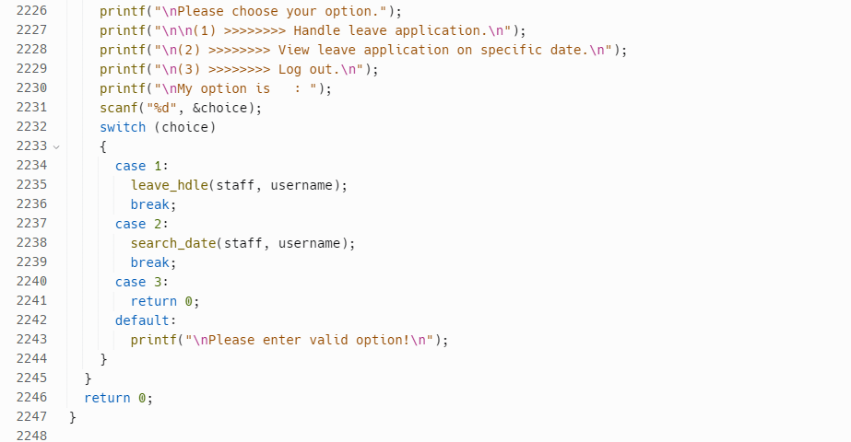

*Figure 4.5.17: apvr_menu function within main.c*

This code defines a function named apvr_menu() which provides a menu-driven interface for approver. It finds the category of the approver by searching through the staff records for the given username and copying the category into the category variable. It then searches through the staff records again to find all the applicants whose category matches the approver's category and searches through the leave application records to count the number of leave applications for these applicants that have a status of "pending" and display it if have.

After this, the function enters a while loop to display the menu options and take approver input. The menu options include handling leave applications, searching for leave applications on a specific date, and exit the system. The approver's input is captured using the scanf function and a switch statement is used to call the appropriate function based on the approver's choice.

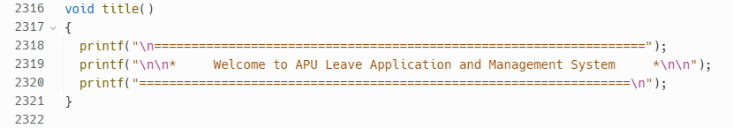 *Figure 4.5.18: title function within main.c*

Show title of the system by using printf statement.

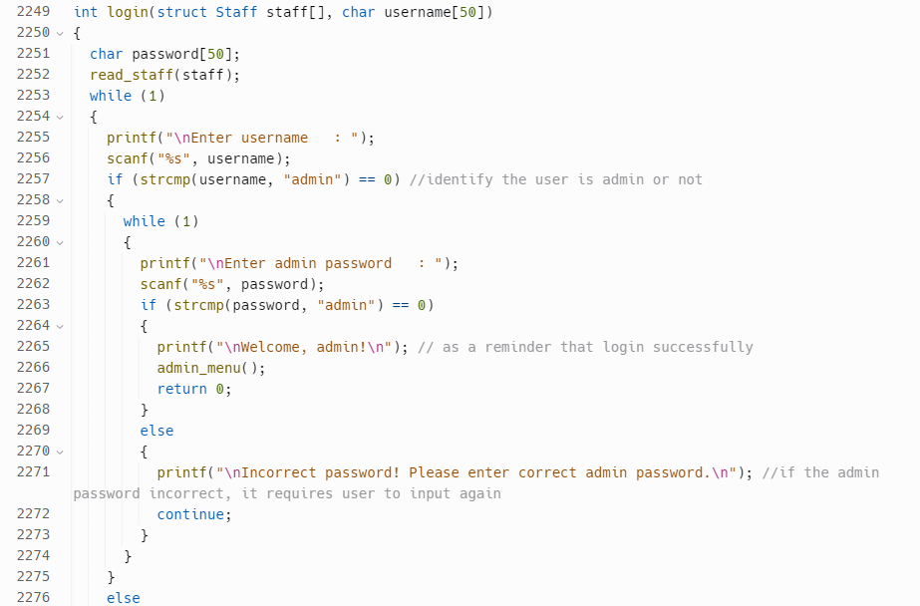 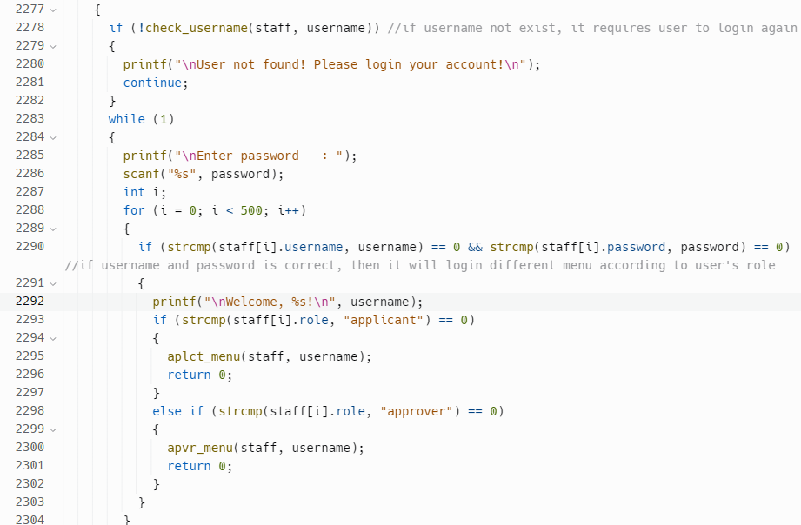 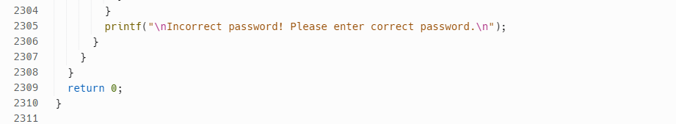 *Figure 4.5.19: login function within main.c*

This function is responsible for verifying the user's login credentials and directing the user to the appropriate menu based on their role.

It enters an infinite loop that prompts the user to enter their username.

If the username entered is "admin", the function enters another loop that prompts the user to enter the admin password. If the password entered matches the hard-coded admin password "admin", the function displays a welcome message and directs the user to the admin menu using the admin_menu function.

If the username entered is not "admin", the function checks if the username exists in the staff information read from the file using the check_username function. If the username does not exist, the function prompts the user to enter their login credentials again.

If the username exists in the staff information, the function enters another loop that prompts the user to enter their password. The function then iterates through the staff information to find a match for the entered username and password. If a match is found, the function displays a welcome message with the username and directs the user to the appropriate menu based on their role using either the aplct_menu or apvr_menu functions.

If the entered password does not match the staff information or no match is found for the entered username and password, the function prompts the user to enter their password again.

# **5.0 Screenshot of Sample Inputs/Outputs & Explanation**

## **5.1 Admin Functionalities**

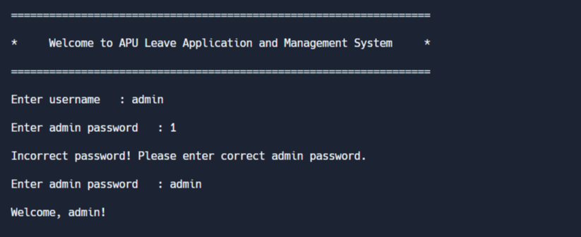

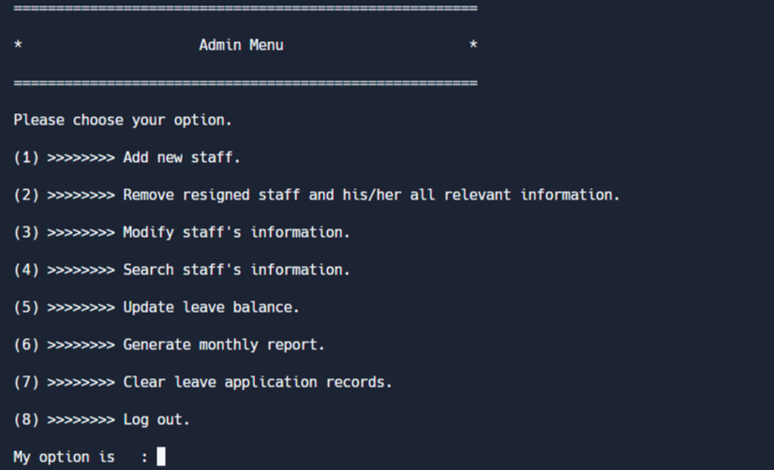

Figure 5.1.1: Login as admin

Once enabling this leave application and management system, it will prompt user to login in order to proceed to the next step. If you login as an admin, it will go directly to the admin menu where a lot of actions can be taken. The system will ask the user to enter again when the input of the admin password is wrong.

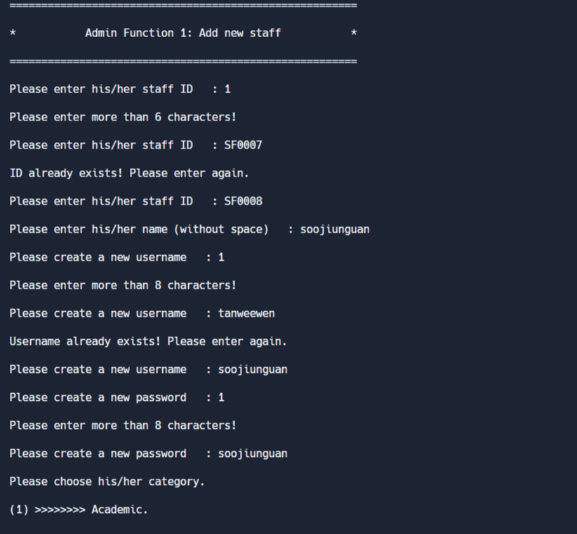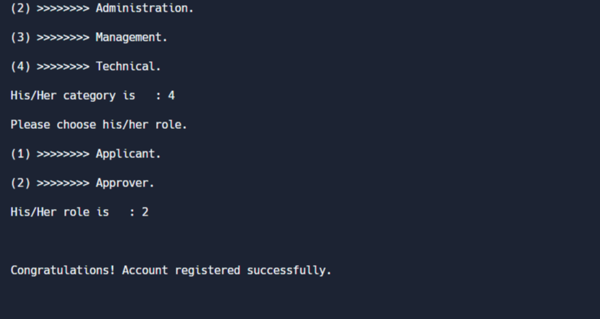

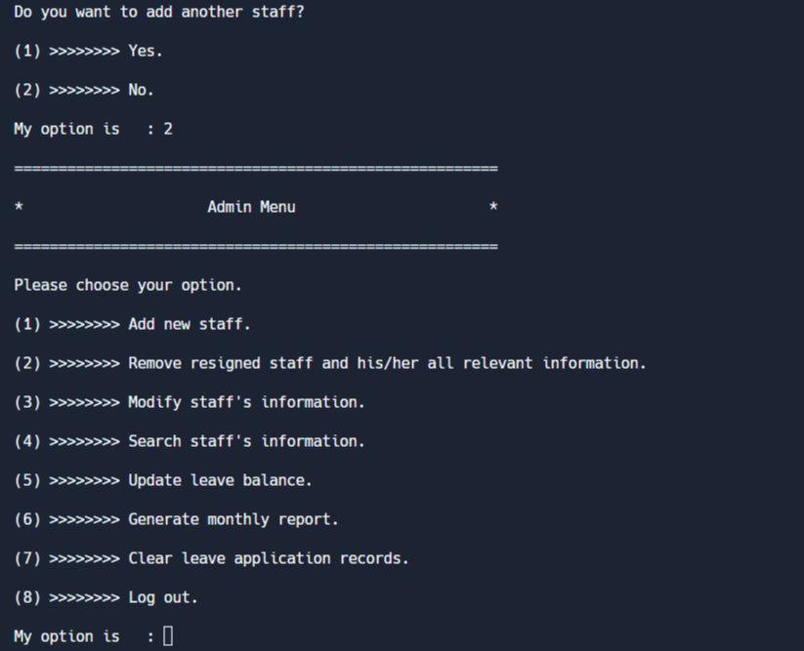

Figure 5.1.2 Admin Function 1: Add New Staff

If admin inputs 1 in the admin menu, it will go to staff registration function. This function requires admin to input ID, name, username, password, category and role. Due to each ID or each username only can belong to one staff, the system will ask admin to key in again if he inputs an existing ID or username. A success reminder will be shown if admin inputs valid information. Afterward, the system will ask the admin if another staff needs to be added.

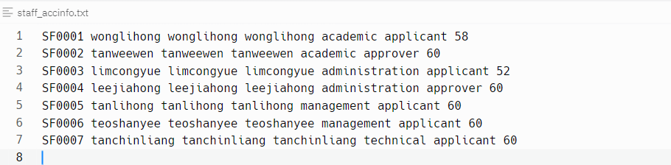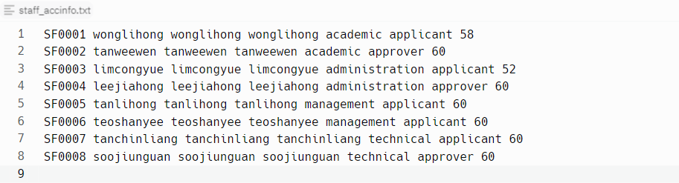

Figure 5.1.3: staff_accinfo.txt before adding new staff Figure 5.1.4: staff_accinfo.txt after adding new staff

The information of the staff that registered just now has been stored in the staff_accinfo.txt.

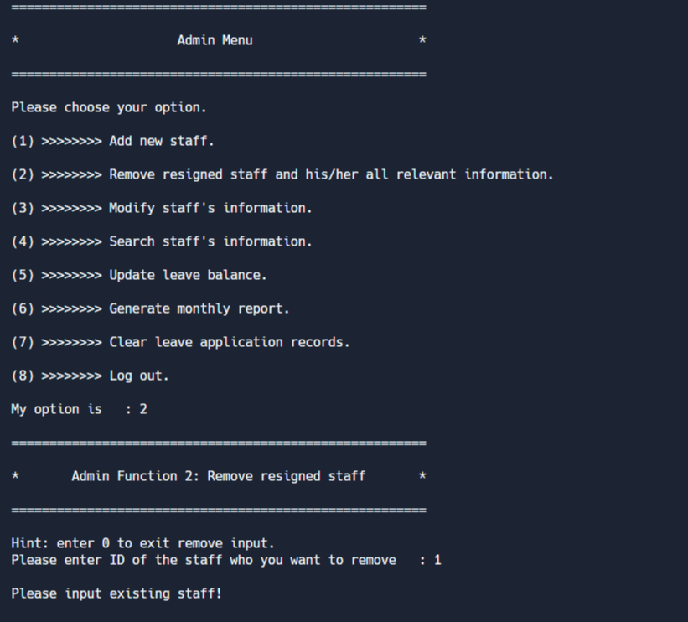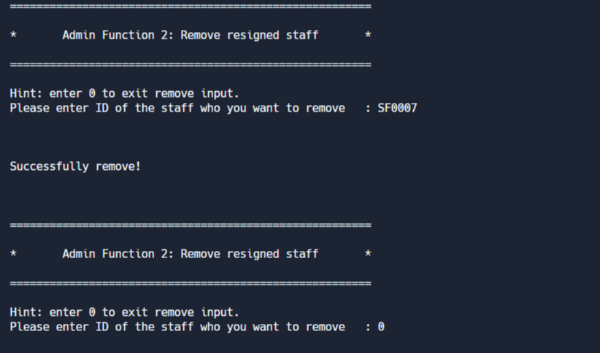

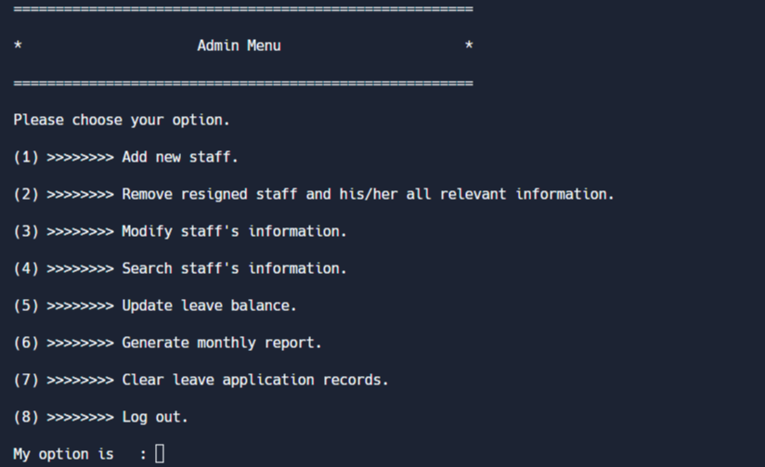

Figure 5.1.5: Admin Function 2: Remove Resigned Staff

If admin input 2 in the admin menu, it will go to staff removal function. It requires admin to input ID of the resigned staff. If admin input non-existent staff, it will ask admin to input again. In contrast, it will show a reminder that successfully removed. If the admin chooses not to remove another staff, they can enter 0 to exit this function and return to the admin menu.

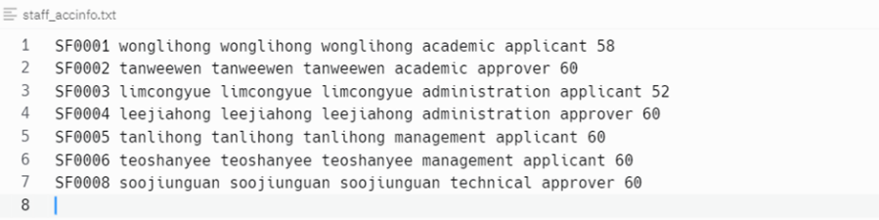

Figure 5.1.6: staff_accinfo.txt before removing resigned staff Figure 5.1.7: staff_accinfo.txt before removing resigned staff

The information of the resigned staff will be removed from the staff_accinfo.txt.

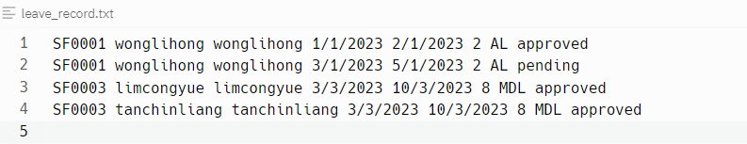 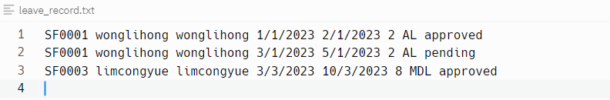

Figure 5.1.8: leave_record.txt before removing resigned staff Figure 5.1.9: leave_record.txt before removing resigned staff

The leave application records of the resigned staff also will be removed from the leave_record.txt.

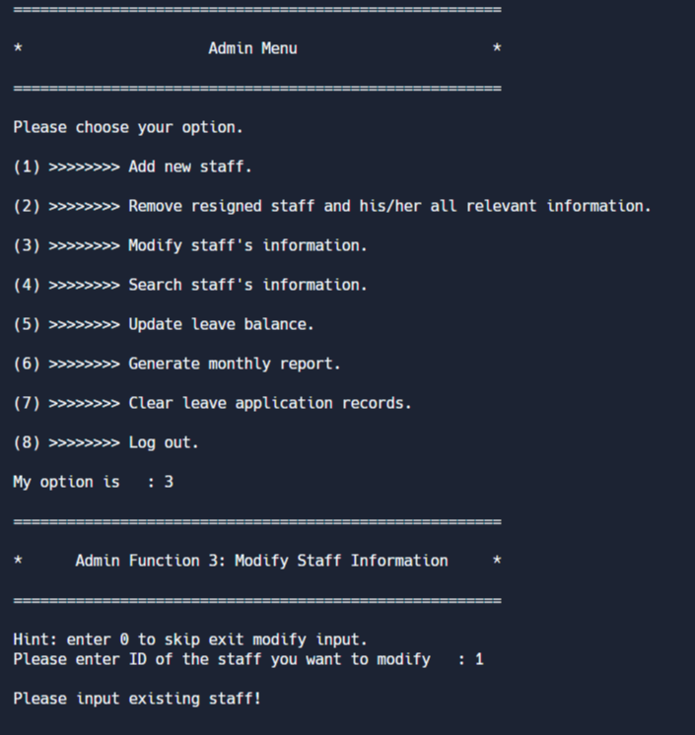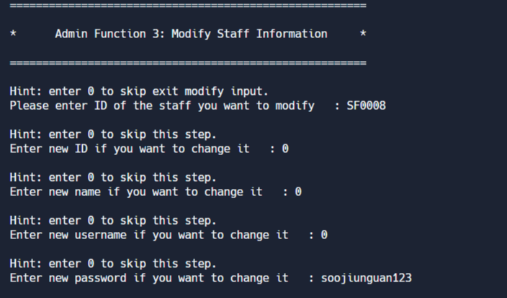

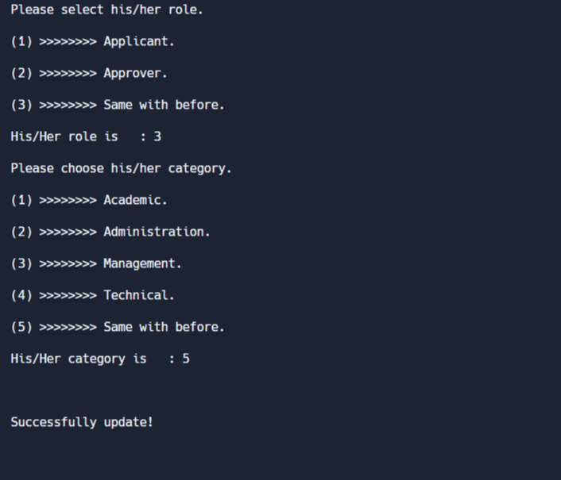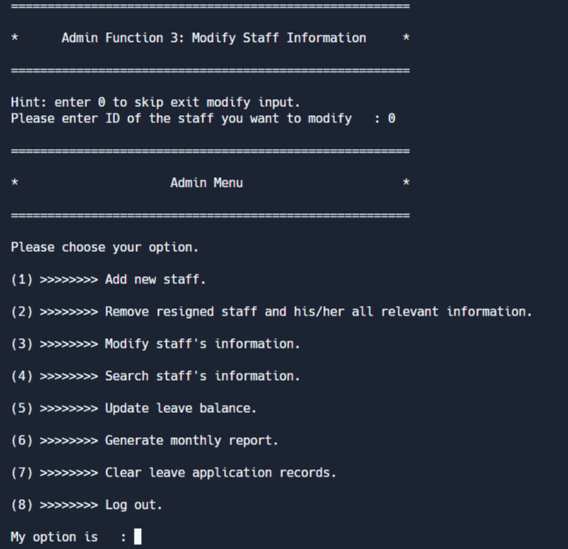



Figure 5.1.10: Admin Function 3: Modify Staff Information

If admin inputs 3 in the admin menu, it will go to modify staff information function. It requires admin to input ID of the staff that want to modify. If admin inputs non-existent staff, it will ask admin to input again. After that, admin can modify all information about the staff or returned to its original condition. When everything is done, it will show a reminder that successfully updated. If admin doesn’t wish to modify another staff, he can input 0 to exit this function and then back to admin menu.

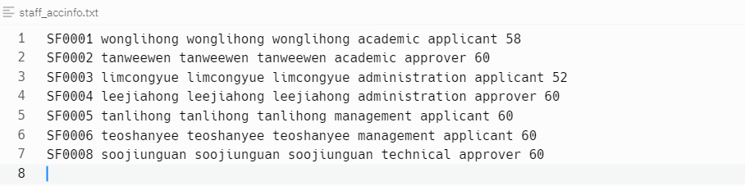

Figure 5.1.11: staff_accinfo.txt before modifying staff information

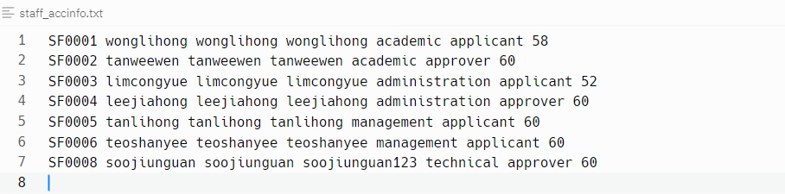

Figure 5.1.12: staff_accinfo.txt after modifying staff information

The information of the modified staff will be changed in the staff_accinfo.txt.

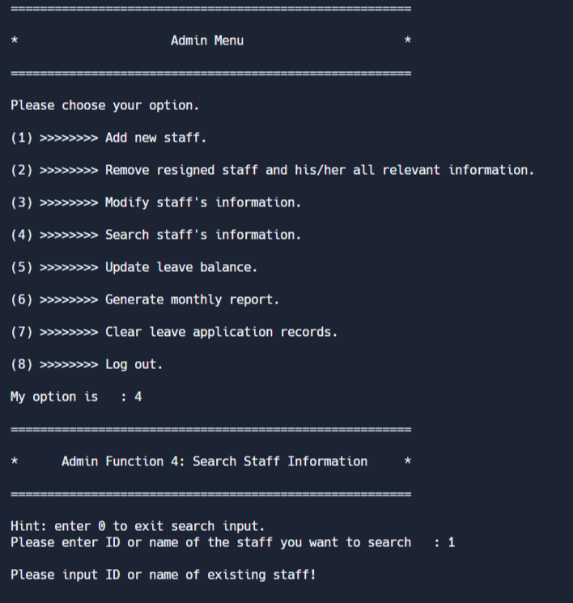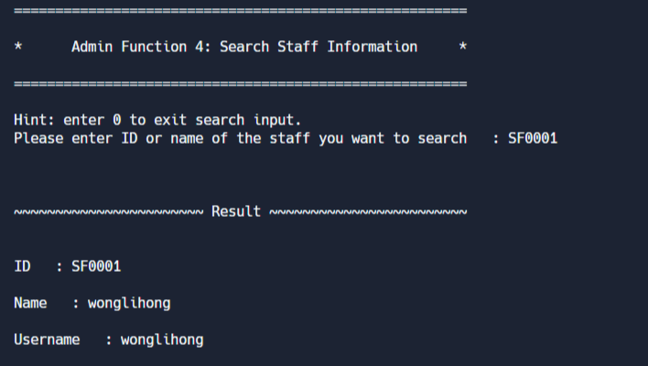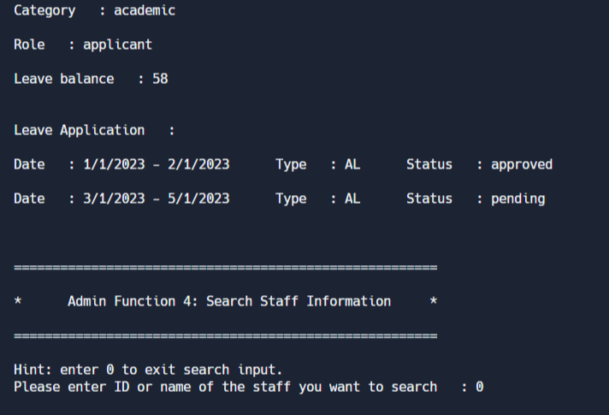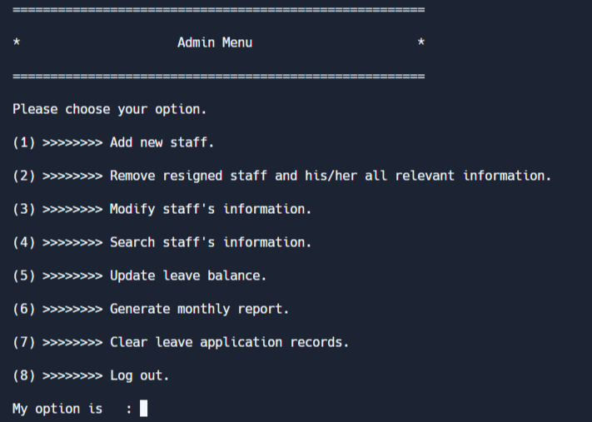

Figure 5.1.13: Admin Function 4: Search Staff Information

If admin inputs 4 in the admin menu, it will go to search staff information function. In this function, admin can search staff information by entering ID or name of the staff that wants to search. If admin inputs non-existent staff, it will ask admin to input again. It will show the search result which includes staff’s personal information and leave application records. Once the search is complete, the admin can choose to return to the admin menu by entering 0 if they do not wish to search for another staff.

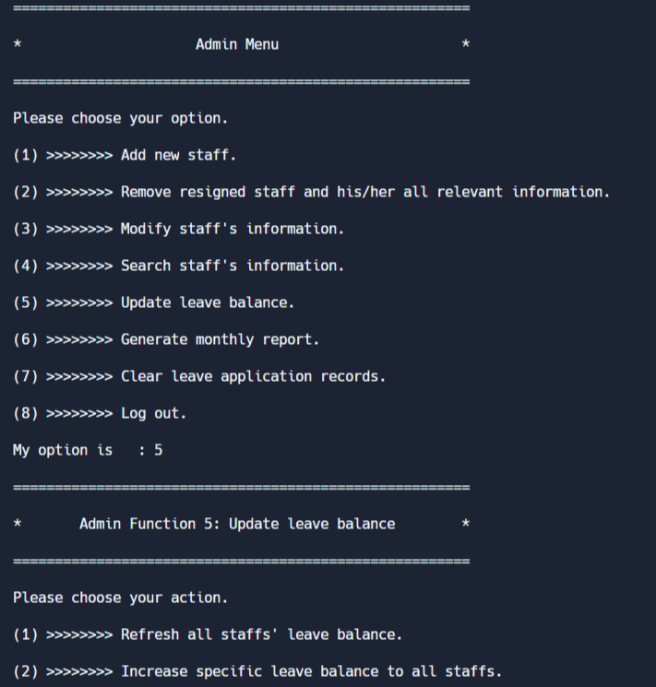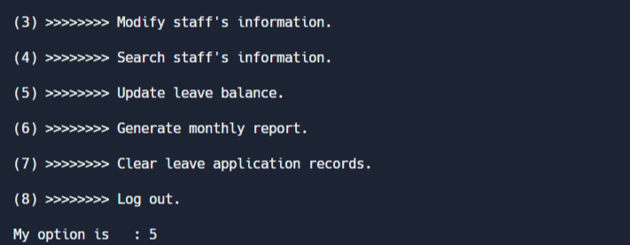

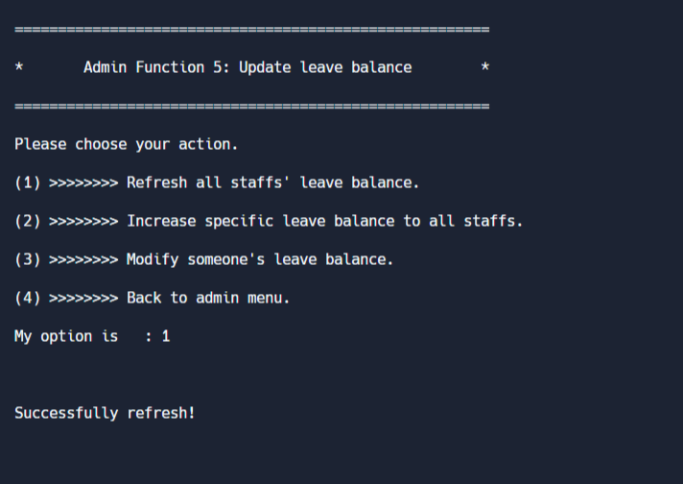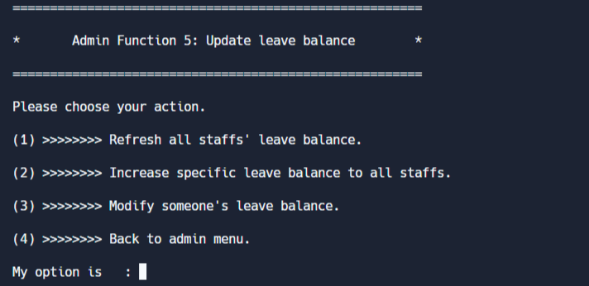

Figure 5.1.14: Refresh Leave Balance within Admin Function 5: Update Leave Balance

If admin inputs 5 in the admin menu, it will go to update leave balance function. In this function, admin can handle something regarding leave balance. If admin inputs 1 in update leave balance menu, it will refresh all staffs’ leave balance. Then, the reminder that has been updated successfully will be displayed. Subsequently, it will back to the update leave balance menu.



Figure 5.1.15: staff_accinfo.txt before refreshing leave balance

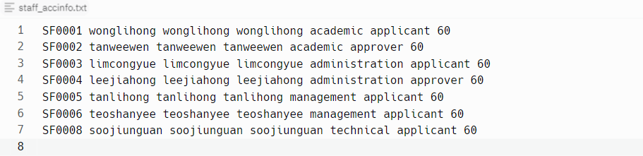

Figure 5.1.16: staff_accinfo.txt after refreshing leave balance

The leave balance of all staffs will be changed to the initial value (60) in staff_accinfo.txt.

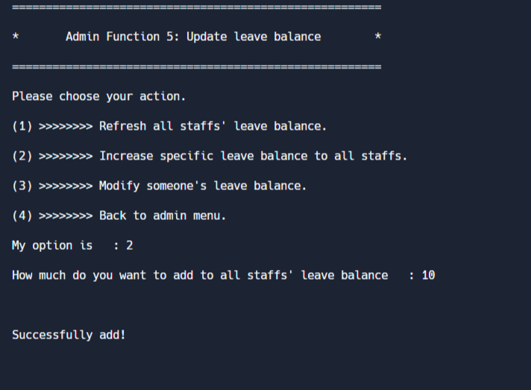

Figure 5.1.17: Increase Leave Balance of All Staff within Admin Function 5: Update Leave Balance

If admin inputs 2 in update leave balance menu, it will ask admin how much want to add to all staffs’ leave balance. A message will be shown as a reminder if successfully added.



Figure 5.1.18: staff_accinfo.txt before adding leave balance

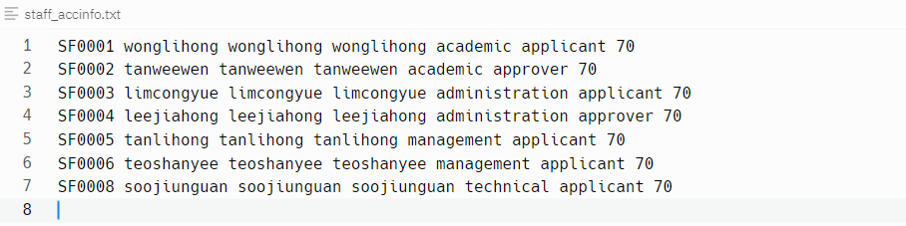

Figure 5.1.19: staff_accinfo.txt after adding leave balance

The leave balance of all staffs will increase by how much the admin enters.

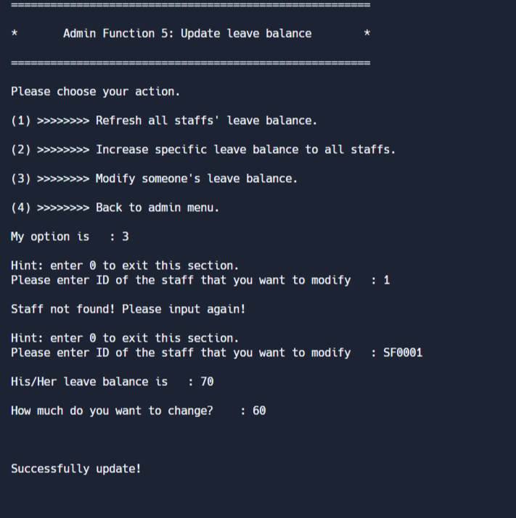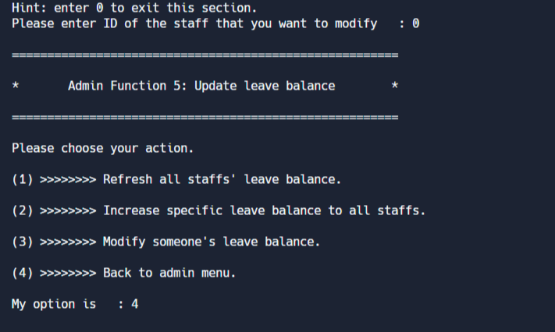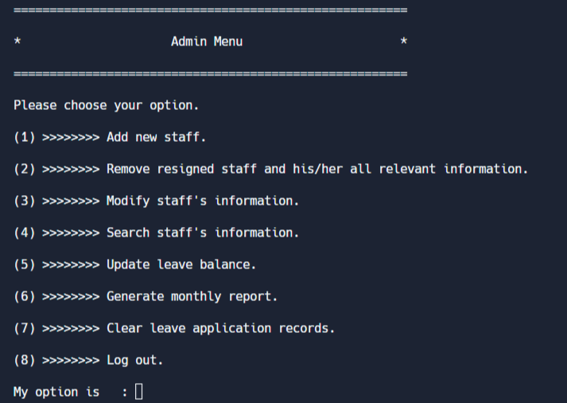

Figure 5.1.20: Modify Leave Balance within Admin Function 5: Update Leave Balance

If admin inputs 3 in update leave balance menu, it will ask admin to key in ID of the staff that want to modify his/her leave balance. In case the administrator enters the ID of a staff that does not exist, the system will prompt the admin to re-enter the staff’s ID. The current leave balance of the staff will be presented before requiring admin to input leave balance that he wants to change. Afterward, a reminder will be shown to notify leave balance was successfully updated. If admin doesn’t wish to modify another staff, he can input 0 to exit this section. Then, admin can input 4 in the update leave balance menu to back to the admin menu in order to move on to next function.



*Figure 5.1.21: staff_accinfo.txt before modifying leave balance*

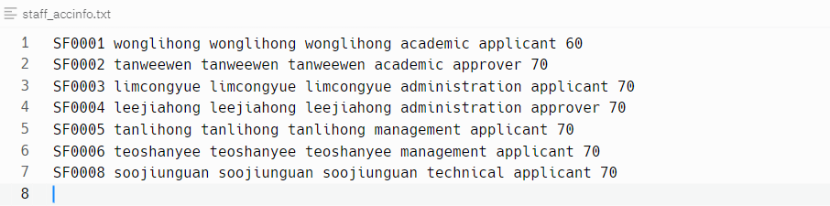

Figure 5.1.22: staff_accinfo.txt after modifying leave balance

The leave balance of specific staff will be changed in staff_accinfo.txt.

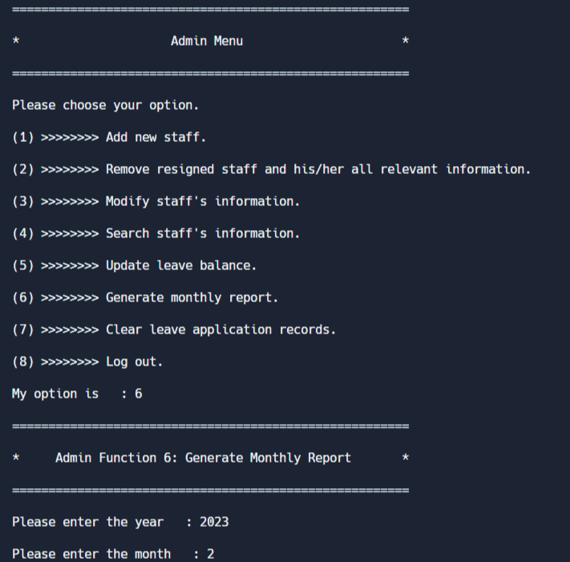



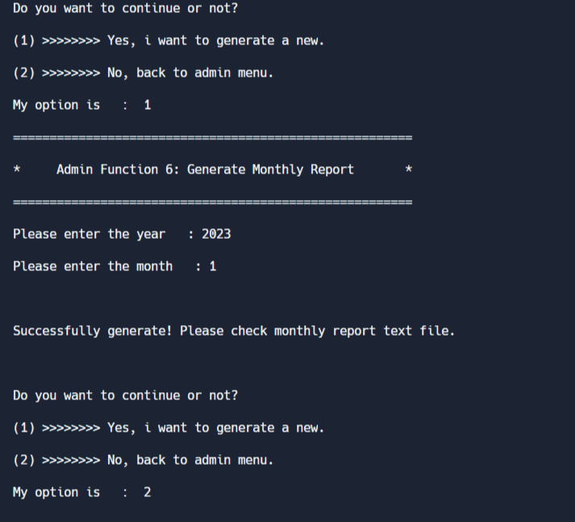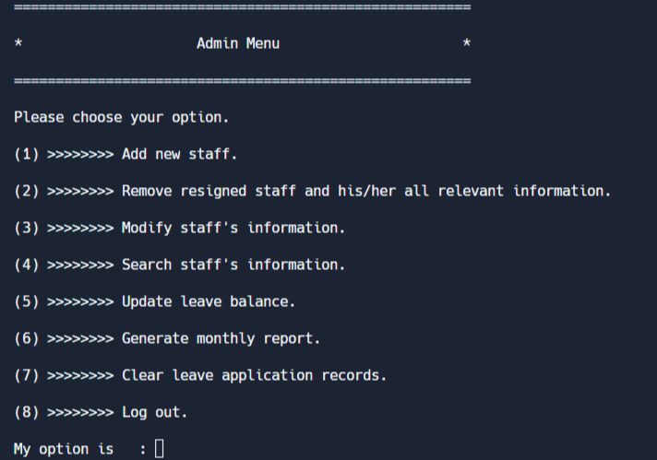

Figure 5.1.23: Admin Function 6: Generate Monthly Report

If admin inputs 6 in the admin menu, it will go to generate monthly report function. It will ask for the month and year of the monthly report that the system needs to generate. It will display different notices in pace with whether there is leave application for the date entered. After that, admin can choose to continue to generate another monthly report or not.

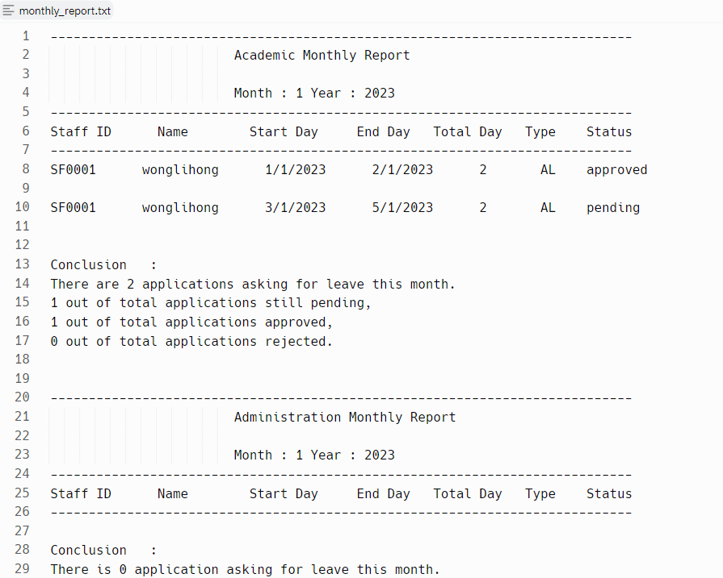

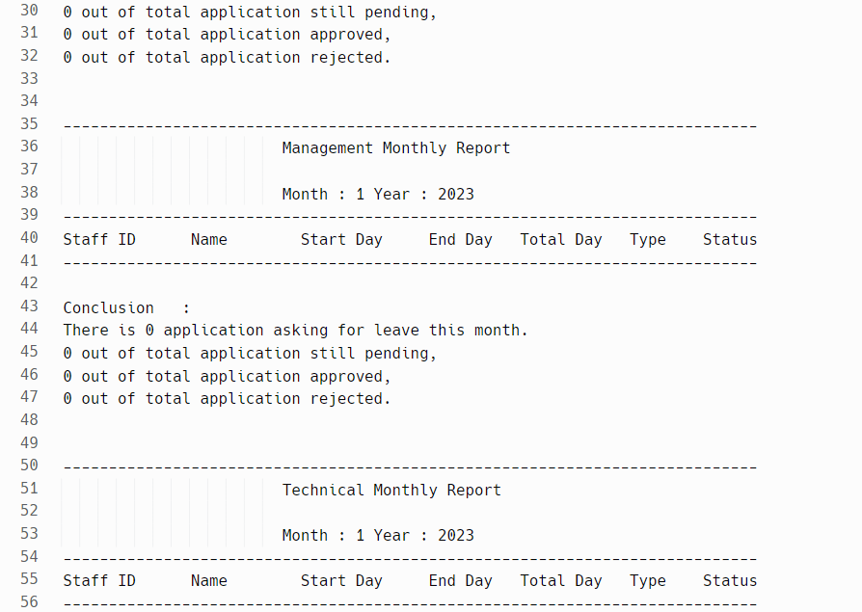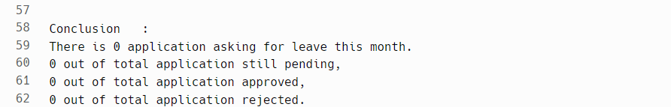

Figure 5.1.24: monthly_report.txt

The monthly report will be generated in the monthly_report.txt.

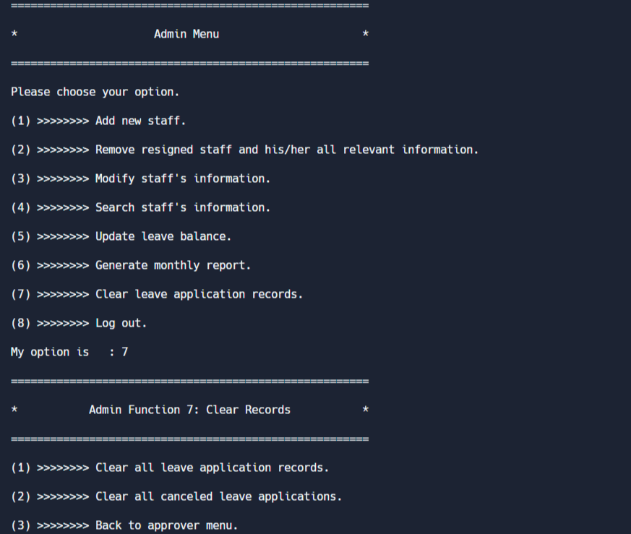 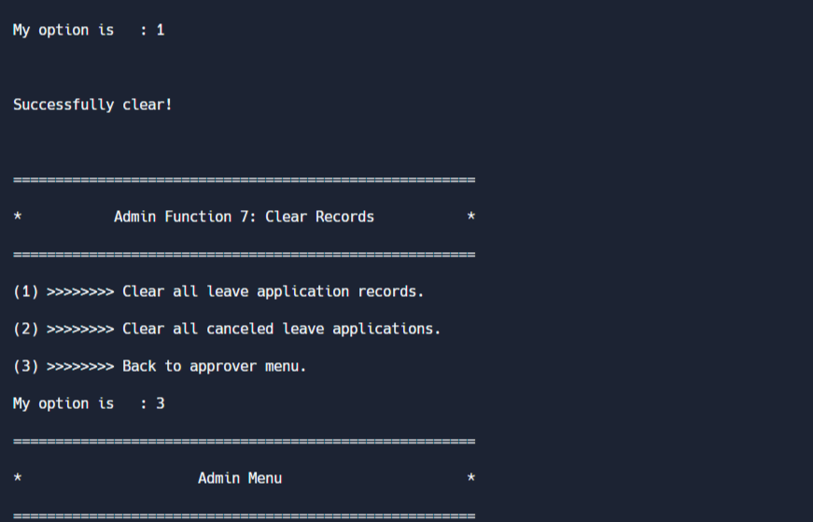 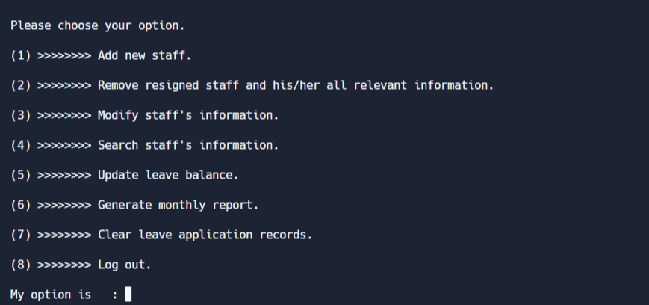

Figure 5.1.25: Admin Function 7: Clear Records

If admin inputs 7 in the admin menu, it will go to clear records function. In the clear records menu, admin can choose for selection of clear all leave application records or just the canceled leave applications. A reminder can be seen if the system has cleared already. After that, admin can back to admin menu by selecting the third option in clear records menu.

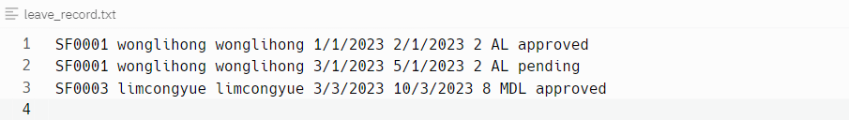

*Figure 5.1.26: leave_record.txt before clearing all leave application records*



*Figure 5.1.27: leave_record.txt after clearing all leave application records*

The records in leave_record.txt have already cleared after admin chooses the first option in the clear records function.

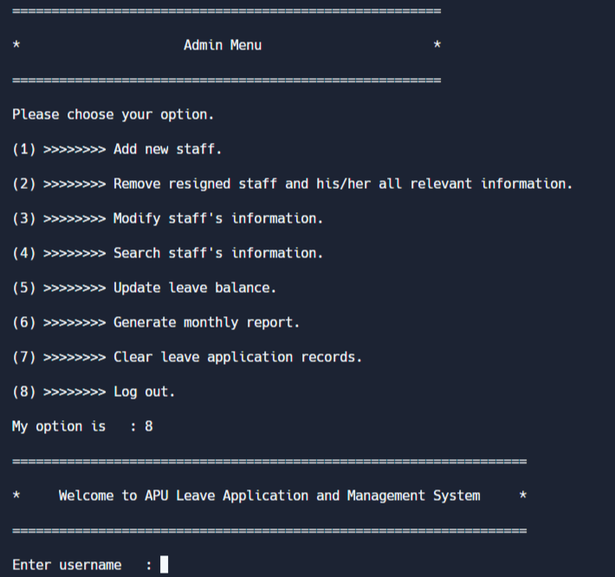

Figure 5.1.28: Admin Function 8: Log Out

If admin inputs 8 in the admin menu, it will back to the login section.

## **5.2 Applicant Functionalities**

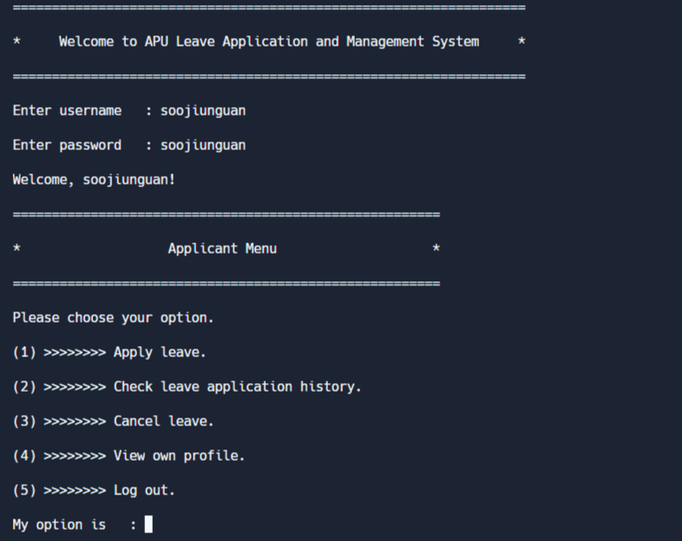

Figure 5.2.1: Login as applicant

If you login with an applicant account, it will go directly to the applicant menu, which allows staff performs actions related to leave matters.

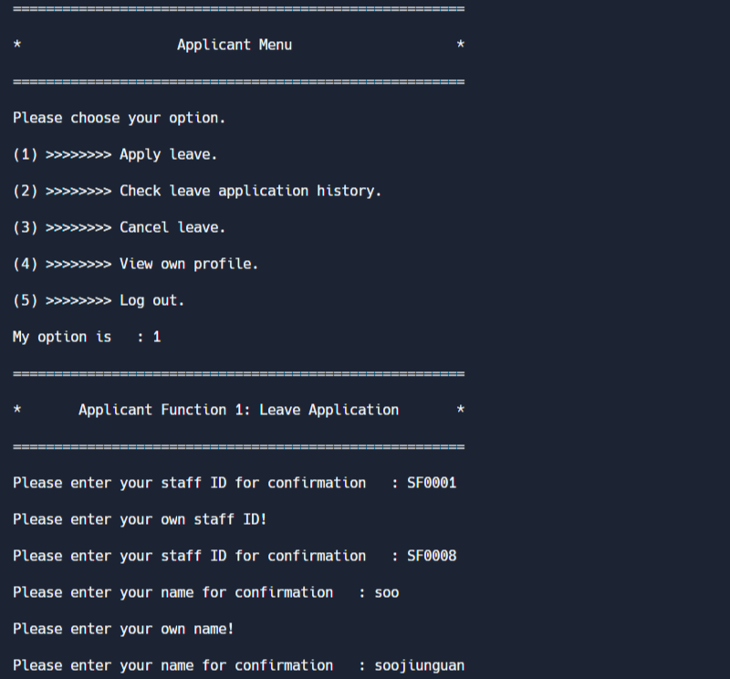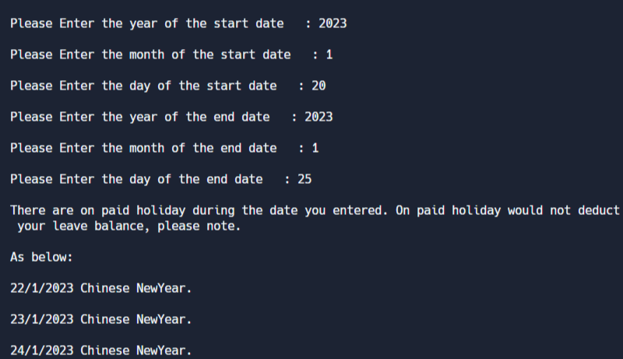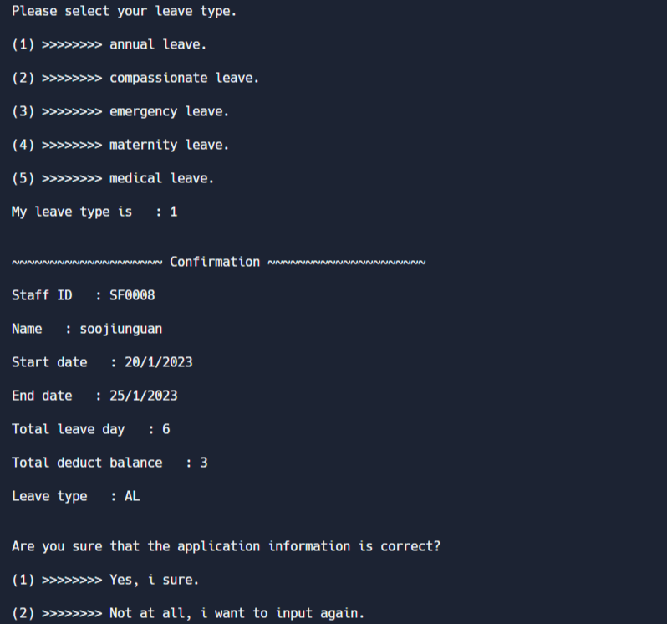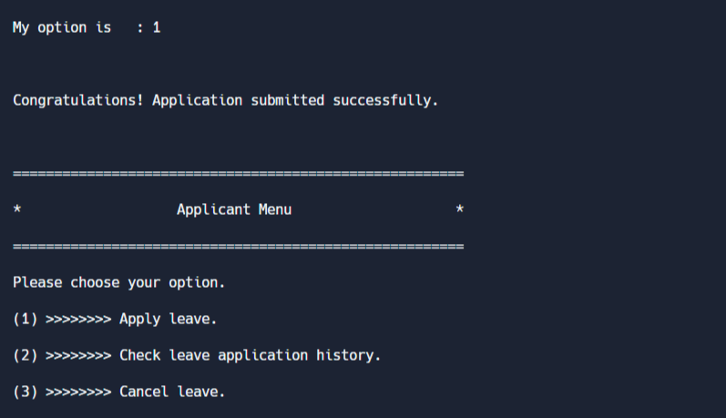

Figure 5.2.2: Applicant Function 1: Apply Leave

If applicant inputs 1 in the applicant menu, it will go to apply leave function. At first, applicant should input his/her ID and name. A wrong message would be displayed if the applicant doesn’t input his/her own ID or name. After that, a lot of questions about the leave application need to be answered by the applicant. If there are public holidays during the date of leave application, it will show how much day would not be deducted on applicant’s leave balance. When applicant confirm their information about his/her leave application is correct, it will show a success reminder and back to applicant menu.



Figure 5.2.3: leave_record.txt before applying leave



Figure 5.2.4: leave_record.txt after applying leave

The leave application will be uploaded to the leave_record.txt.

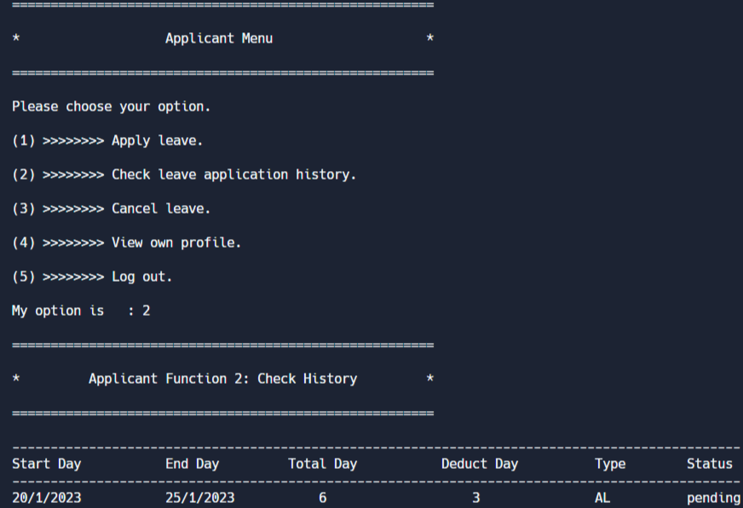 

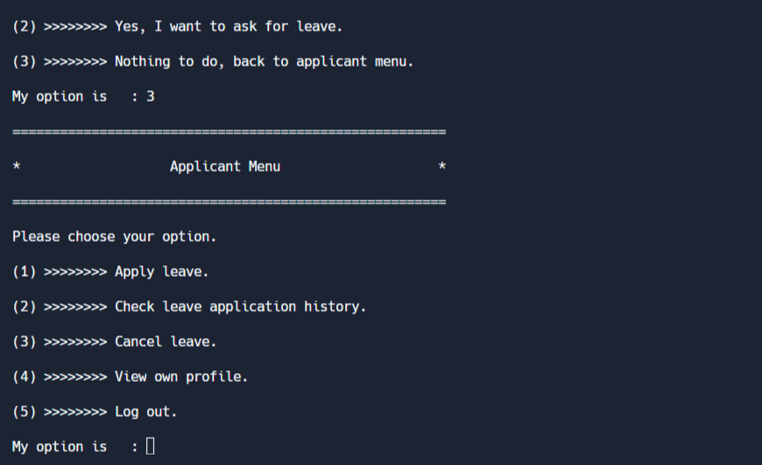

Figure 5.2.5: Applicant Function 2: Check History

If applicant inputs 2 in the applicant menu, it will go to check history function. All leave application record about the staff will be found here, which allow applicant to check the status of leave application and summary. Then, there are some actions that can be conducted such as cancel leave, apply leave or back to the menu.

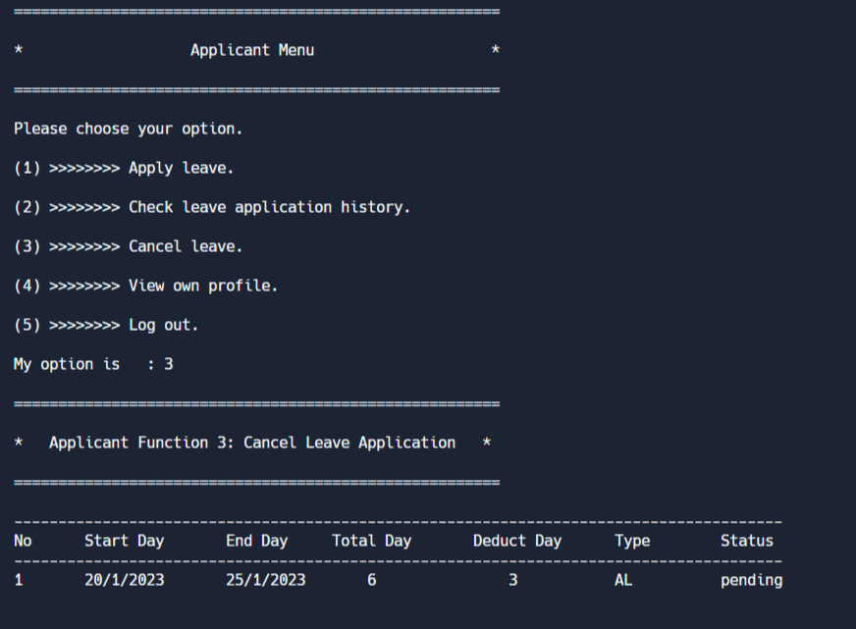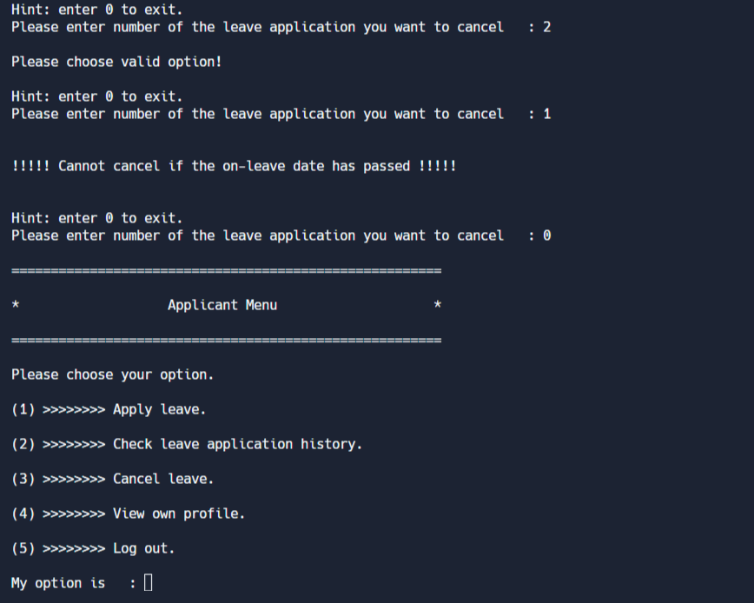

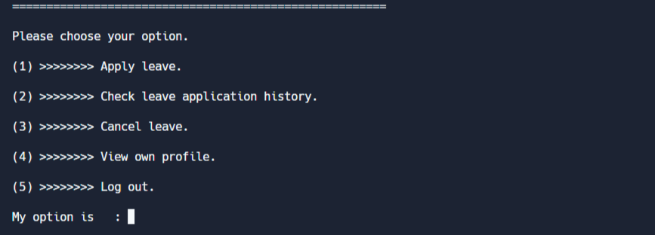

*Figure 5.2.6: Applicant Function 3: Cancel Leave*

If applicant inputs 3 in the applicant menu, it will go to cancel leave function. It will show the pending or approved leave application for applicant to choose which one he/she wishes to cancel. It will ask applicant to re-enter when staff enters a selection that is outside the permissible range. It is worth mentioning that cannot cancel if the date of the chosen leave application has passed. Then, applicant can enter 0 to exit this function.

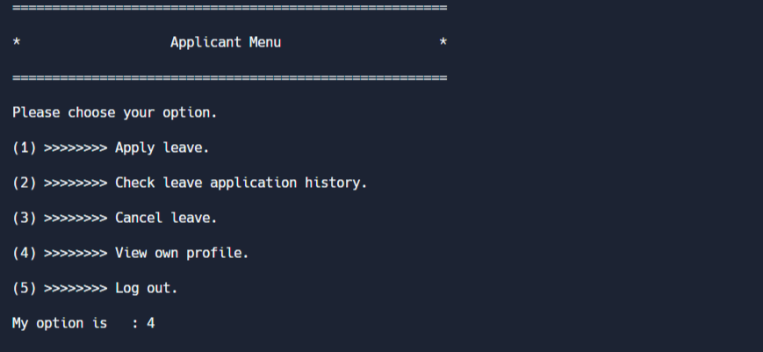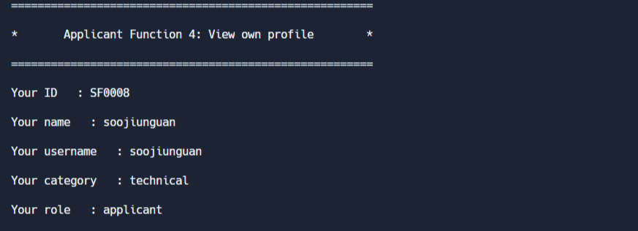

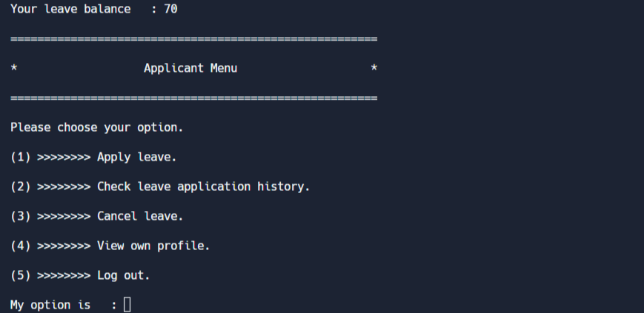

*Figure 5.2.7: Applicant Function 4: View Own Profile*

If applicant inputs 4 in the applicant menu, it will go to view own profile function. His/Her information would be printed, which enable applicant to check their leave balance.

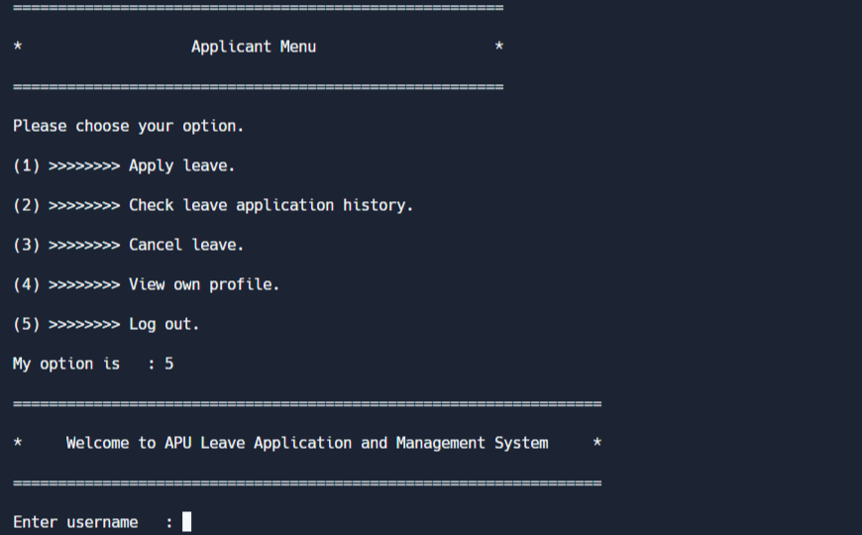

*Figure 5.2.8: Applicant Function 5: Log Out*

If applicant inputs 5 in the applicant menu, it will back to the login section.

## **5.3 Approver Functionalities**

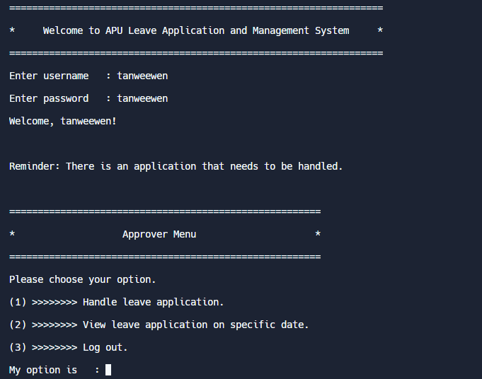

*Figure 5.3.1: Login as approver*

If you login with an approver account, it will go directly to the approver menu, which allows approver to handle leave applications. A reminder will be shown when there is leave application that needs to be handled.

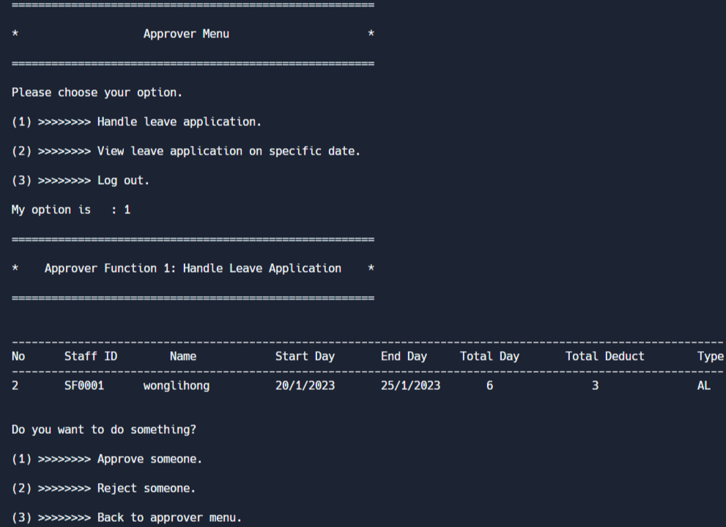 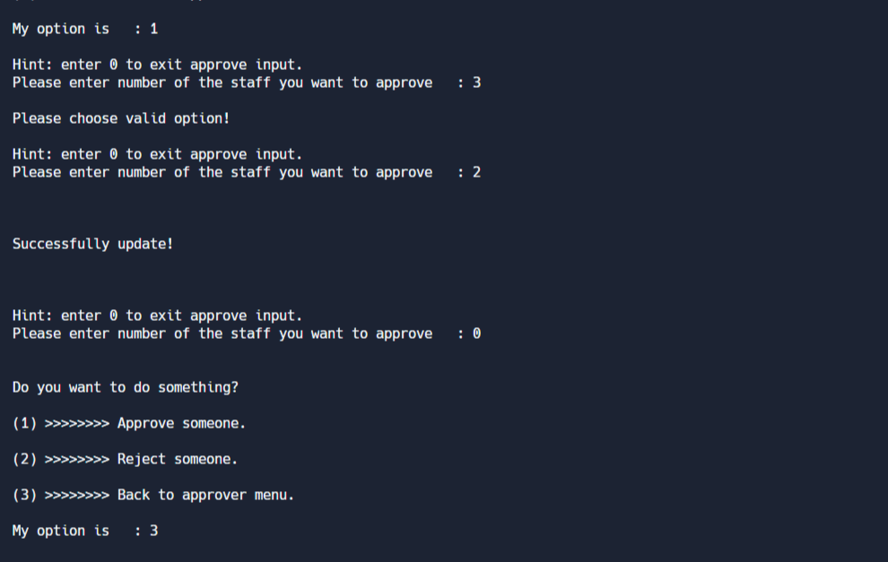 

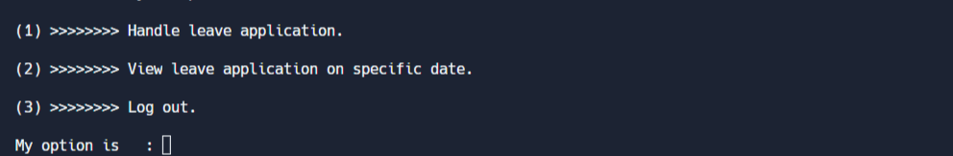

*Figure 5.3.2: Approver Function 1: Handle Leave Application*

If approver inputs 1 in the approver menu, it will go to handle leave application function. In this function, approver can approve and reject the leave applications which are belong to approver’s category. If approver enters an invalid leave application, the system will require approver to input again. A reminder that successfully updated would be shown to notice approver when he/she input a valid option. After that, approver can return to the menu through a series of operations.

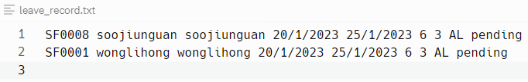

Figure 5.3.3: leave_record.txt before approving leave application

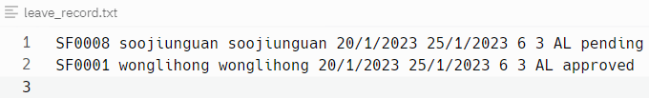

Figure 5.3.4: leave_record.txt after approving leave application

The status of the approved leave application will be updated to the leave_record.txt.

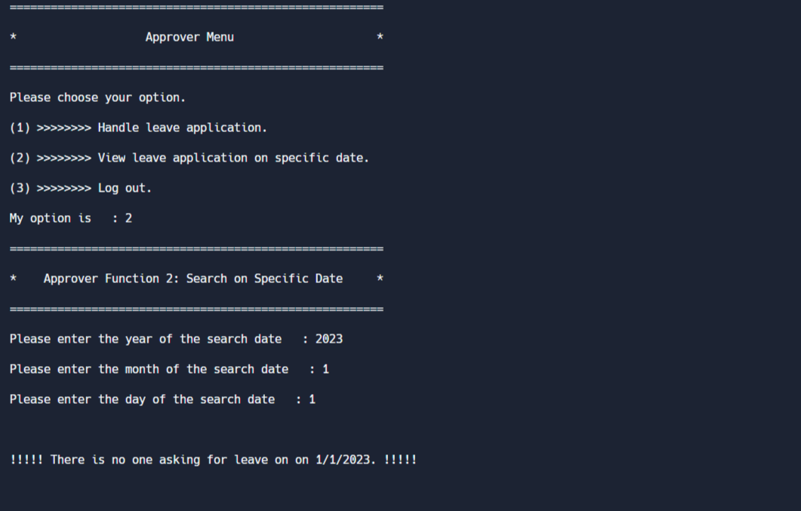 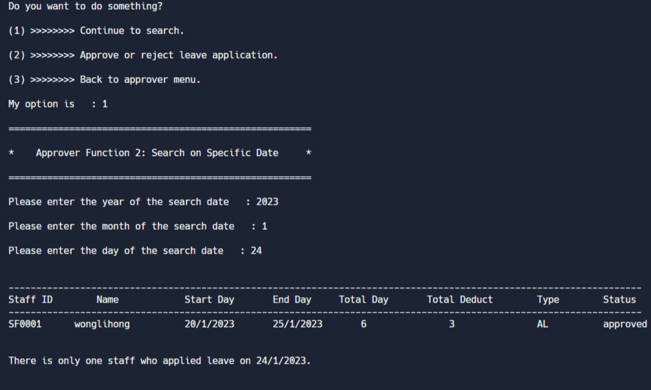 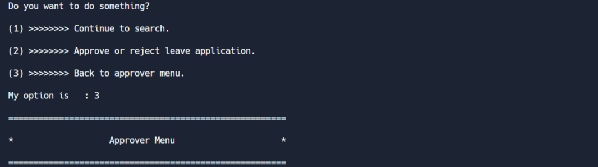

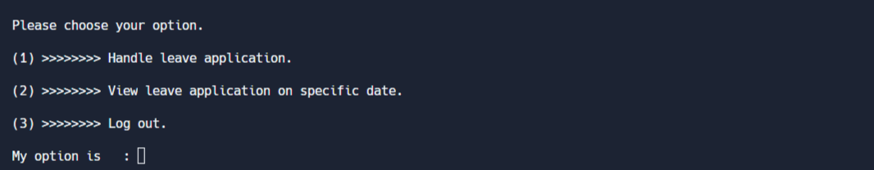

*Figure 5.3.5: Approver Function 2: Search on Specific Date*

If approver inputs 2 in the approver menu, it will go to search on specific date function. It prompts approver to input the date they want to search. If there is not any leave application on that day, it will show a reminder. On the contrary, leave applications that are involved that day will be displayed and provide some relevant options for approver to choose.

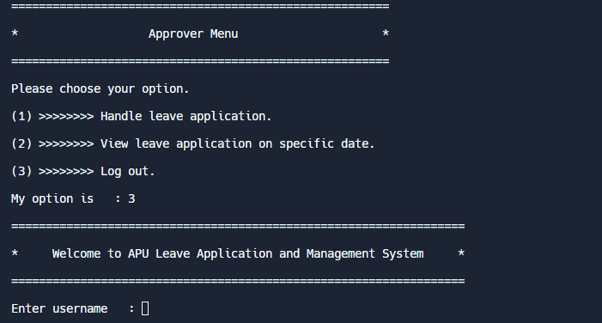

*Figure 5.3.6: Approver Function 3: Log Out*

If approver inputs 3 in the approver menu, it will back to the login section.

# **6.0 Conclusion**

In conclusion, the APU leave application and management system designed using C programming language is an effective and attractive system that helps manage employee leaves. The system was developed using various programming concepts and functions in C, including input/output operations, file handling, conditional statements, loops, and user-defined functions.

Through the process of designing this system, I have gained a deeper understanding of the syntax and concepts of C programming, including the use of pointers, structures, and arrays. I have also learned how to integrate different functions to create an efficient and user-friendly system.

The APU leave application and management system has the potential to increase efficiency and productivity in the workplace by automating the leave application process and providing real-time updates on employee leave status. Additionally, the system has the potential to reduce errors and improve accuracy in leave management.

Overall, this assignment has provided me with a practical experience in developing a real-world application using C programming language, and I am confident that the skills and knowledge gained through this task will be valuable in future programming projects.

# **7.0 References**

GeeksforGeeks. (2022, July 5). *Header files in C/ C++ and its uses*. <https://www.geeksforgeeks.org/header-files-in-c-cpp-and-its-uses/>

GeeksforGeeks. (2023a, January 5). *Structures in C*. <https://www.geeksforgeeks.org/structures-c/>

GeeksforGeeks. (2023, February 14). *scanf and fscanf in C*. <https://www.geeksforgeeks.org/scanf-and-fscanf-in-c/>